

Introduction 2

The General 2

Business Problem 2

Analysis and Models 3

About the Data 3

Strategy 4

Deep Learning: Multiclass Classifiers (large dataset) 6

Data Pre-processing 7

About Convolutional Neural Network (CNN) 8

Model 1 10

Model 2 11

Deep Learning: Binary/Multiclass Classifiers (reduced dataset) 13

Data Pre-processing 13

Binary Classifier 17

Multiclass Classifier 31

CNN: Visualizing Intermediate Activations 43

Traditional Models: Binary/Multiclass Classifiers (reduced dataset) 47

Data Pre-processing 47

Multiclass Classifiers 56

Binary Classifier 74

Results 93

Deep Learning: Multiclass Classifiers (large dataset) 93

Deep Learning: Binary/Multiclass Classifiers (reduced dataset) 94

Traditional Models: Binary/Multiclass Classifiers (reduced dataset) 95

Conclusions 98

Extended Research & Future work 99

References 100

# **Introduction**

## **The General**

The project team has chosen the data set that comes from the interesting Kaggle competition “Image retrieval using Google Landmarks data”. The objective was to predict the images correctly by labels, using deep learning techniques (convolutional neural networks) and to compare the results with traditional models, such as Decision tree, k-Nearest Neighbors, Support Vector Machines and Random Forest. In addition, the team investigated the configuration of the architecture of convolutional neural networks (CNNs) and explored hyperparameter-tuning for model-fitting to determine whether CNNs are better than traditional classification algorithms for an image classification task.

## **Business Problem**

Landmark search is important for a search engine company as landmarks account for a large portion of what people like to photograph. To improve landmark image retrieval, Google posted a competition at Kaggle and stated the business problem: Given an image, can you find all of the same landmarks in a dataset?

Essentially, this is an image classification problem. Using a sample set from the Google Landmark image data set provided by Kaggle, the project team attempted to address this business problem using TensorFlow neural network modeling and traditional data mining classification algorithms and compared their accuracy. Due to the tight time frame, the project team selected a small portion of the given dataset to create a proof of concept.

# **Analysis and Models**

## **About the Data**

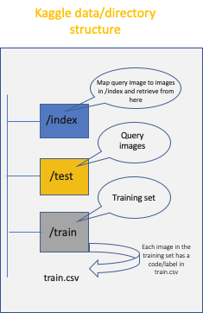

**Fig: Kaggle directory structure**

The Kaggle data is organized as shown above and comprises /index, /test and /train folders and a train.csv, that maps images under /train to corresponding landmark ids. train.csv would prove to be extremely useful in sampling datasets and splitting train data into validation or test. The train data was ~100GB comprising 1.5 million images and 81314 unique landmarks.

Example of landmark diversity below:

.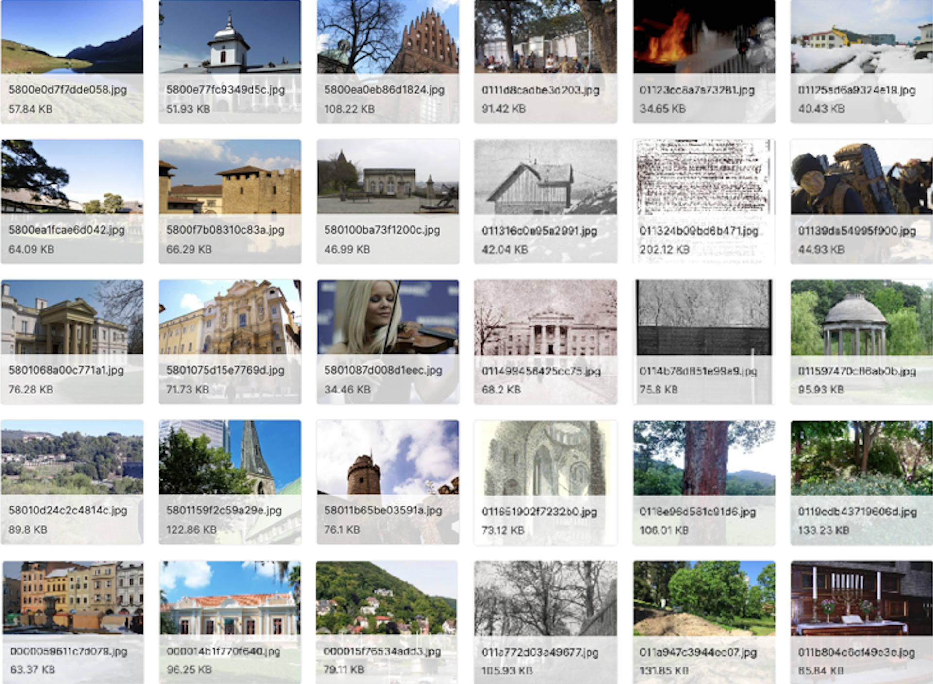

**Fig: Examples from the original data set**

## **Strategy**

Dealing with a complex dataset involving image processing tasks to solve landmark retrieval problems in a short span of time needed a clear-cut strategy and execution plan. A high-level pipeline is presented here - read left to right, depth-first (stage-wise).

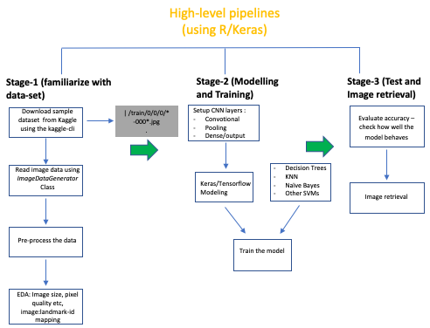

**Fig: Work process pipelines**

Also, some key decision points were:

* To adopt Keras, a Tensor-flow based library in R will be used for all image processing and analysis
* Leverage shell wrappers, Kaggle-cli etc. for data-retrieval and data split across train, test and validation directories
* Divide and conquer approach - Setup small proof-of-concept experiments and review outcomes.
* The analysis and results would broadly be based on the following experiments:
  + **Experiment-1** - Deep Learning: Multiclass Classifiers (large dataset)
  + **Experiment-2 -** Deep Learning: Binary/Multiclass Classifiers (reduced dataset)
  + **Experiment-3** - Traditional Models: Binary/Multiclass Classifiers (reduced dataset)

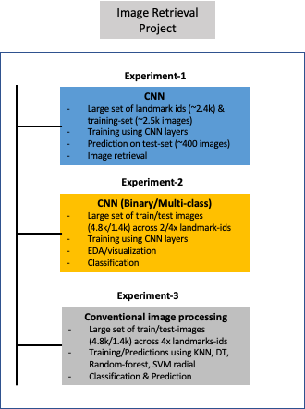

**Fig: High-level project execution strategy**

## 

## 

## **Deep Learning: Multiclass Classifiers (large dataset)**

The first experiment attempts to solve the retrieval problem albeit, at lower scale. The Kaggle train data was split as follows for this experiment:

* Train - 2,000 landmark ids and 20,000 images*
* Test - 2,000 landmark ids and 10,000 images
* Validation - 2,000 landmark ids and 10,000 images

*Some experiments went as high as 40,000 images to solve problems around what seemed to arise from model overfitting

Images across datasets were mutually exclusive with train and validation used when training the model as below:

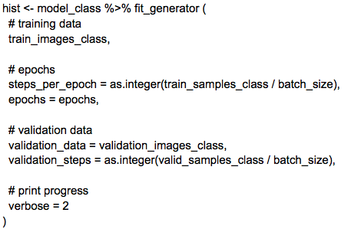

**Fig: Code excerpt showing train and validation data in model training**

And, the test dataset used to evaluate model accuracy.

### **Data Pre-processing**

The initial data or image pre-processing involved study of the quality of images, pixels, dimensions etc. before it could be fed to the convolutional neural network.

Below is a sample image (in grayscale):

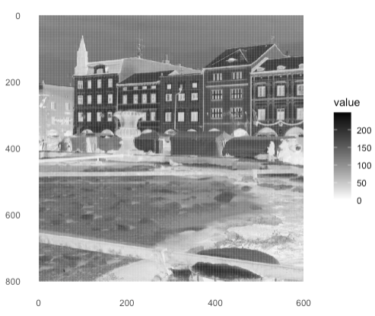

**Fig: Sample landmark image in grayscale**

This shows us, the pixel values are between 0-255 and the image is 600 x 800 dimension. We will correspondingly scale down the image as shown in the code excerpt:

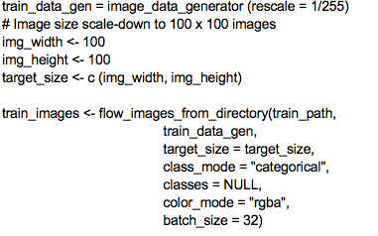

**Fig: Code excerpt showing image scale-down**

The images are finally, in the following format when input to the neural net:

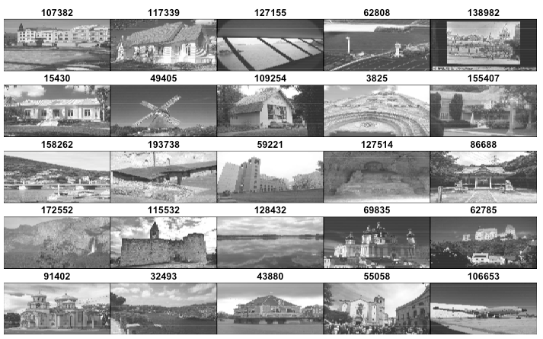

**Fig: Sample images input to the neural net**

### **About Convolutional Neural Network (CNN)**

CNN is a type of deep-learning model, which dominates in computer vision applications and is widely used for image classification tasks. A CNN comprises of convolution layers, pooling layers, and fully connected layers. It adaptively learns spatial hierarchies of features through a backpropagation algorithm, using gradient descent. In this experiment, the Keras Library was used to build the CNN models with the TensorFlow backend. Keras provides high-level building blocks for building deep-learning models and enables rapid prototyping with minimal lines of code.

CNN (convnet) - comprises layers defined below:

* Convolutional layers - Extract feature-sets from images starting with a basic layer to retrieve details like edges to subsequent layers that can retrieve details from 2D window-like image portions
* Max pooling layer - To aggressively down-sample image feature-sets and uses the *MAX* tensor function to output maximum value from each channel
* Flattening layer - To convert 3D arrays from Convolution layers to 1D arrays
* Dense layer - The dense layer is the output layer, each node represented as a probability and therefore adding up to 1.

The initial convnet architecture and layers were setup as below:

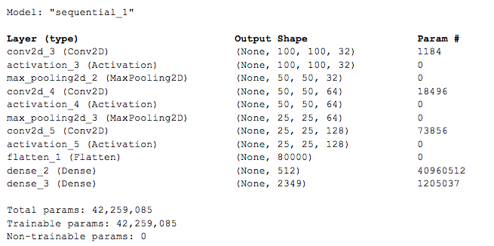

**Fig: Summary of a compiled convnet model**

Since the images were complex (often with landmarks camouflaged with other subjects, structures etc.) the convnet was performing poorly likely due to the noise, and the model lacking ability to generalize well enough. Some well-known techniques were sought to solve this problem along with a seemingly overfitting problem:

1. Add dropout
2. Reducing the network-size
3. Increase the training-set and train longer (find the right balance of epochs and time to train so as not to overfit or generalize the model)

### **Model 1**

The first model experiments around adding drop-out layers and experimenting with reducing the network-size. The drop-out functionality randomly drops out or sets to zero a number of output features during training. This is known to be most effective in neural networks.

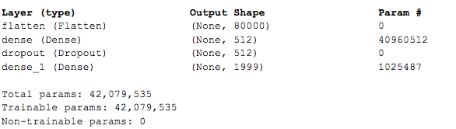

**Fig: Compiled convnet layer with drop-out**

The drop-out option is present in Keras via *layer_dropout(<val>)* where val is usually set between 0.2-0.5. This experiment sets *layer_dropout = 0.5*

Further, the network is simplified by reducing the number of units in the dense layer:

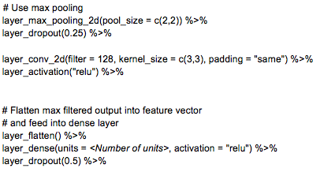

**Fig: Code excerpt showing reduced units**

Finally, to presumably solve an overfitting problem the experiment used larger training-set:

Found 28502 images belonging to 1999 classes. <- Train

Found 11453 images belonging to 1999 classes. <- Validation

Found 9979 images belonging to 1999 classes. <- Test

### **Model 2**

The second model uses the notion of a pre-trained convolutional neural net. For this project, the Visual Geometry Group or commonly referred to as VGG16 was used. The architecture that comprises 16 layers can be visualized as:

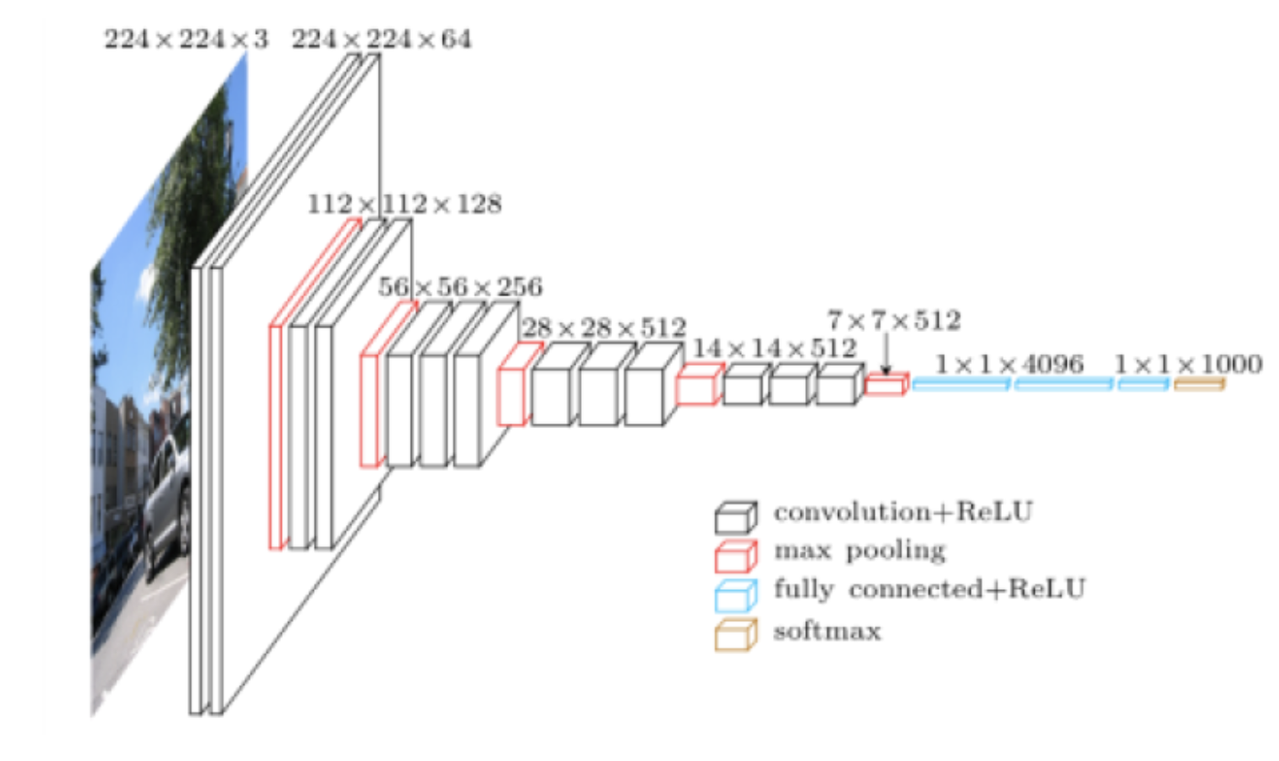**Fig: VGG16 convolutional neural network layers**

The VGG model was modified to fit the number of classifiers in the dataset:

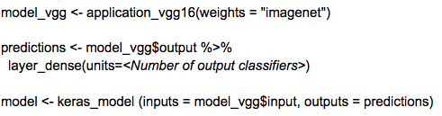

The results are presented in detail in the Results section.

## **Deep Learning: Binary/Multiclass Classifiers (reduced dataset)**

To take a different approach from the first experiment, the second experiment started small — building a binary classifier using convolutional neural networks (CNN) — focusing on solving the classification problem for two labels (20409, 126637), which have the largest numbers of images among the four labels. After trial and error with hyperparameter-tuning, three models gave high accuracy results between 97.3% and 97.7%.

The experiment then expanded to include the whole sample set of four labels (20409, 83144, 113209, 126637). The same architecture for the binary classifier (except for the output layer unit and activation function) was also used to build the multiclass classifier:

* Binary Image Classifier — 2 labels, output layer with 1 unit and sigmoid function
* Multiclass Image Classifier — 4 labels, output layer with 4 units and softmax function.

The three models of the 4-labels classifier reached the accuracy between 89.8% and 93.1%.

The details of the experiment are explained below, starting from sample set selection, data pre-processing, and model analysis, to results summary.

### Data Pre-processing

To select images for the sample set for the second experience, the training set from the original data set from Kaggle was inspected and explored. The train.csv file provided image IDs with the Landmark ID assigned to each image. A histogram was plotted to visualize the distribution of images by Landmark ID.

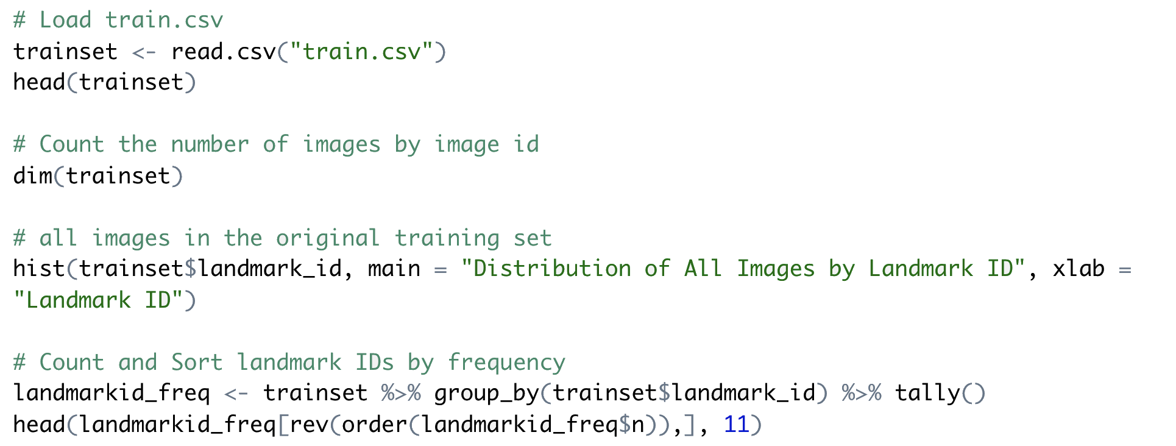

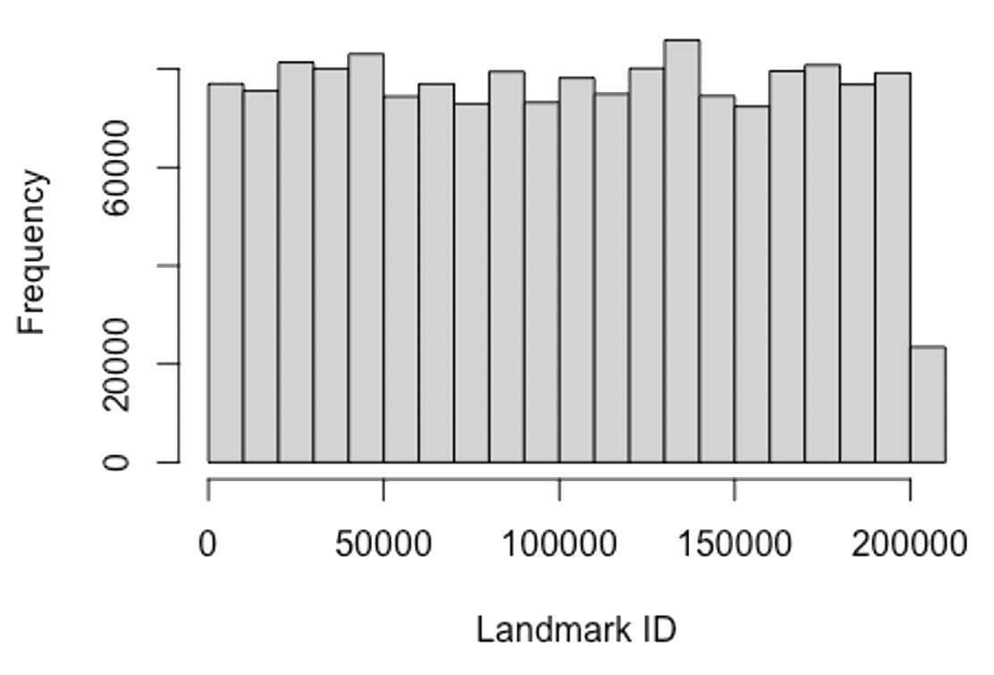

**Fig: Distribution of All Images by Landmark ID**

Through data exploration, four landmark IDs (labels) from the original Kaggle training data set were found to contain the highest numbers of homogeneous images within each label:

- 20409: 1758 images

- 83144: 1741 images

- 113209: 1135 images

- 126637: 2231 images

The total number of images in the four classes added up to 6865. This formed the sample set for the subsequent second and the third experiments. The images were of various sizes, and of various widths and heights.

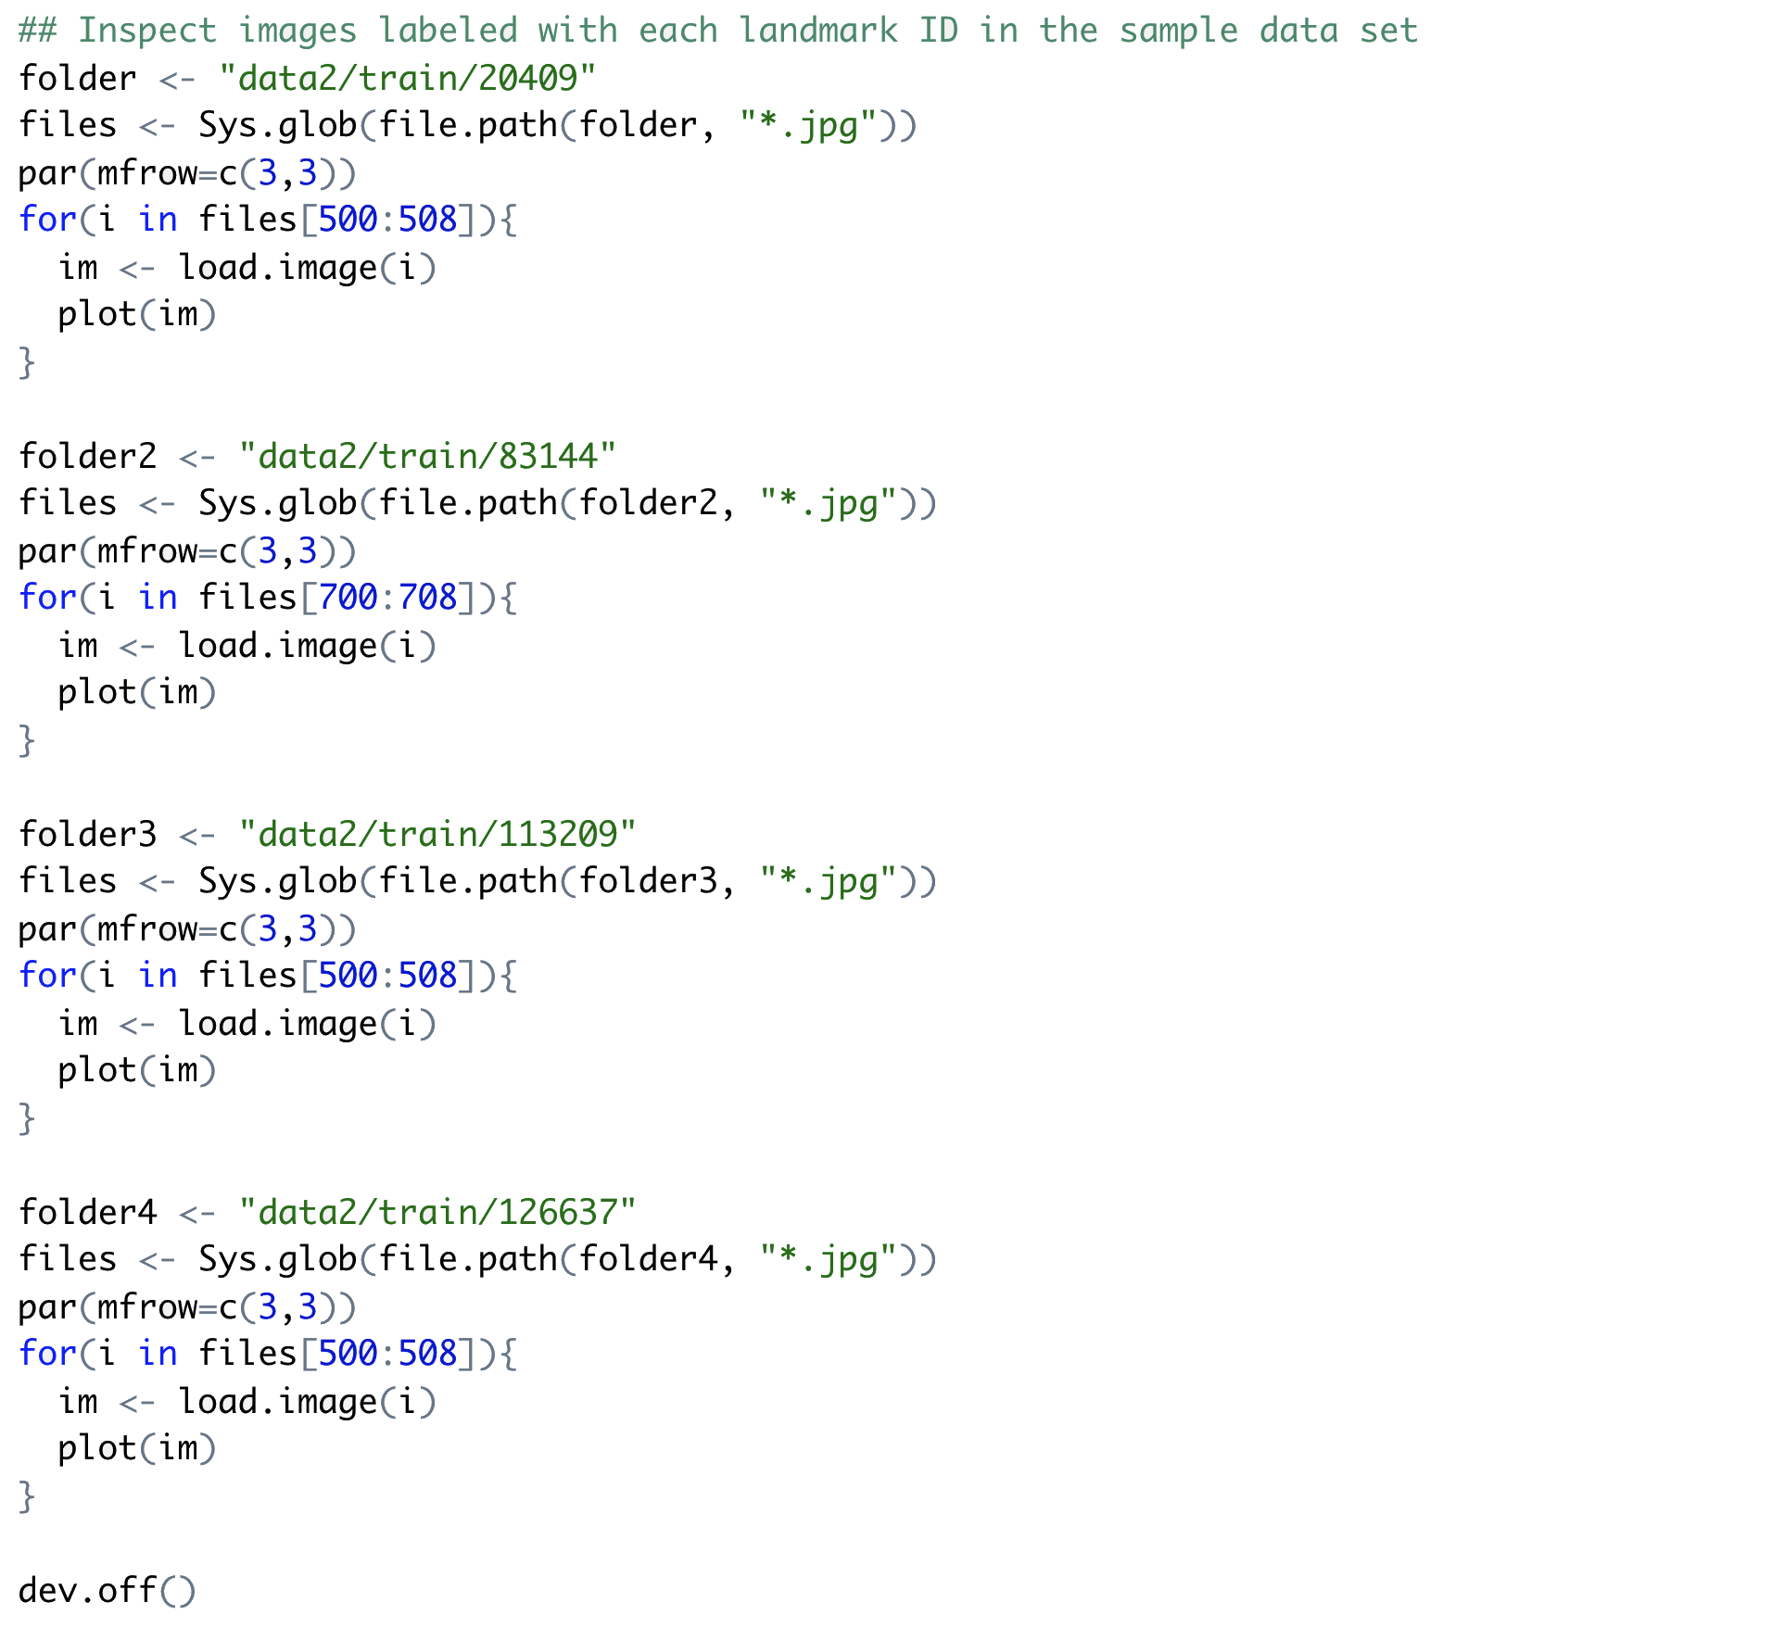

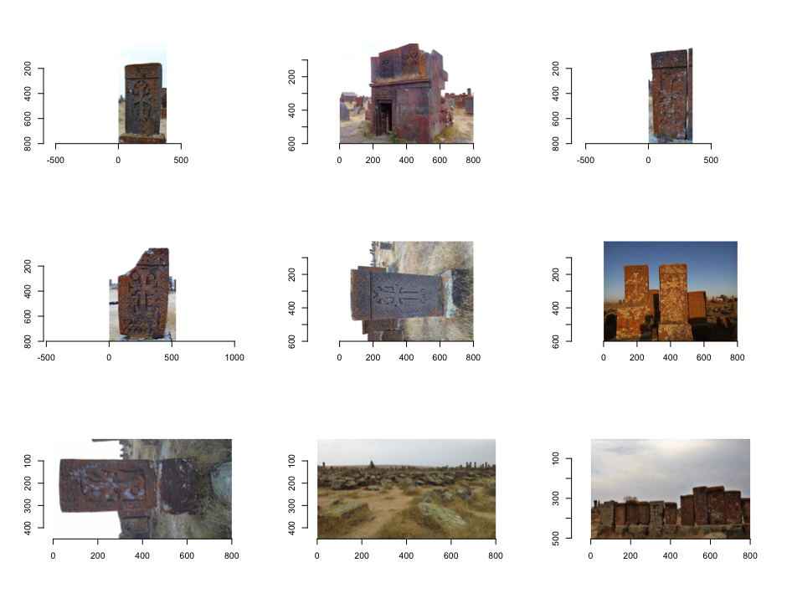

**Fig: Sample Images with Landmark ID 20409**

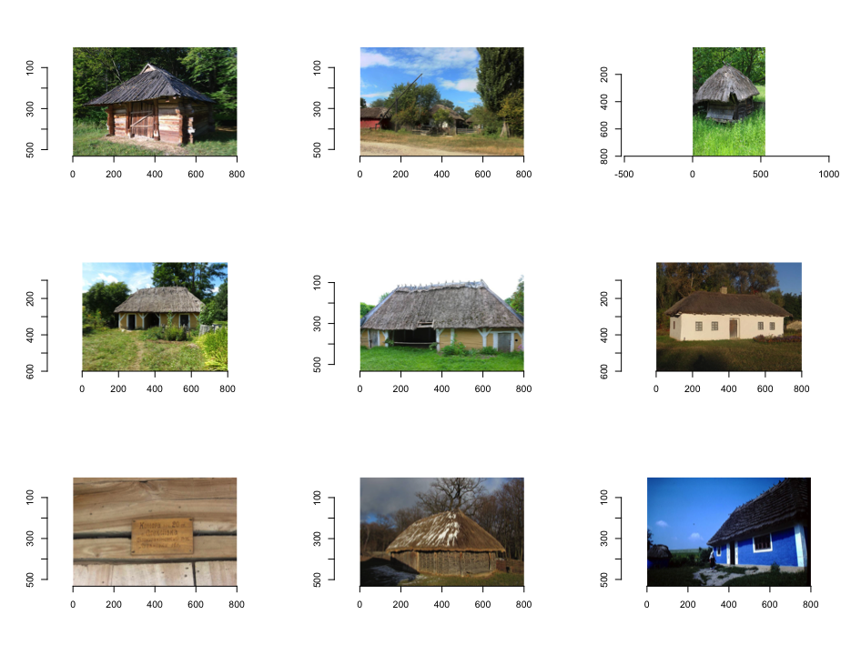

**Fig: Sample Images with Landmark ID 83144**

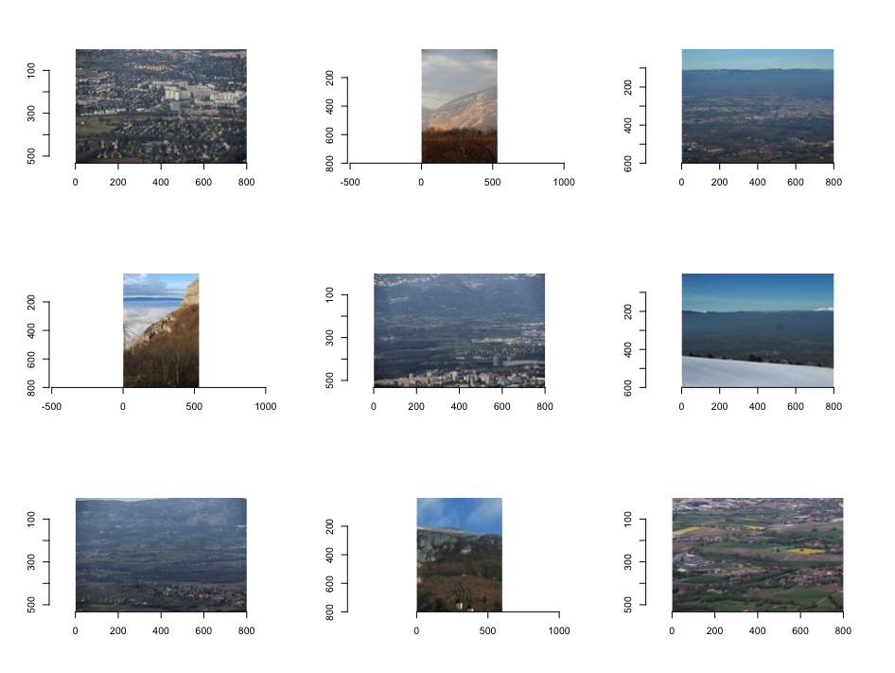

**Fig: Sample Images with Landmark ID 113209**

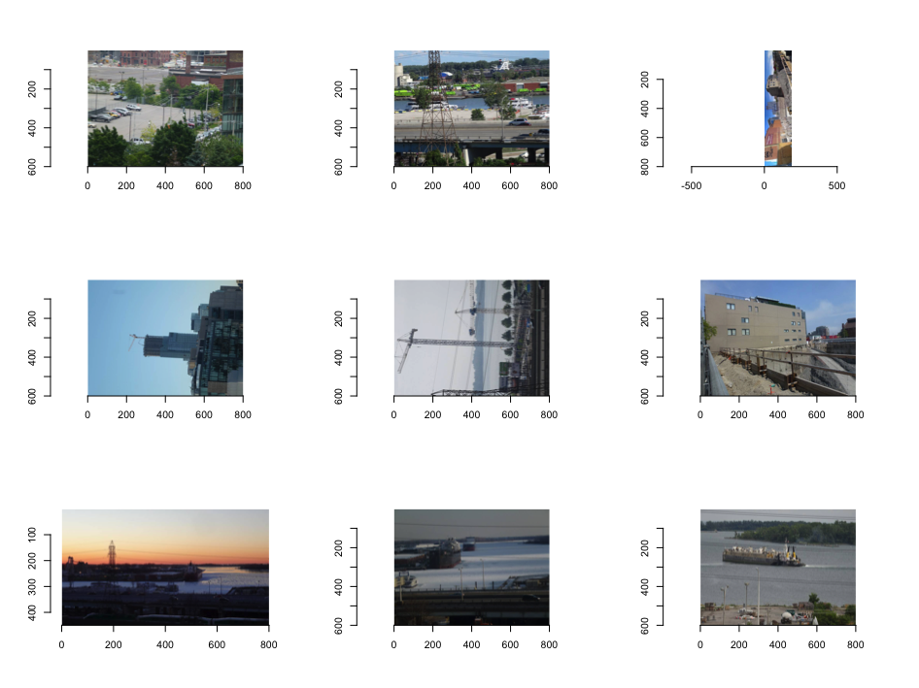

**Fig: Sample Images with Landmark ID 126637**

### **Binary Classifier**

The images in classes 20409 and 126637 were used as the sample set for the binary classifier. For each class, images were split into the training set (50%), the validation set (25%), and the test set (25%). The same proportion of the split for each class ensured that the training set, validation set, and test set had the same distribution of images as compared with the whole sample data set.

* Training images in class 20409: 879
* Validation images in class 20409: 440
* Testing images in class 20409: 439
* Training images in class 126637: 1115
* Validation images in class 126637: 558
* Testing images in class 126637: 558

To enable the loading of the images from a folder into the network, the image files had to be saved into a folder structure with individual subfolders for training images, validation images, and testing images respectively; within each subfolder were two subfolders, each containing images for a class.

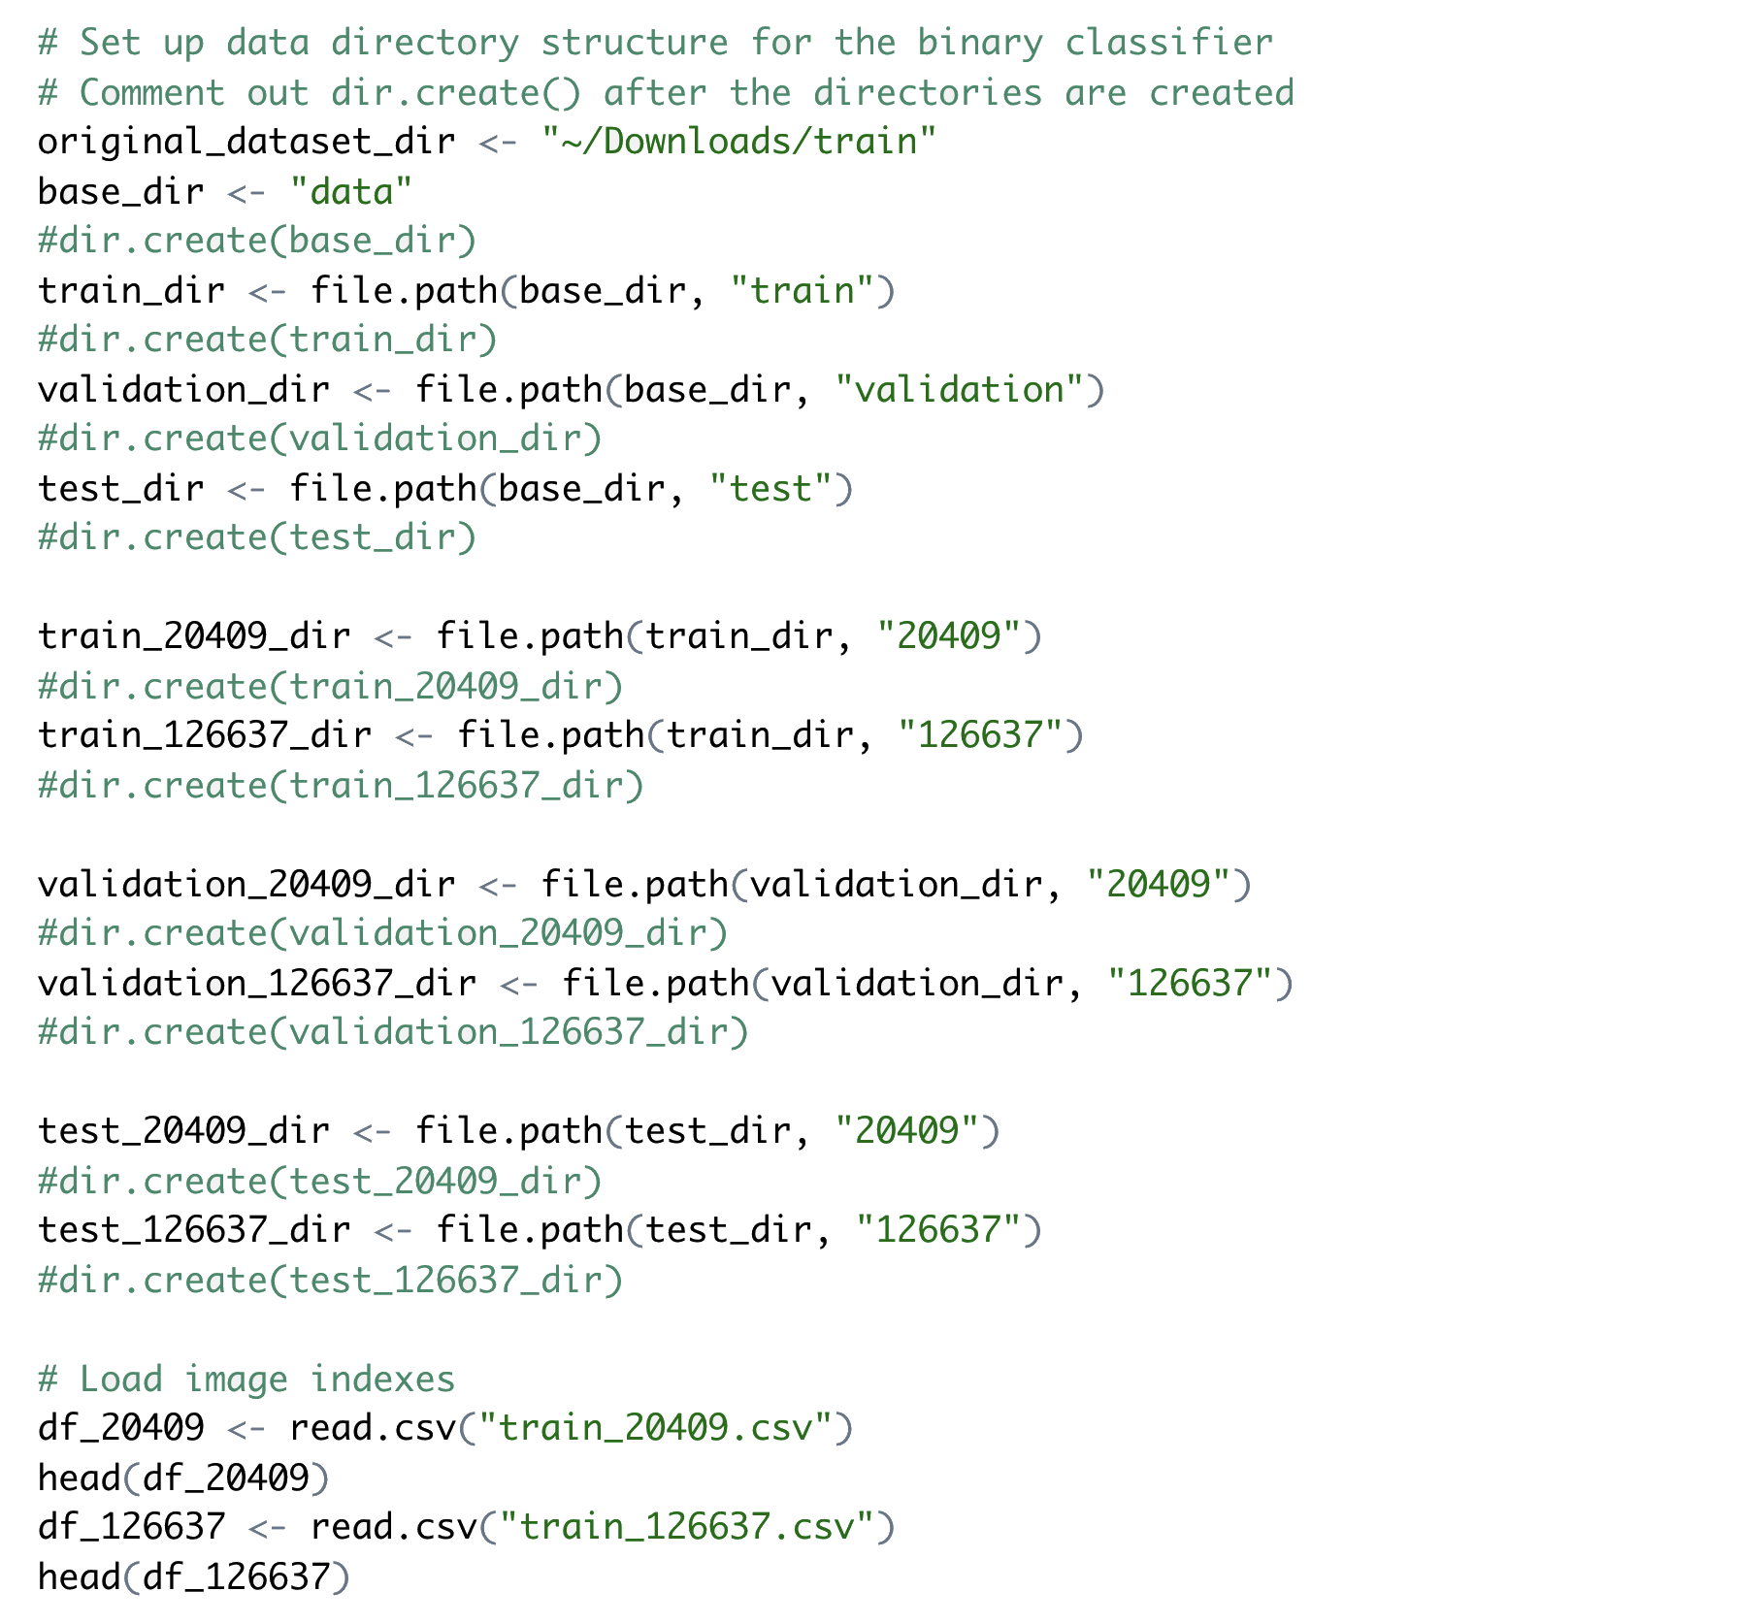

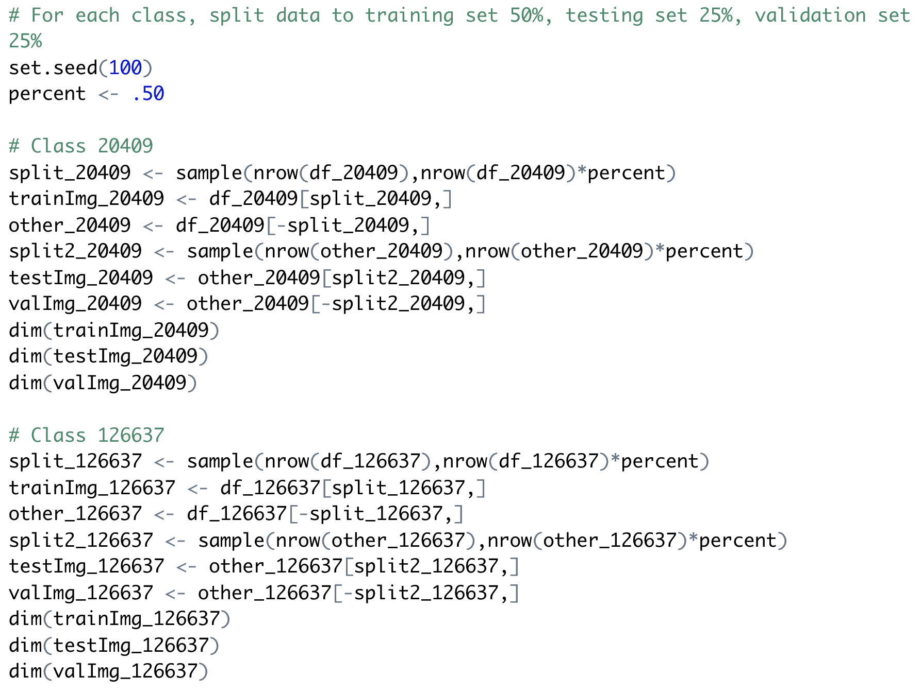

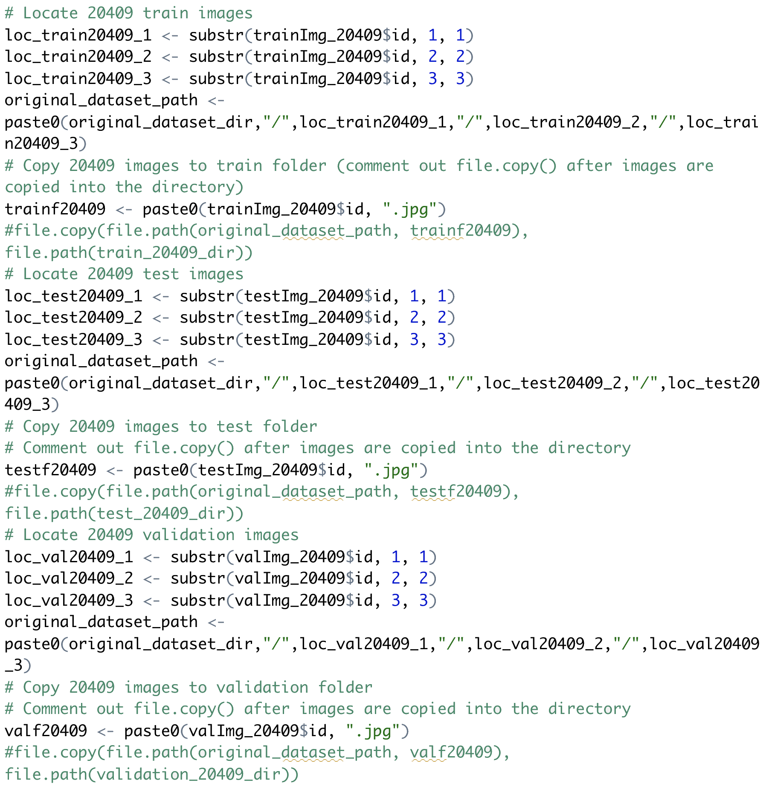

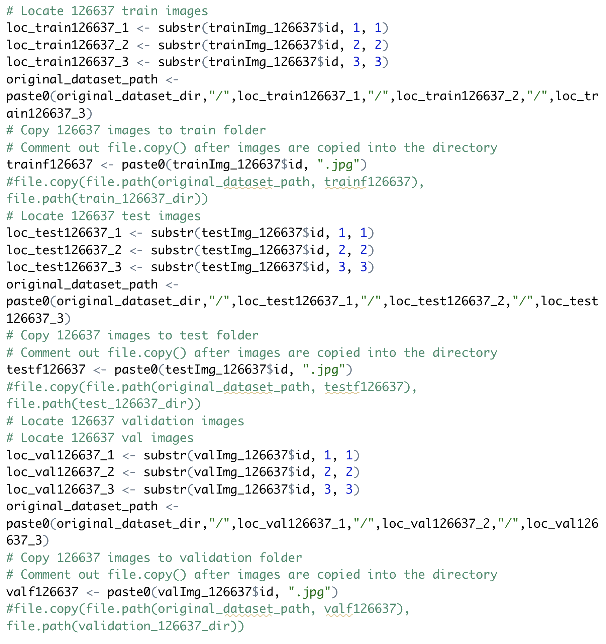

Read images from directories, convert them into batches of pre-processed floating-point tensors.

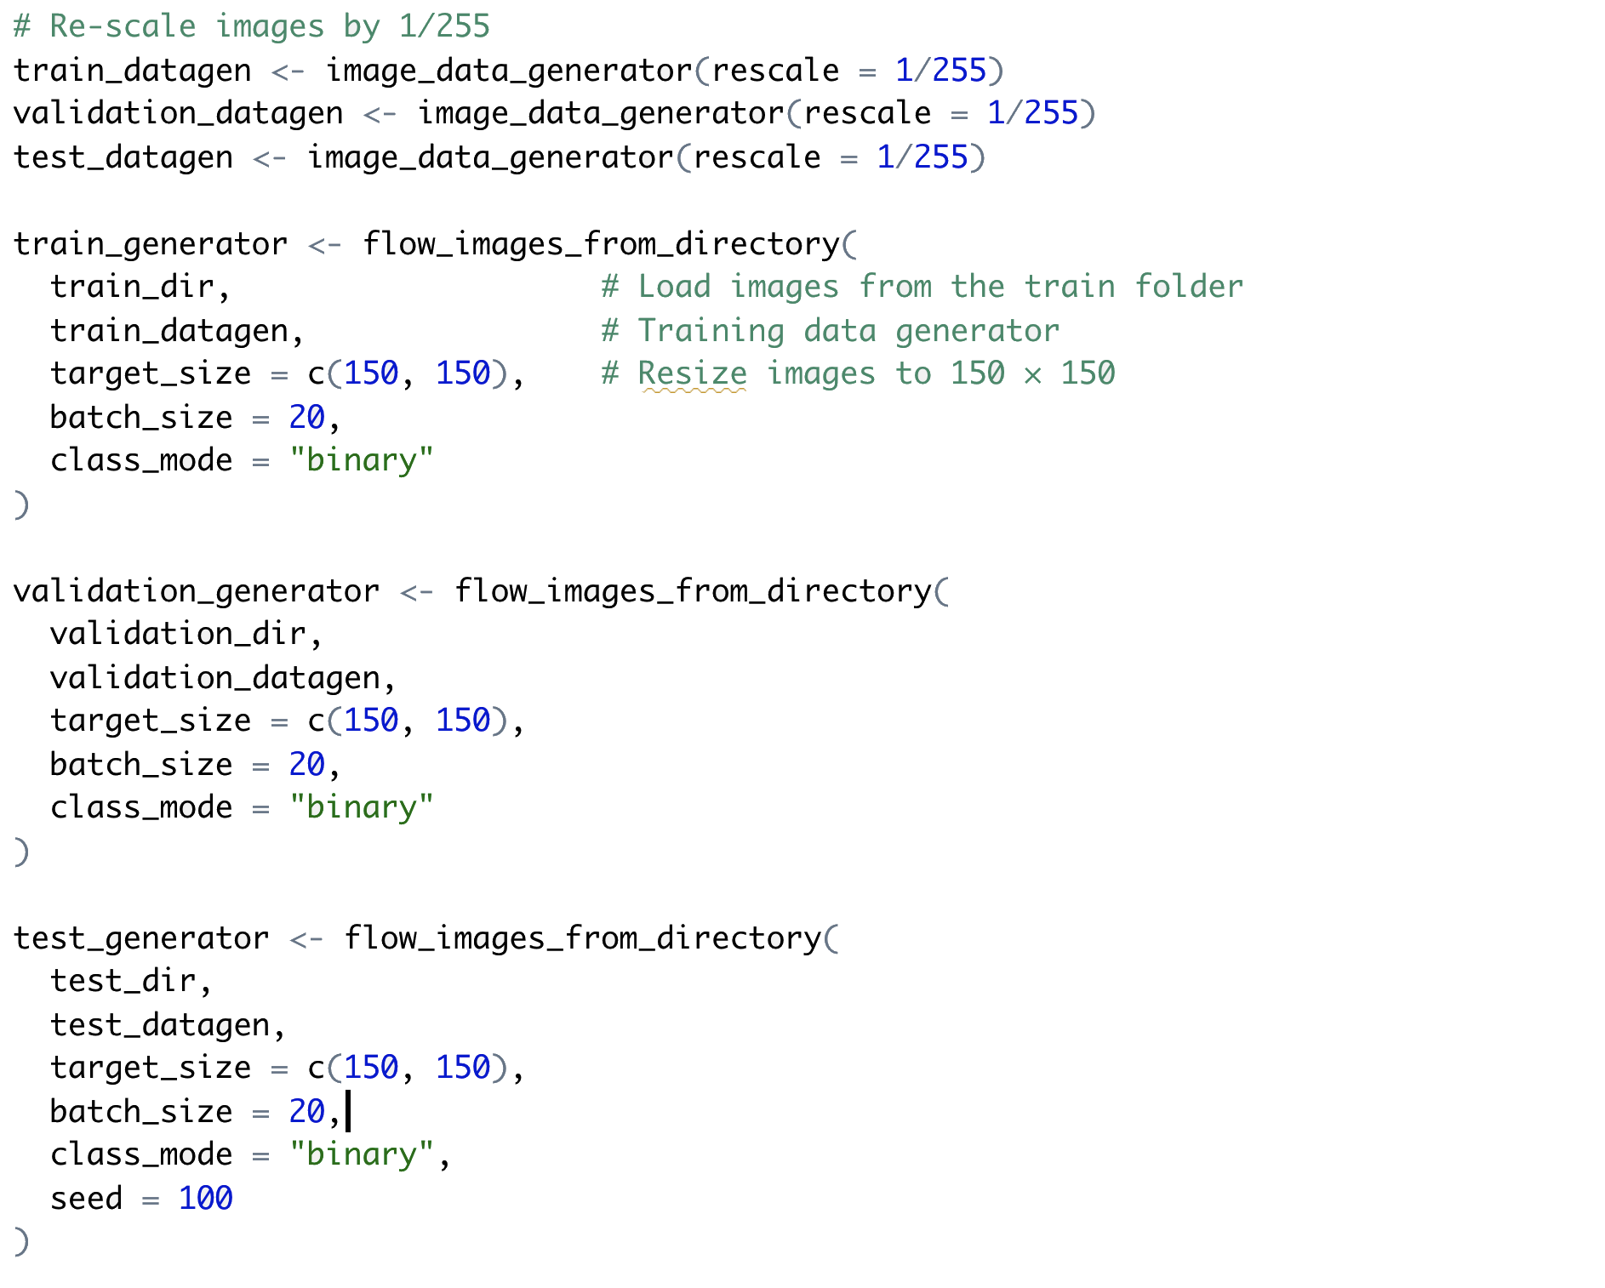



List of 2

$: num [1:20, 1:150, 1:150, 1:3] 0.137 0.353 0.31 0.745 1 ...

$: num [1:20(1d)] 0 0 0 0 1 1 1 0 1 1 ...

The training data generator output batches of 150 × 150 RGB images (shape (20, 150, 150, 3)) and binary labels (shape (20)), 20 images in each batch. The data were then ready to be fed into the network.

#### 

**Binary Classifier: Model One: The Base Model**

In the first CNN model, the network architecture contained a linear stack of 11 layers, including 4 alternated convolution layers (with relu activation) to augment the network capacity. Each was followed by a pooling layer to down sample feature maps to reduce feature-map coefficients processing and induce spatial-filter hierarchies. As the depth of the feature maps increased from 32 to 128, the size of the feature maps decreased from 148 × 148 to 7 × 7. After these 8 intermediate layers was a flattened layer and two dense layers (i.e. fully connected layers). For the binary classification problem, the output layer (the 2nd dense layer) had a single unit, with the sigmoid activation. The unit produced the probability of one class or the other.

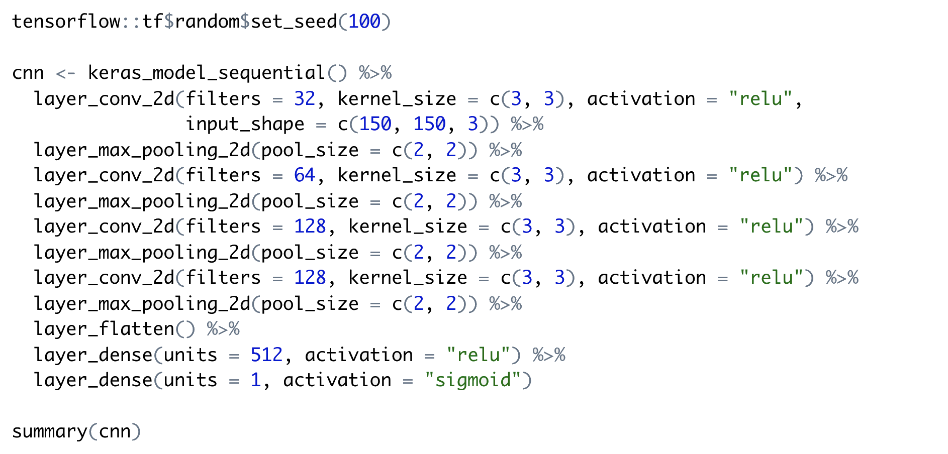

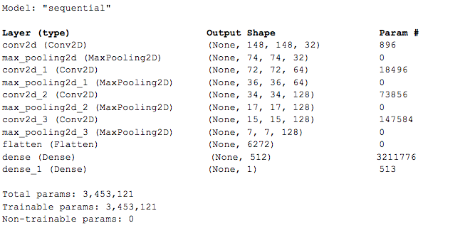

**Compiling Model One**

To configure the learning process, the RMSProp optimizer with the learning rate of 0.0001 was used in the compilation step and `binary_crossentropy` was used as the loss function. "Accuracy" was used as the metrics, which calculated how often predictions equal labels.

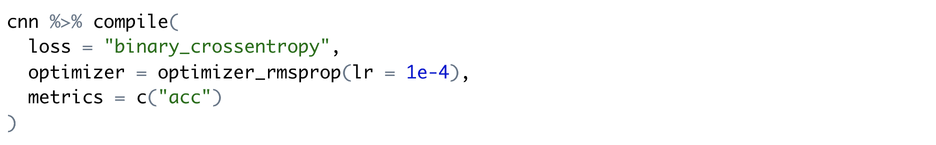

**Training Model One**

Using `fit_generator ()`, the model was trained and validated through 30 epochs. An epoch is an iteration of passing all the training and validation data forward and backward through the neural network. The trained model was saved after training.

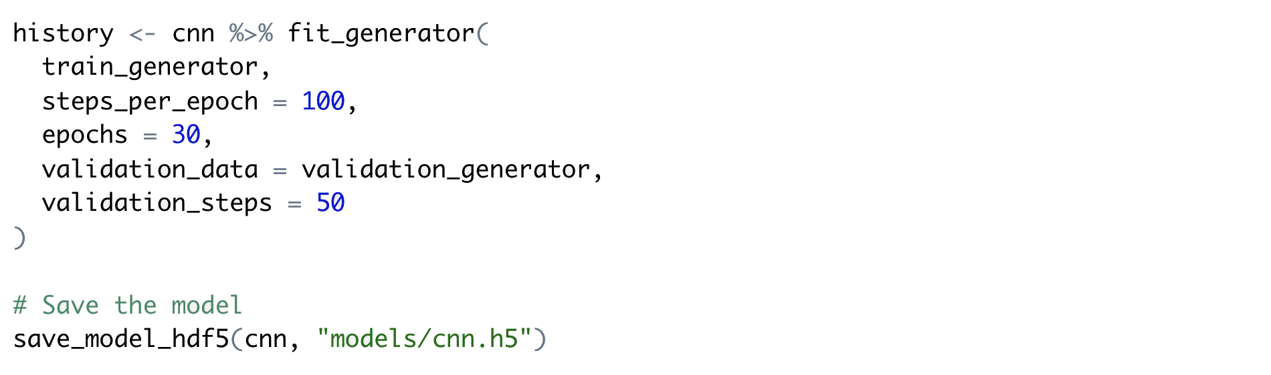

The plot showed the loss and accuracy of the model during training and validation through 30 epochs. It was clear from the plot that after 5 epochs the validation loss gradually pulls further above the training loss, and the training accuracy further above the validation accuracy. This was a sign of overfitting. It may have been caused by the small training sample data set (1994 images in 2 classes).



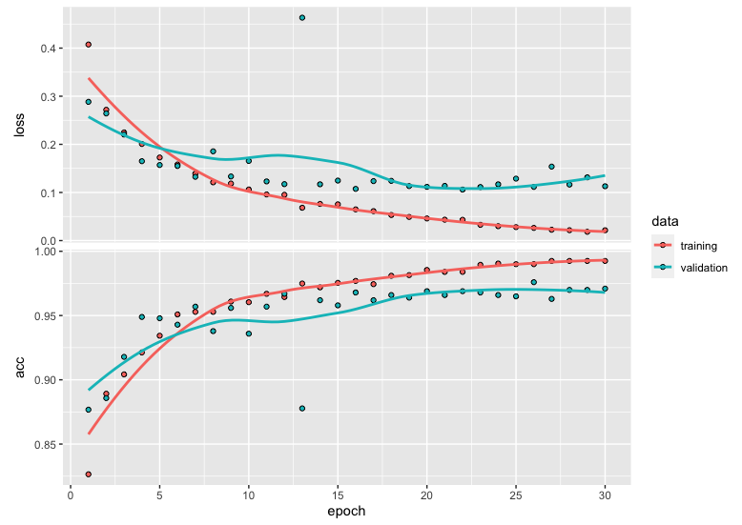

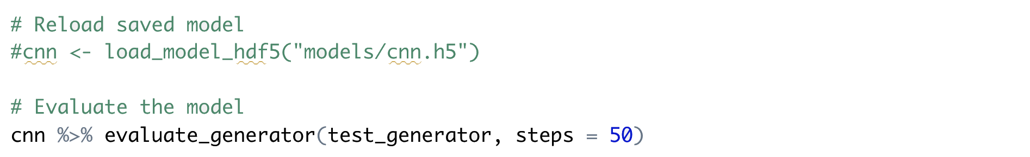

Even though the model was overfitted, the test accuracy still reached approximately 97.6%.

**Binary Classifier: Model Two: Adding Data Augmentation & Dropout**

Based on the same architecture, the second model added data augmentation and dropout to resolve the overfitting issue.

**Adding Data Augmentation**

Overfitting is caused by not having enough training samples from which the model can learn. Therefore, the model is not able to generalize to new data. One way to help resolve the overfitting problem is to use the Data Augmentation strategy to increase the diversity of the existing sample data during training. It does a number of random transformations on the sample images so, at training time, the model is exposed to more aspects of the data; thus the model can generalize better.

Common data augmentation techniques include:

1. Random rotation between 0-180 degrees
2. Random shifting of width and height of images
3. Random zooming inside images
4. Random horizontal ﬂipping

image_data_generator() is used to random transformations are performed on the images. Below is an example of the resulted images after data augmentation techniques are performed.



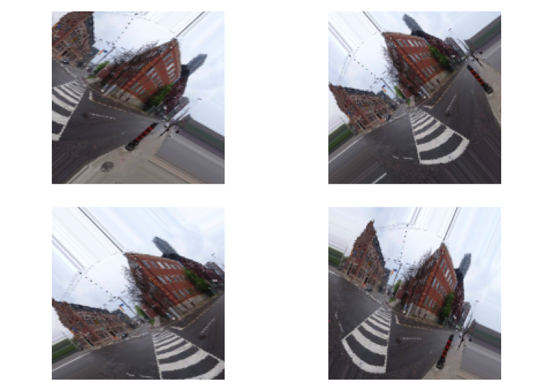

**Fig: An Example of Data Augmentation**

**Adding Dropout**

Data augmentation made the inputs more intercorrelated, because they included a large number of variations of the same images from the original small sample data set. Thus, it may not be enough to resolve the overfitting issue. In order to reduce intercorrelation, a dropout layer was added to the model after the flattened layer. "Dropout" is a regulation technique, which randomly selects neurons to ignore. The rate of the dropout was set as 50% in this model.

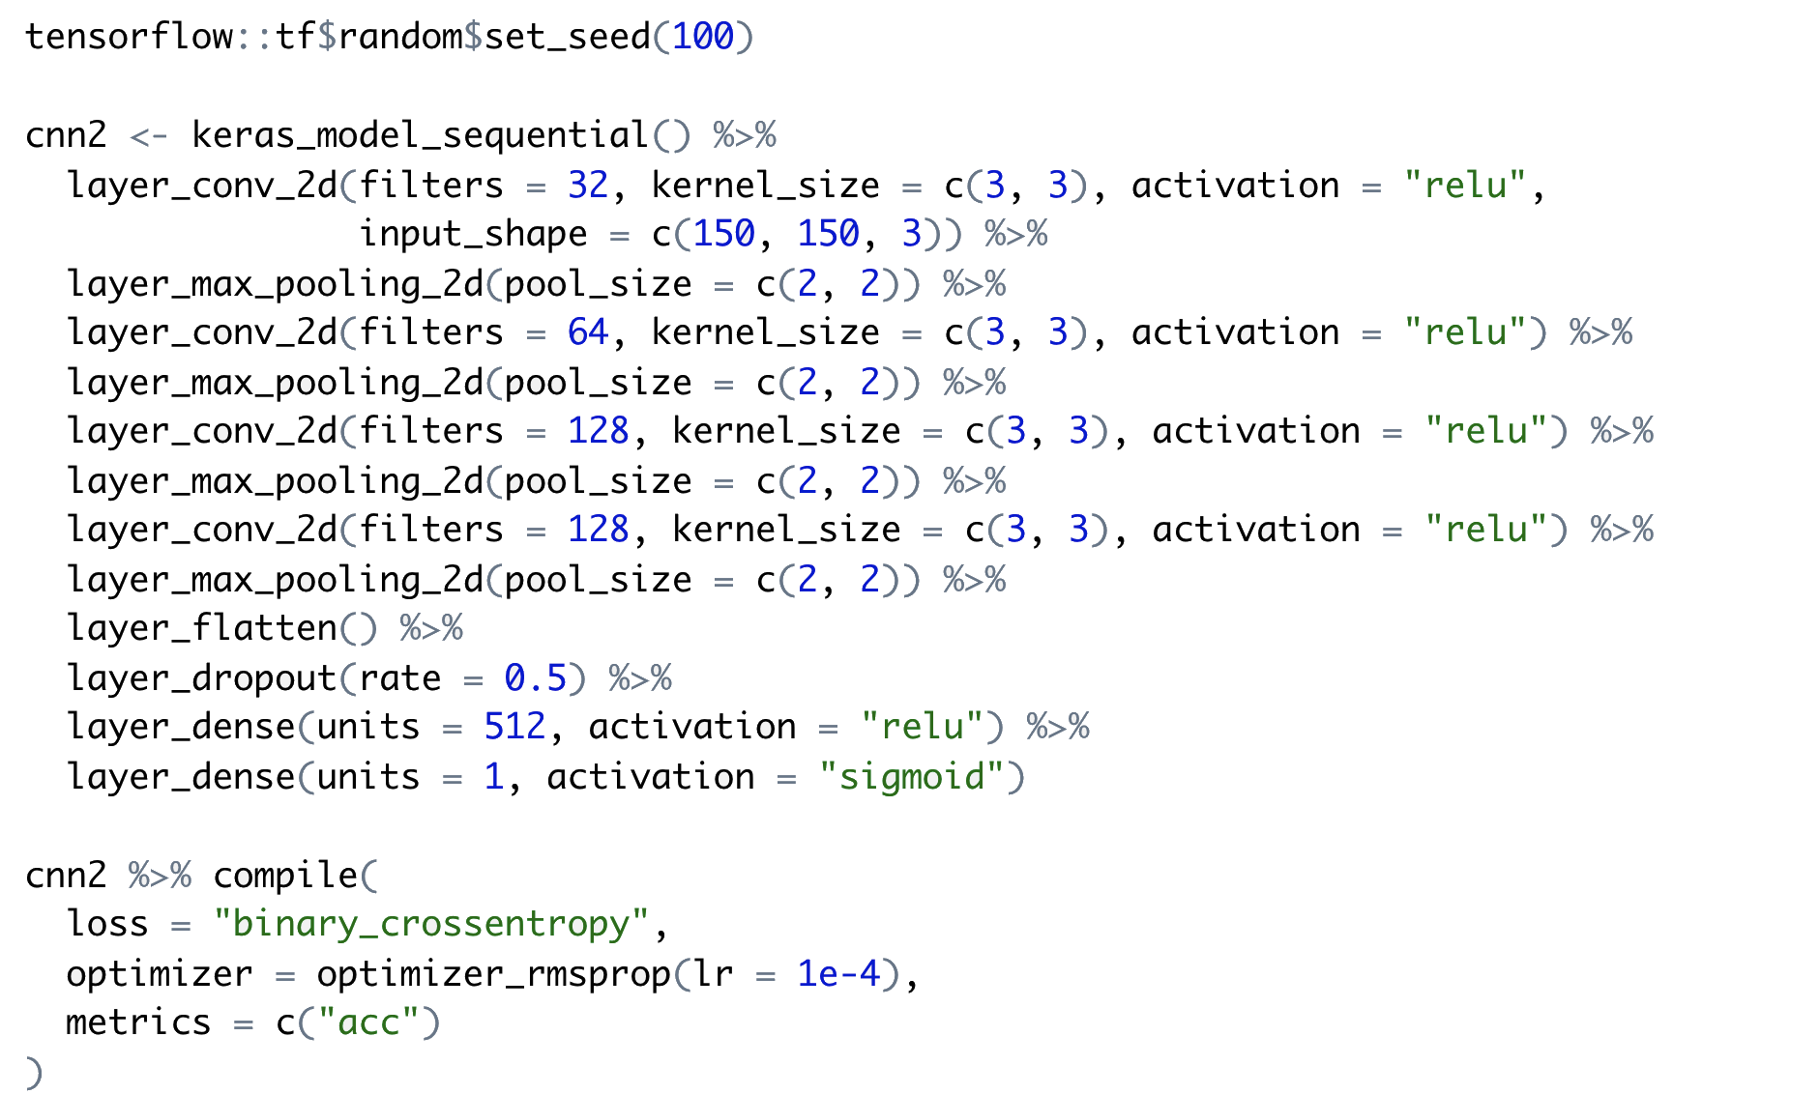

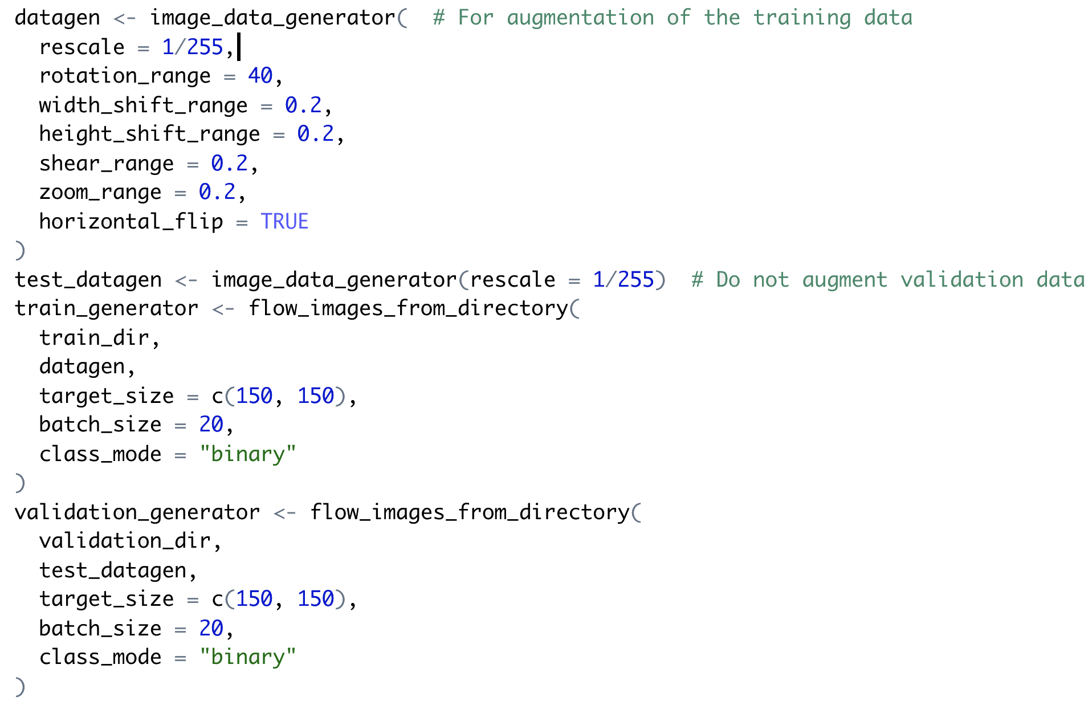

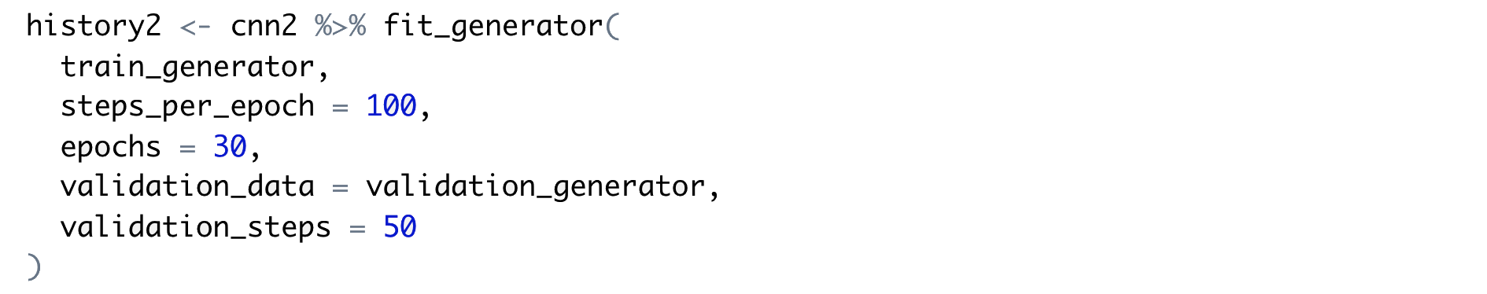

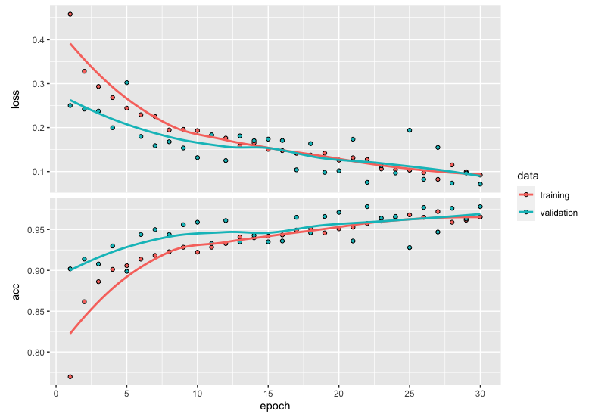

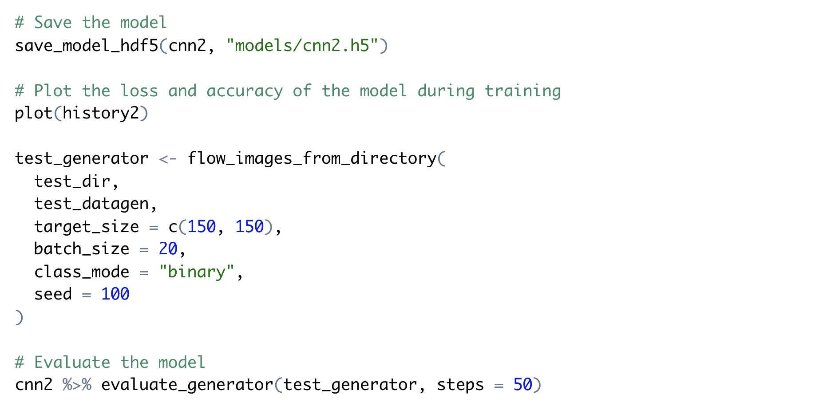

The use of data augmentation and dropout techniques have mostly resolved the overfitting issue. The loss and accuracy plot showed that both training loss and validation loss gradually went down and converged near epoch 30. The accuracy for both gradually increased and converged after epoch 24; however, the validation accuracy rose very slightly above the training accuracy at epoch 30. It could have been caused by the dropout rate (50%) being a bit high. Further testing could be done with lower dropout rates.

The test accuracy was high, approximately 97.7%, but it was only about 0.1% higher than the first model. It was a bit surprising that the overfitted model had similar high accuracy as the better-fitted model.

#### 

**Binary Classifier: Model Three: Using RMSProp's Adaptive Learning Rate**

The learning rate is a hyperparameter controlling how big the step is taken in gradient descent. In the first two models, RMSProp was used with a very low learning rate (0.0001) to be cautious, preventing overshooting in gradient descent. To test the impact of the low learning rate, in the third model the RMSProp optimizer was used without manually setting the learning rate. In Keras, the default learning rate for RMSProp is 0.001. As one of the adaptive learning rate methods, RMSProp maintains and adapts learning rates for each of the weights in the model.

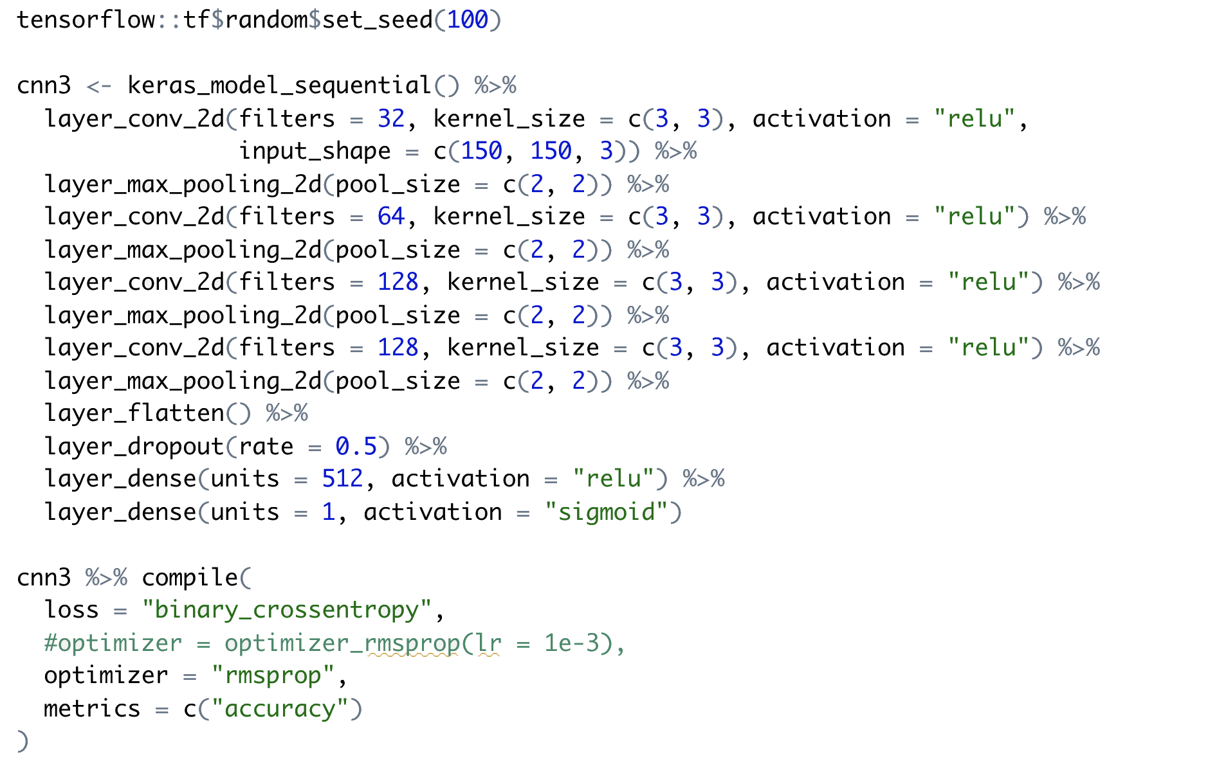

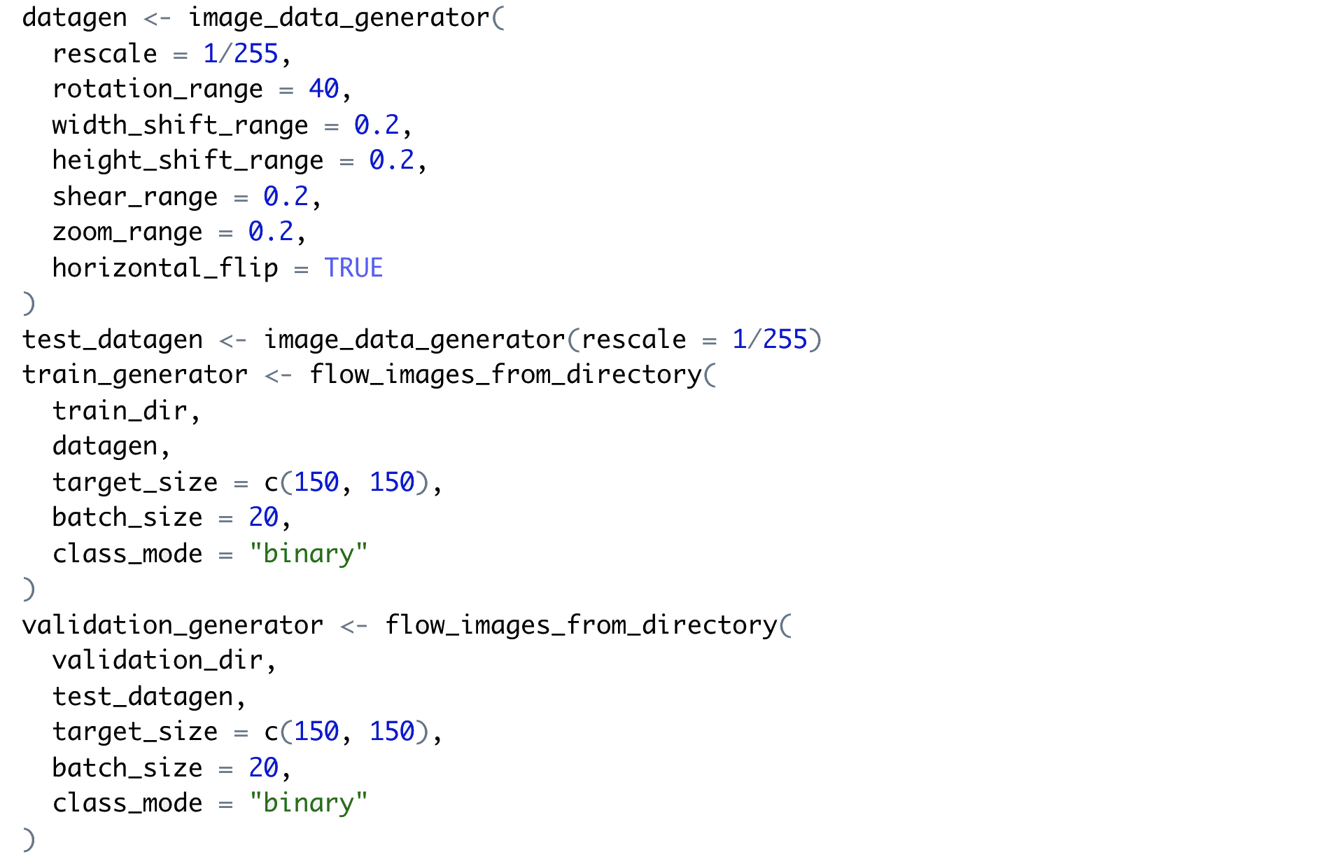

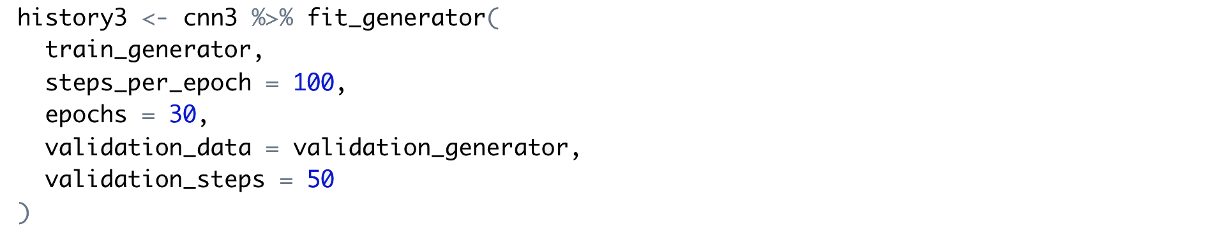

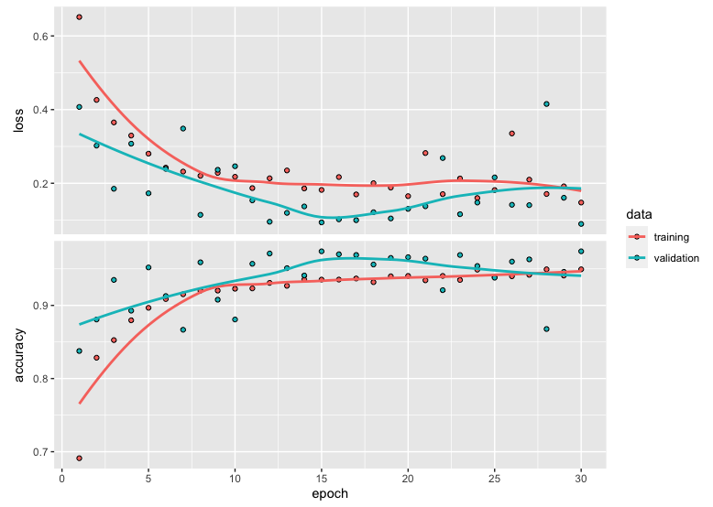

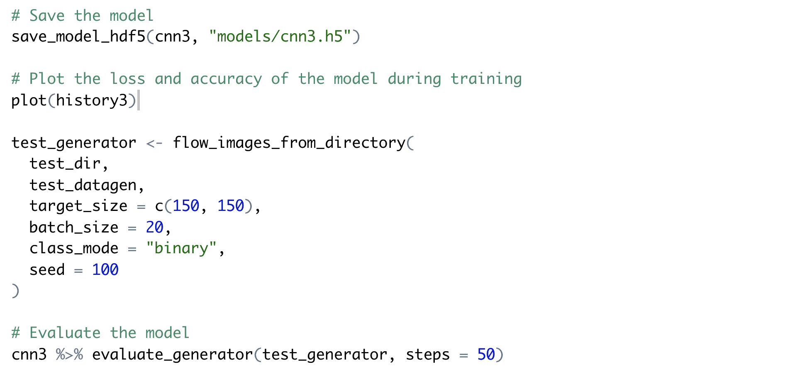

Using the default RMSProp's adaptive learning rate (instead of the manually set low learning rate) in the third model lowered the test accuracy of the model from approximately 97.7% to 97.3%. It showed that manually tuning the learning rate hyperparameter could help improve accuracy, even though the improvement was very small in this case.

### **Multiclass Classifier**

**Data Pre-processing**

The sample set included four labels (20409, 83144, 113209, 126637). The same architecture for the binary classifier (except for the 4 units for output layer and softmax activation function) was used to build the multiclass classifier.

For each class, images were split into the training set (50%), the validation set (25%), and the test set (25%). The same proportion of the split for each class ensured that the training set, validation set, and test set had the same distribution of images as compared with the whole sample data set.

* Training images in class 20409: 879
* Validation images in class 20409: 440
* Testing images in class 20409: 439
* Training images in class 83144: 870
* Validation images in class 83144: 436
* Testing images in class 83144: 435
* Training images in class 113209: 567
* Validation images in class 113209: 284
* Testing images in class 113209: 284
* Training images in class 126637: 1115
* Validation images in class 126637: 558
* Testing images in class 126637: 558

The image files were saved into a folder structure separated from the folder structure used for the binary classifier. The base folder included individual subfolders for training images, validation images, and testing images respectively; within each subfolder were four subfolders, each containing images for a class.

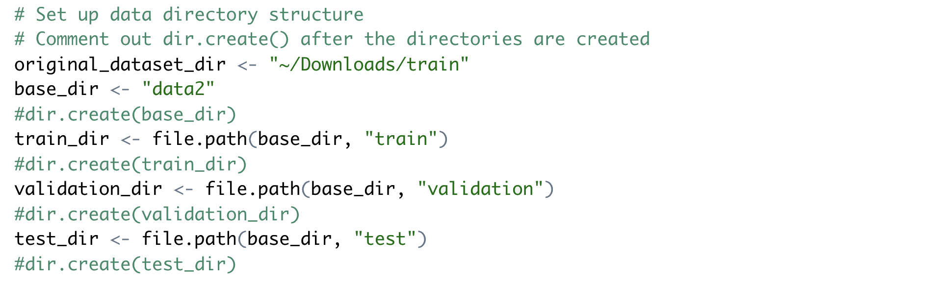

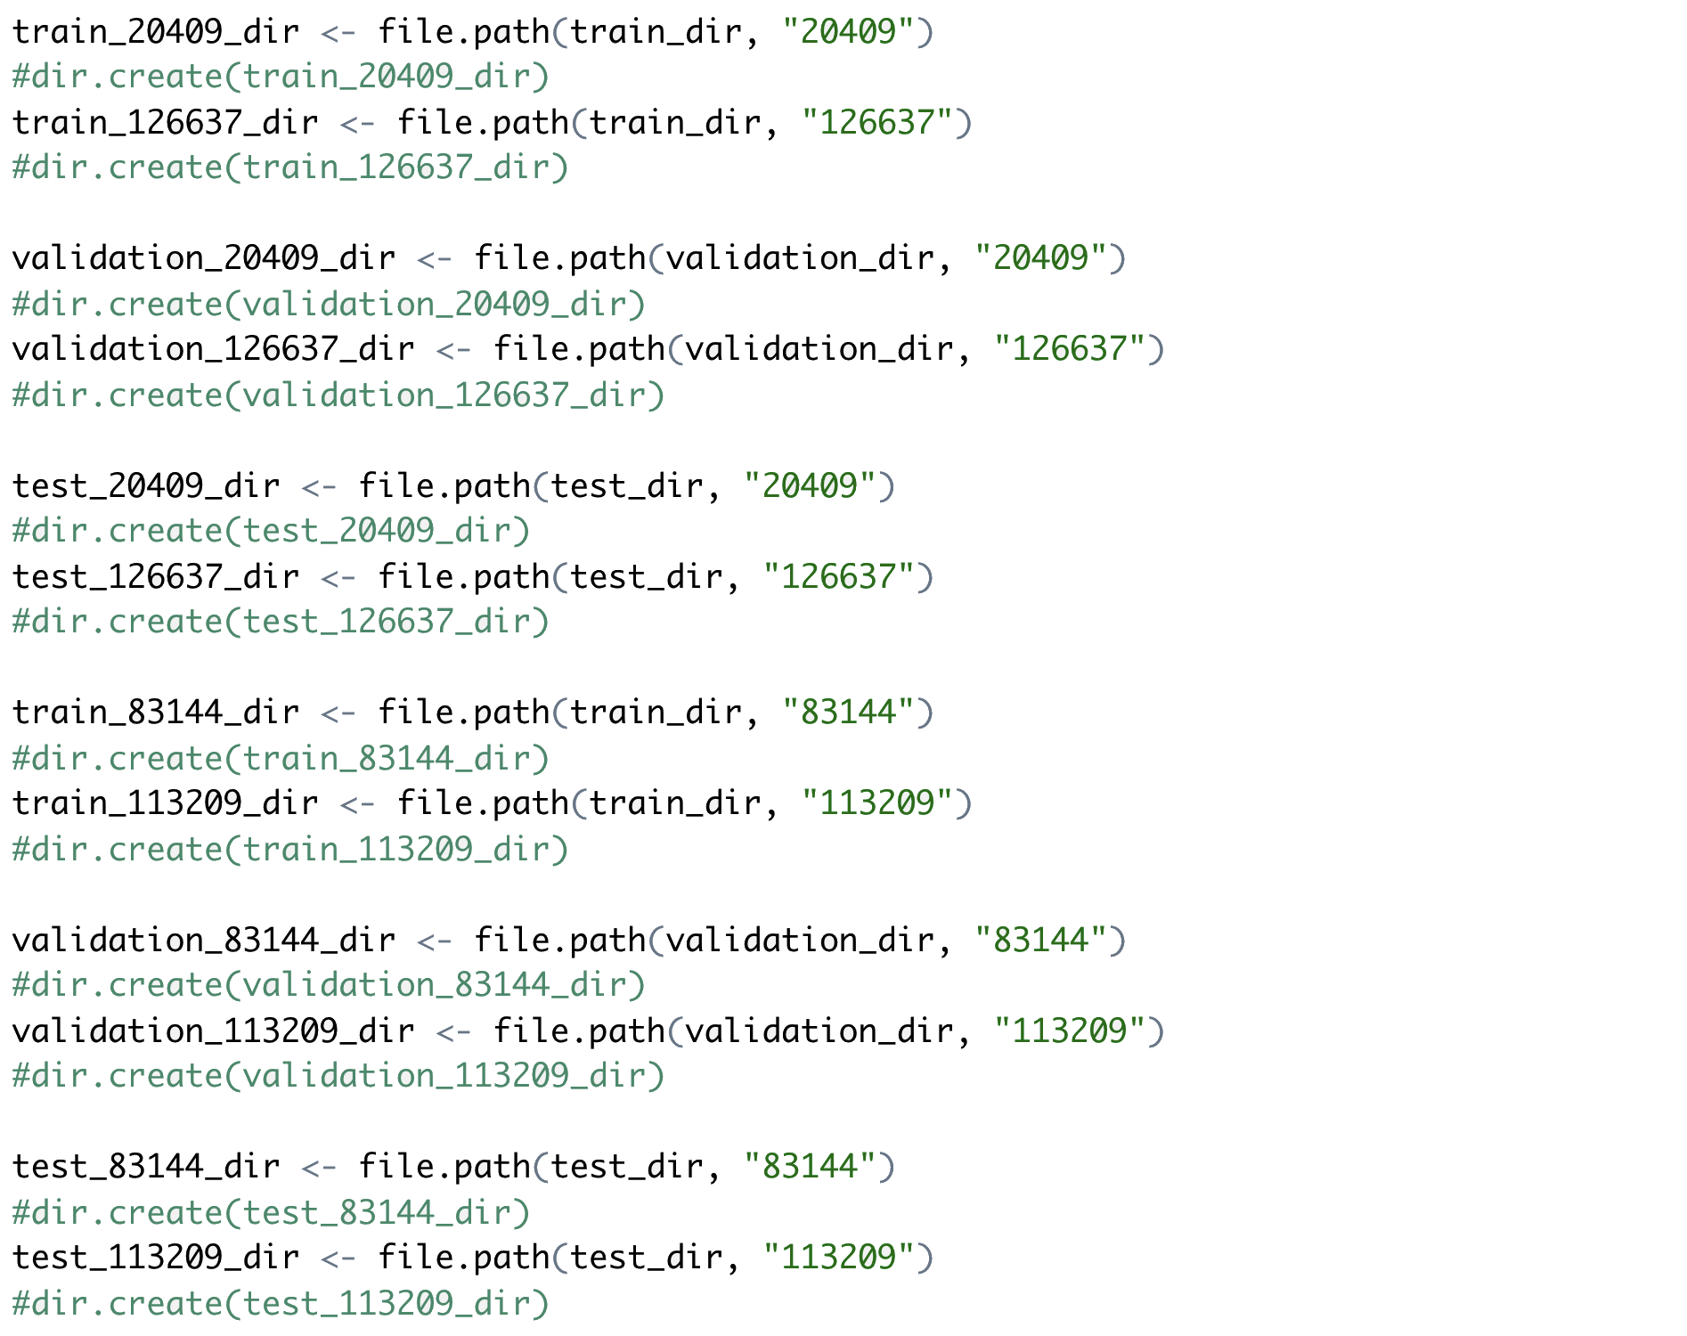

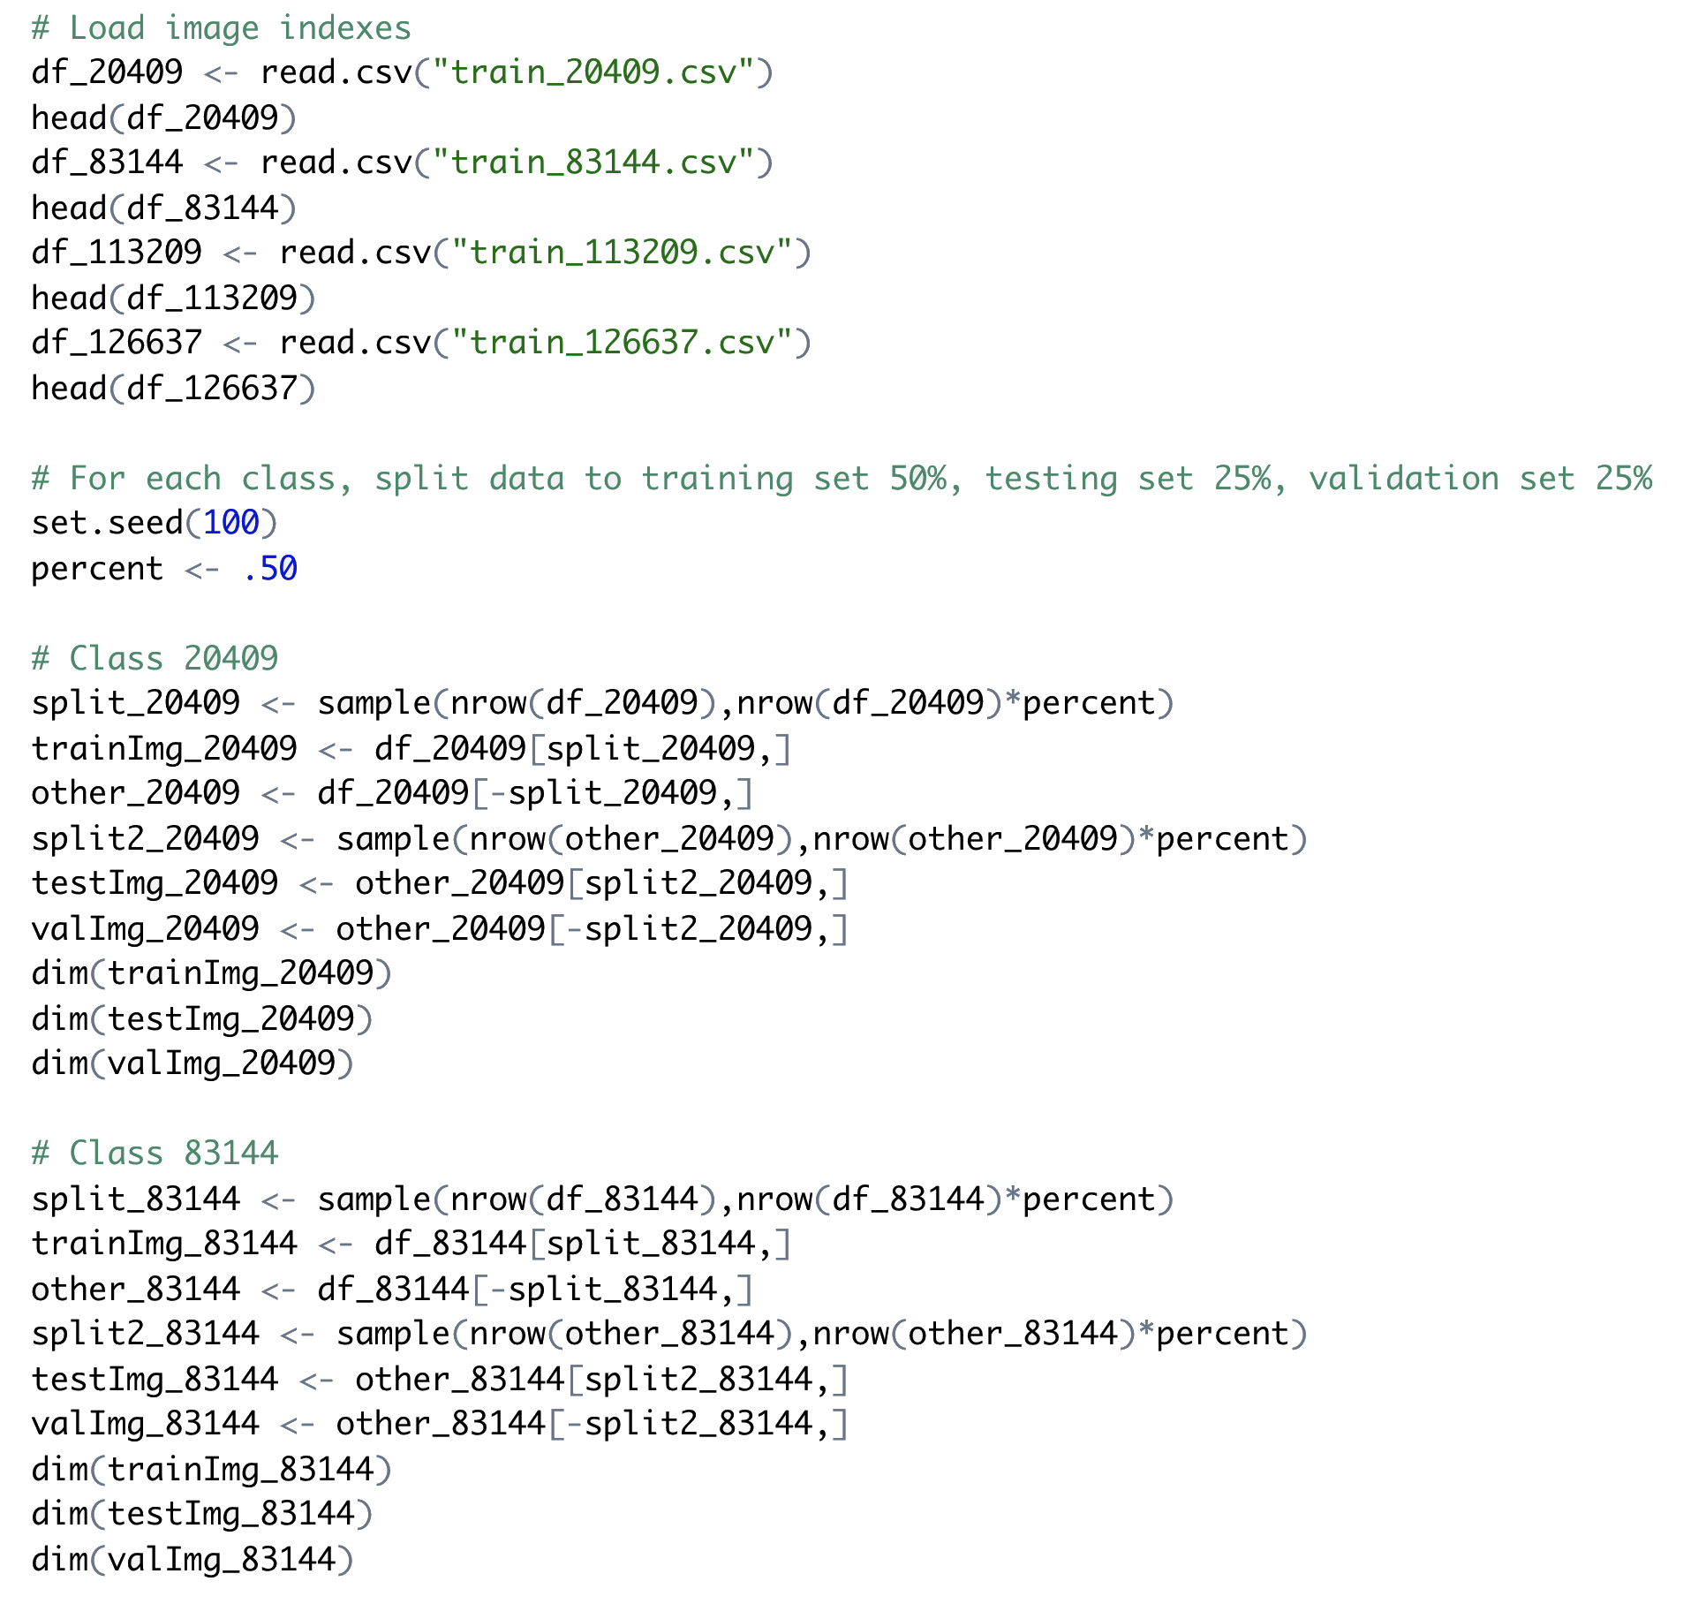

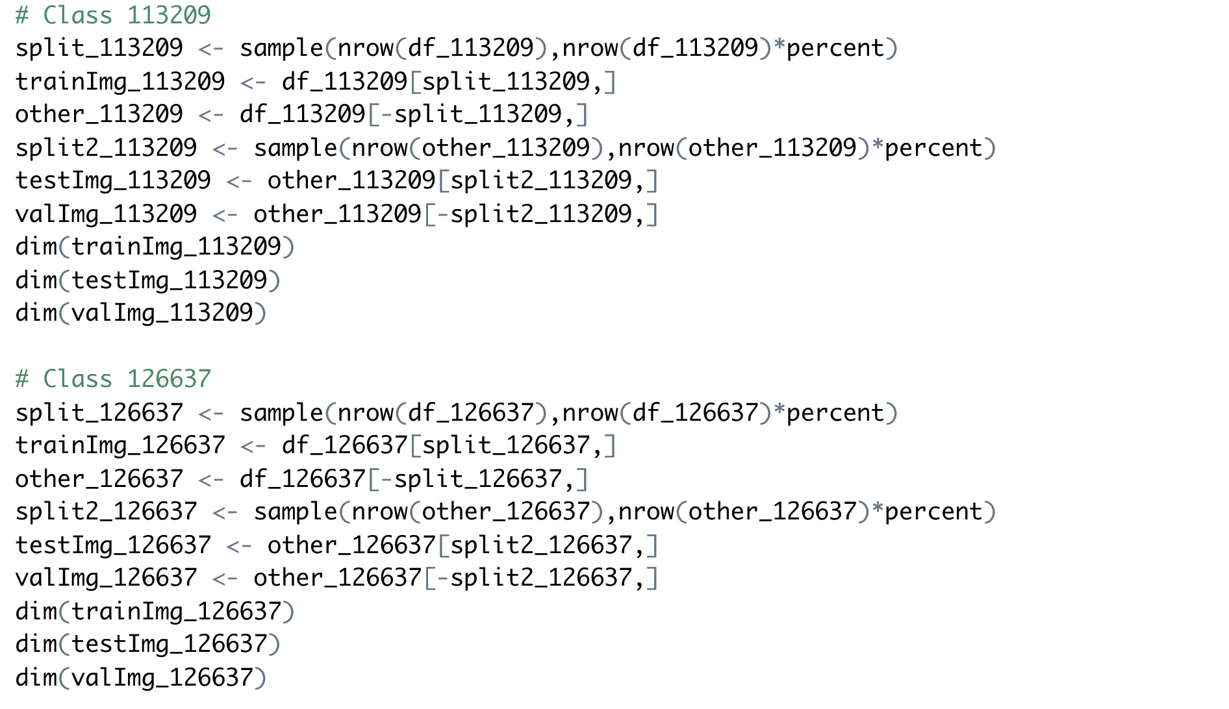

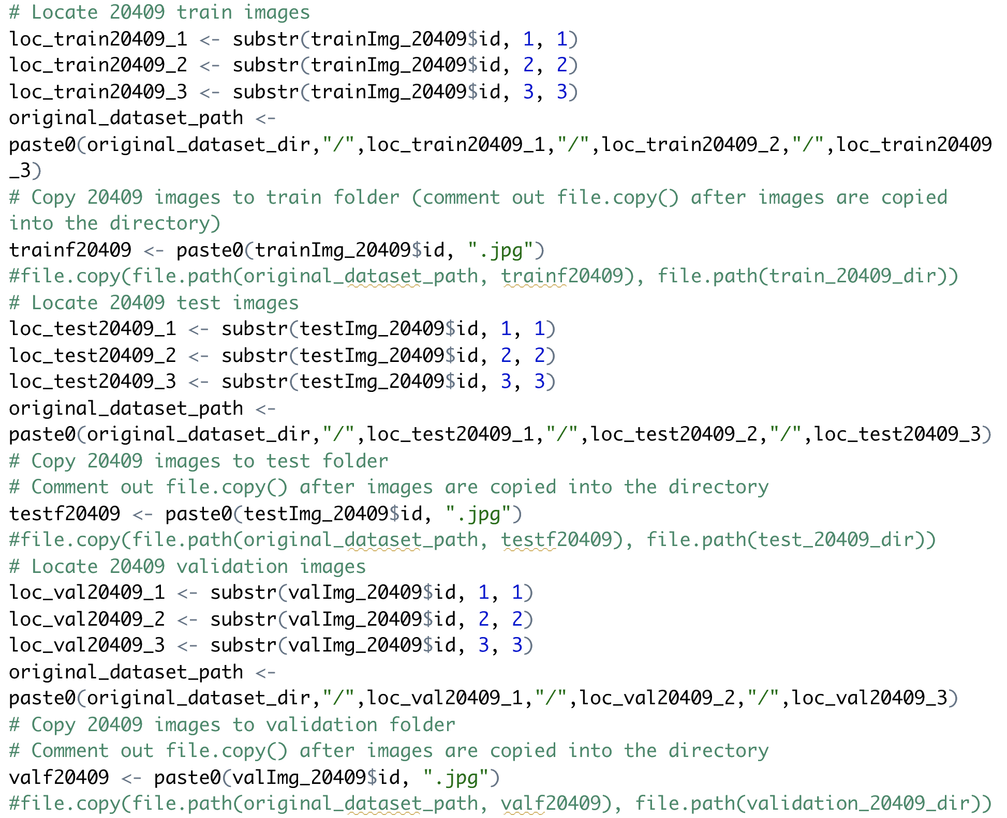

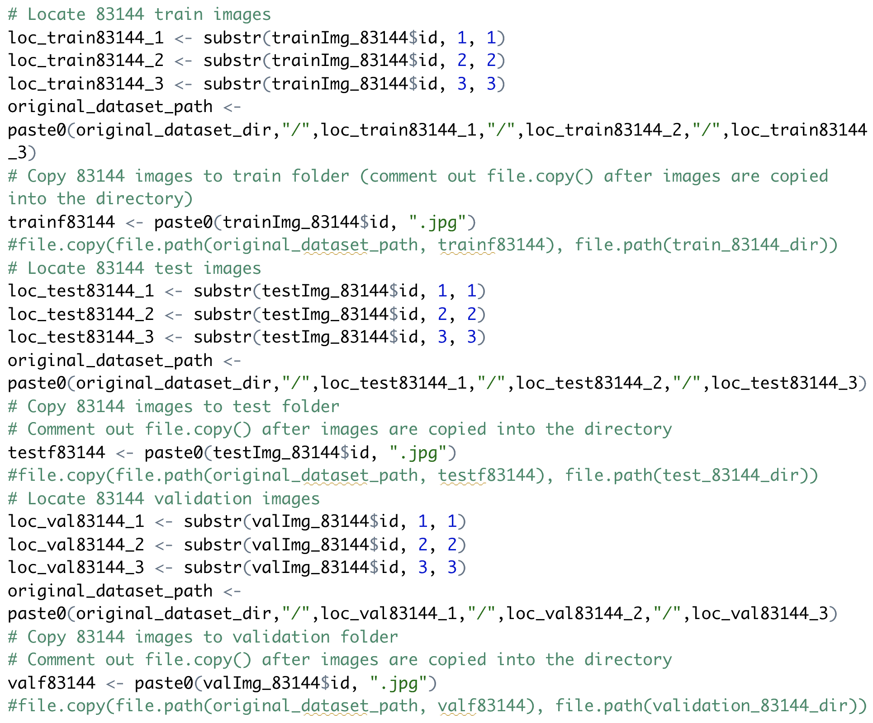

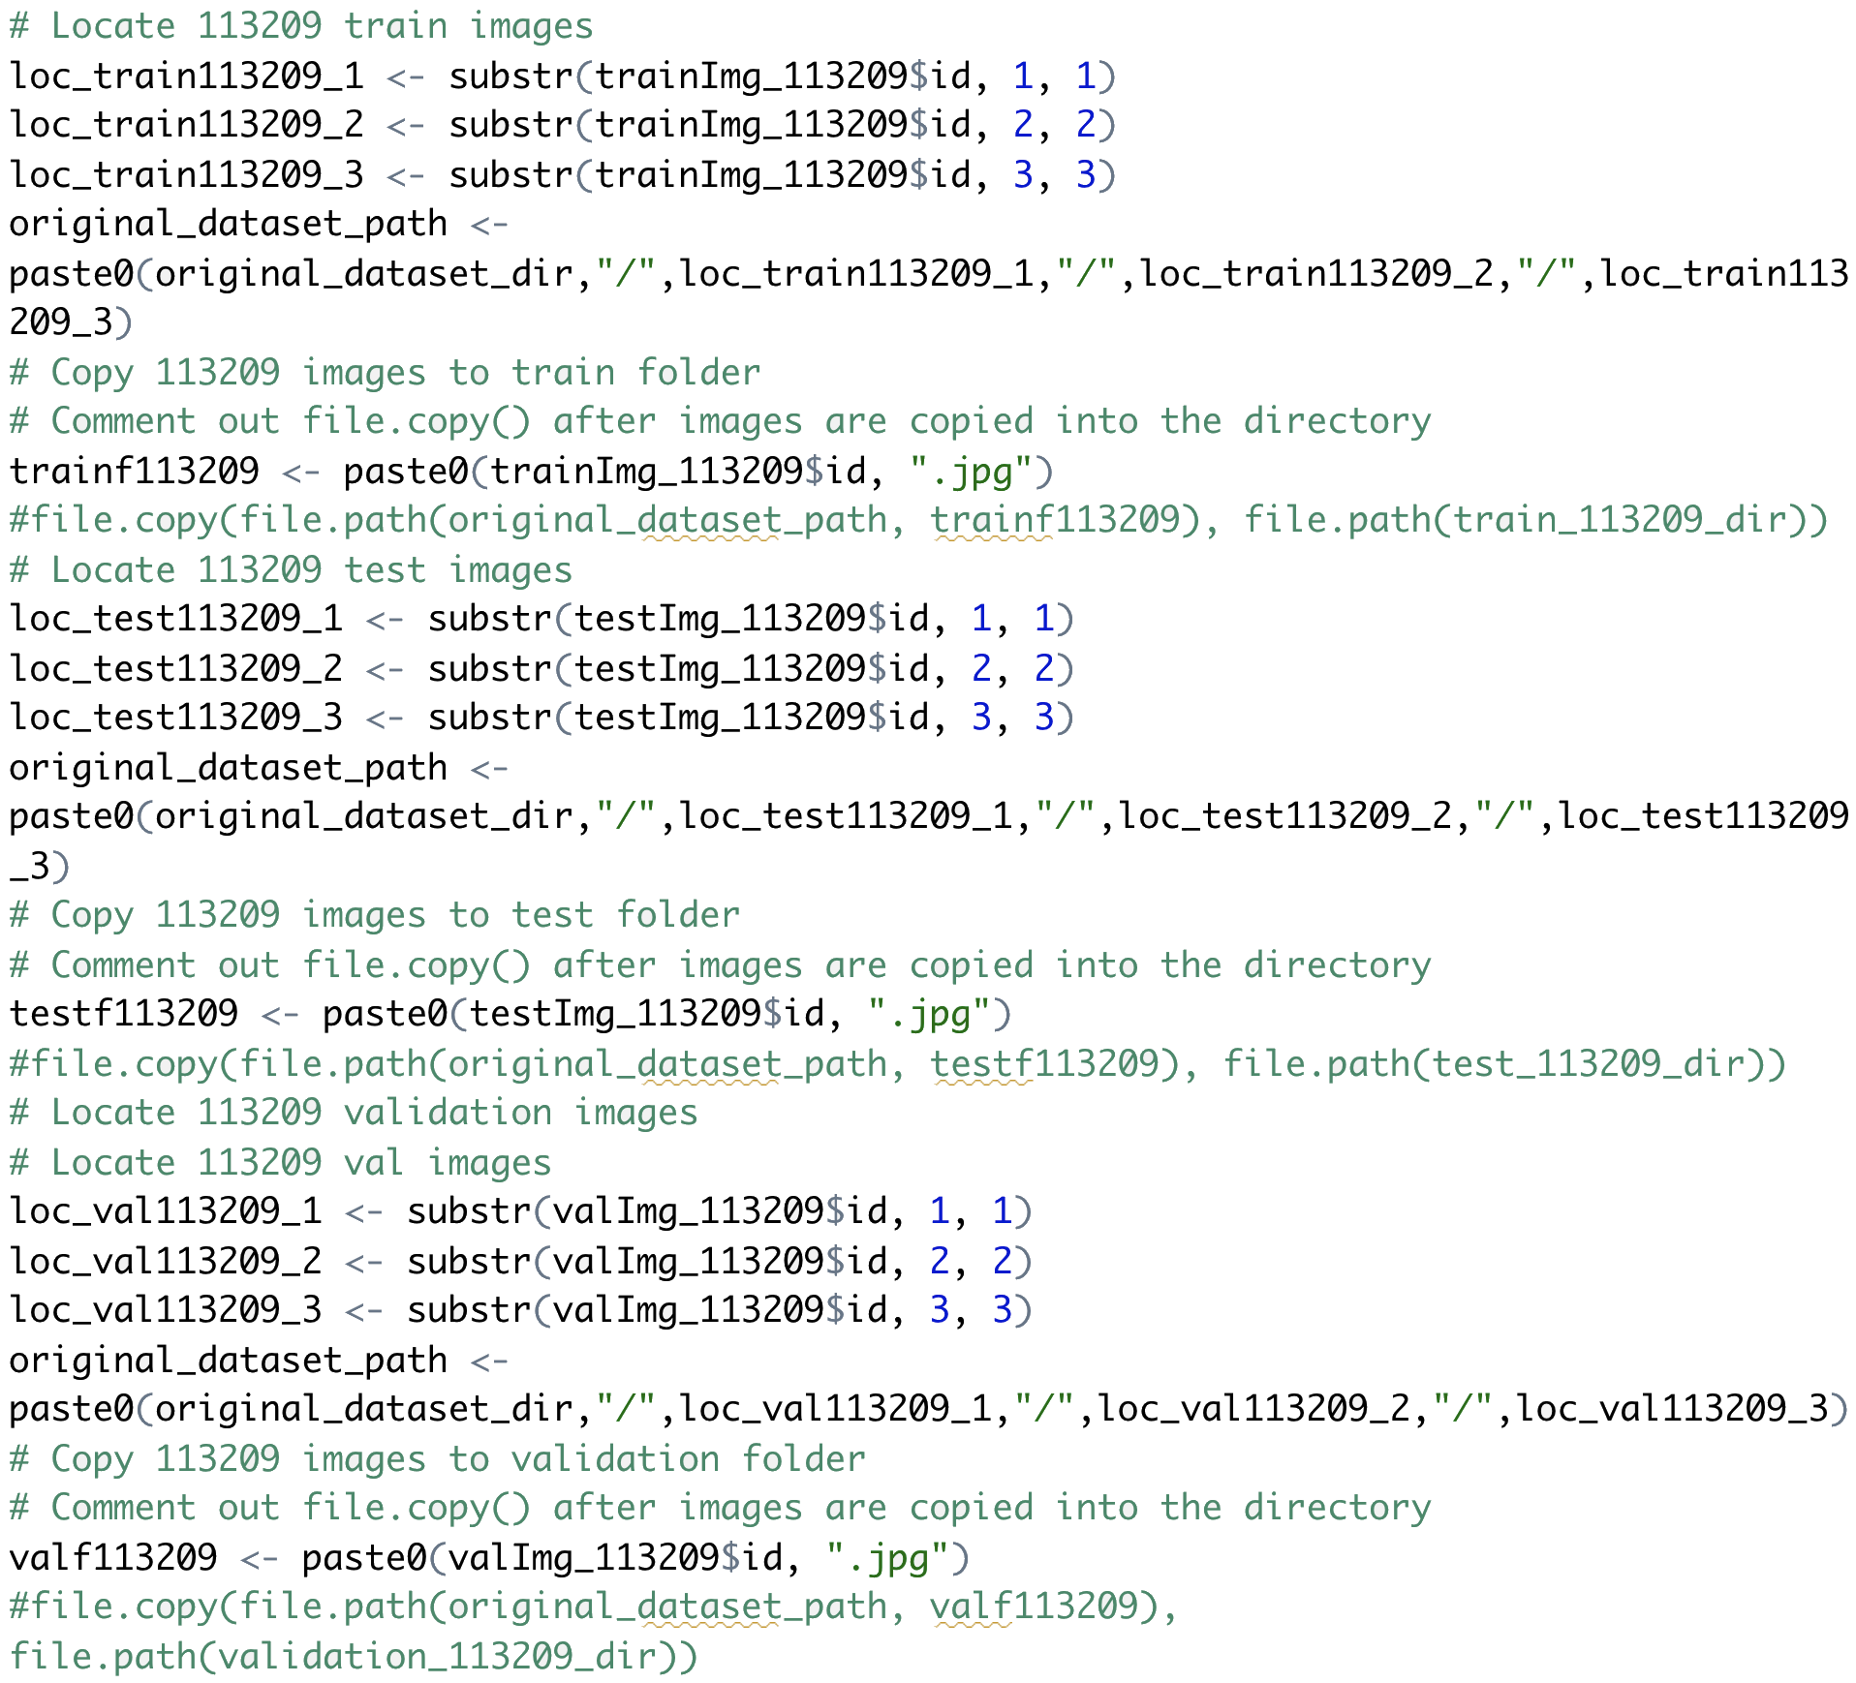

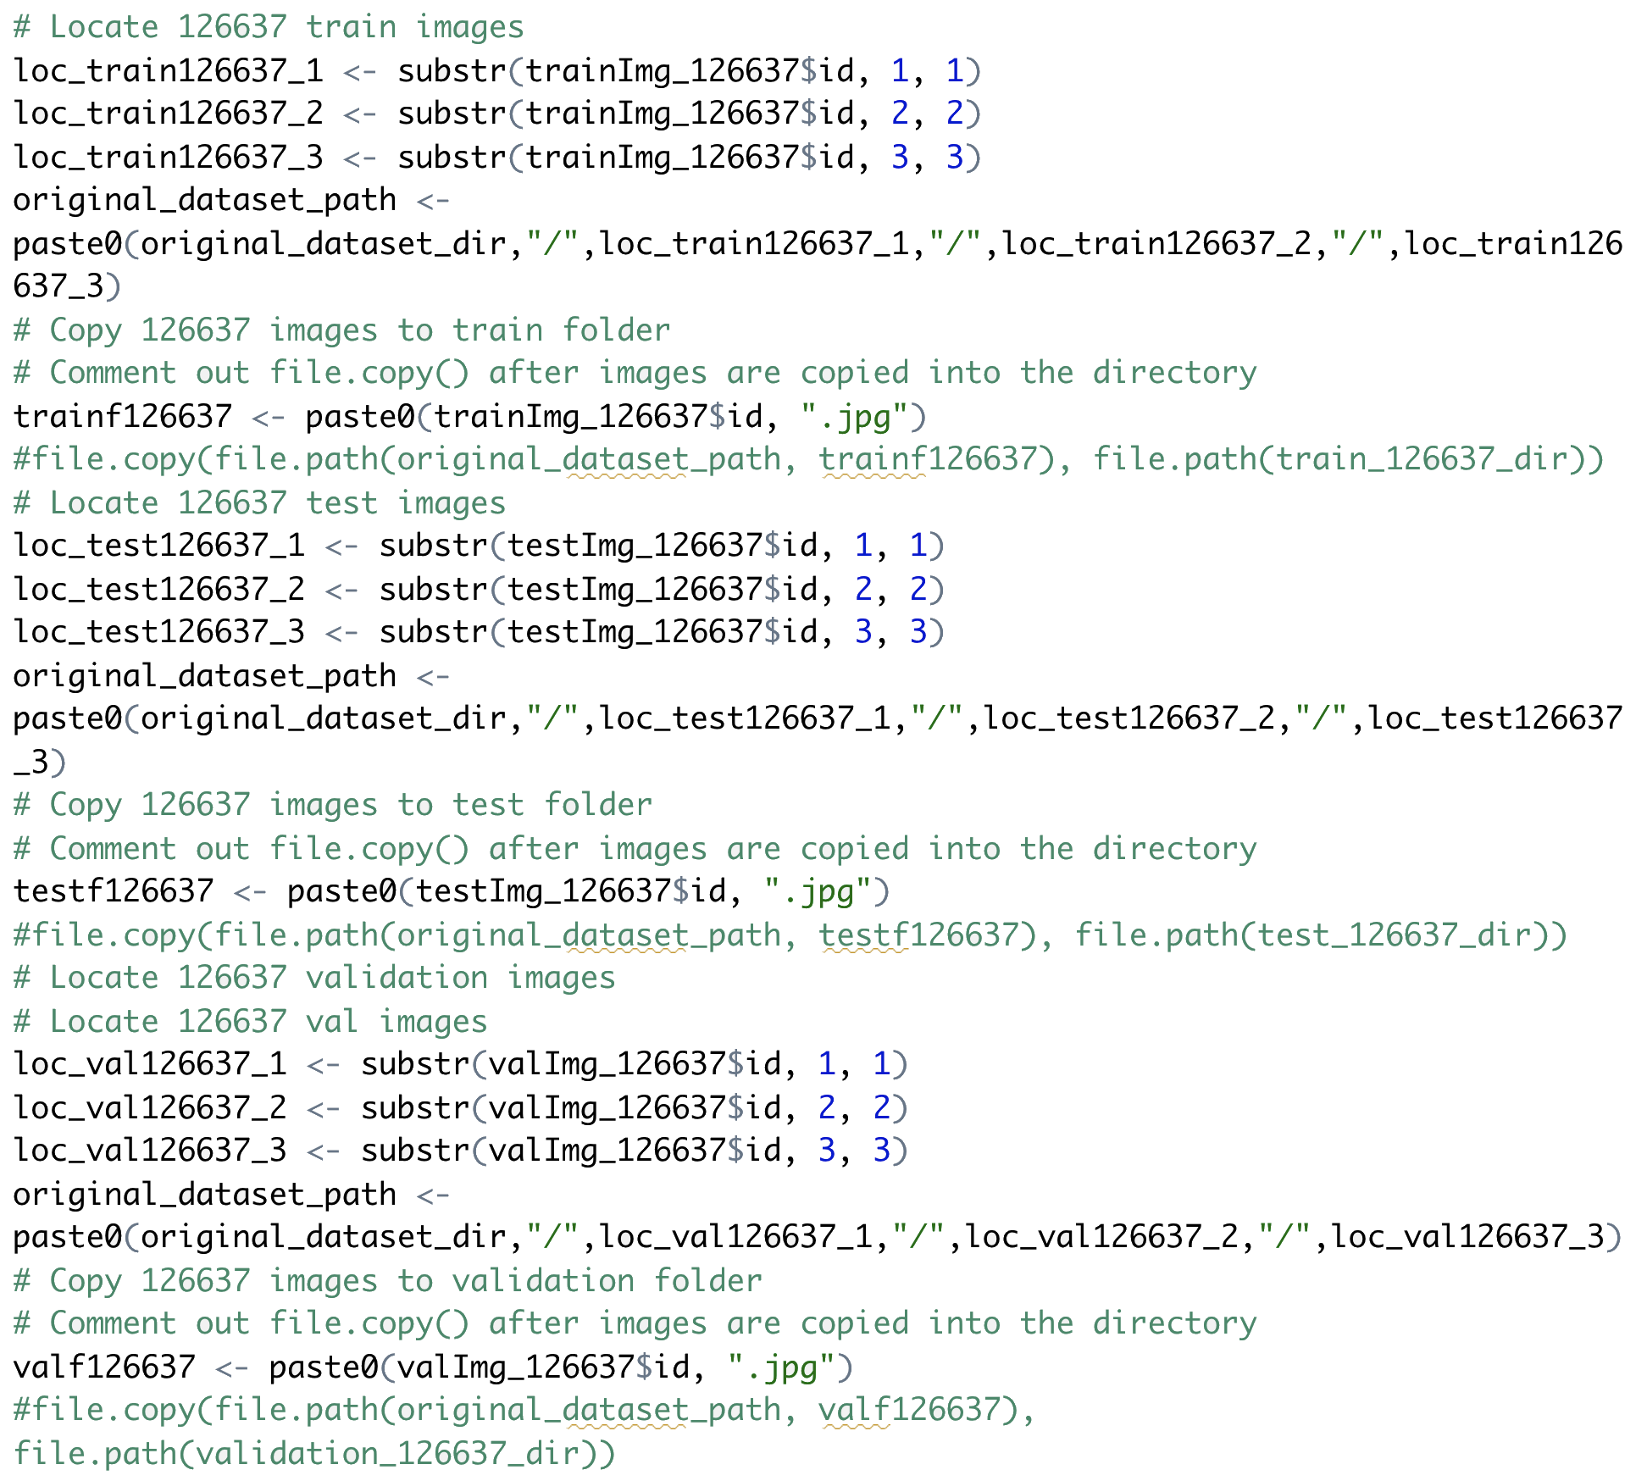

Read images from directories, convert them into batches of pre-processed floating-point tensors.

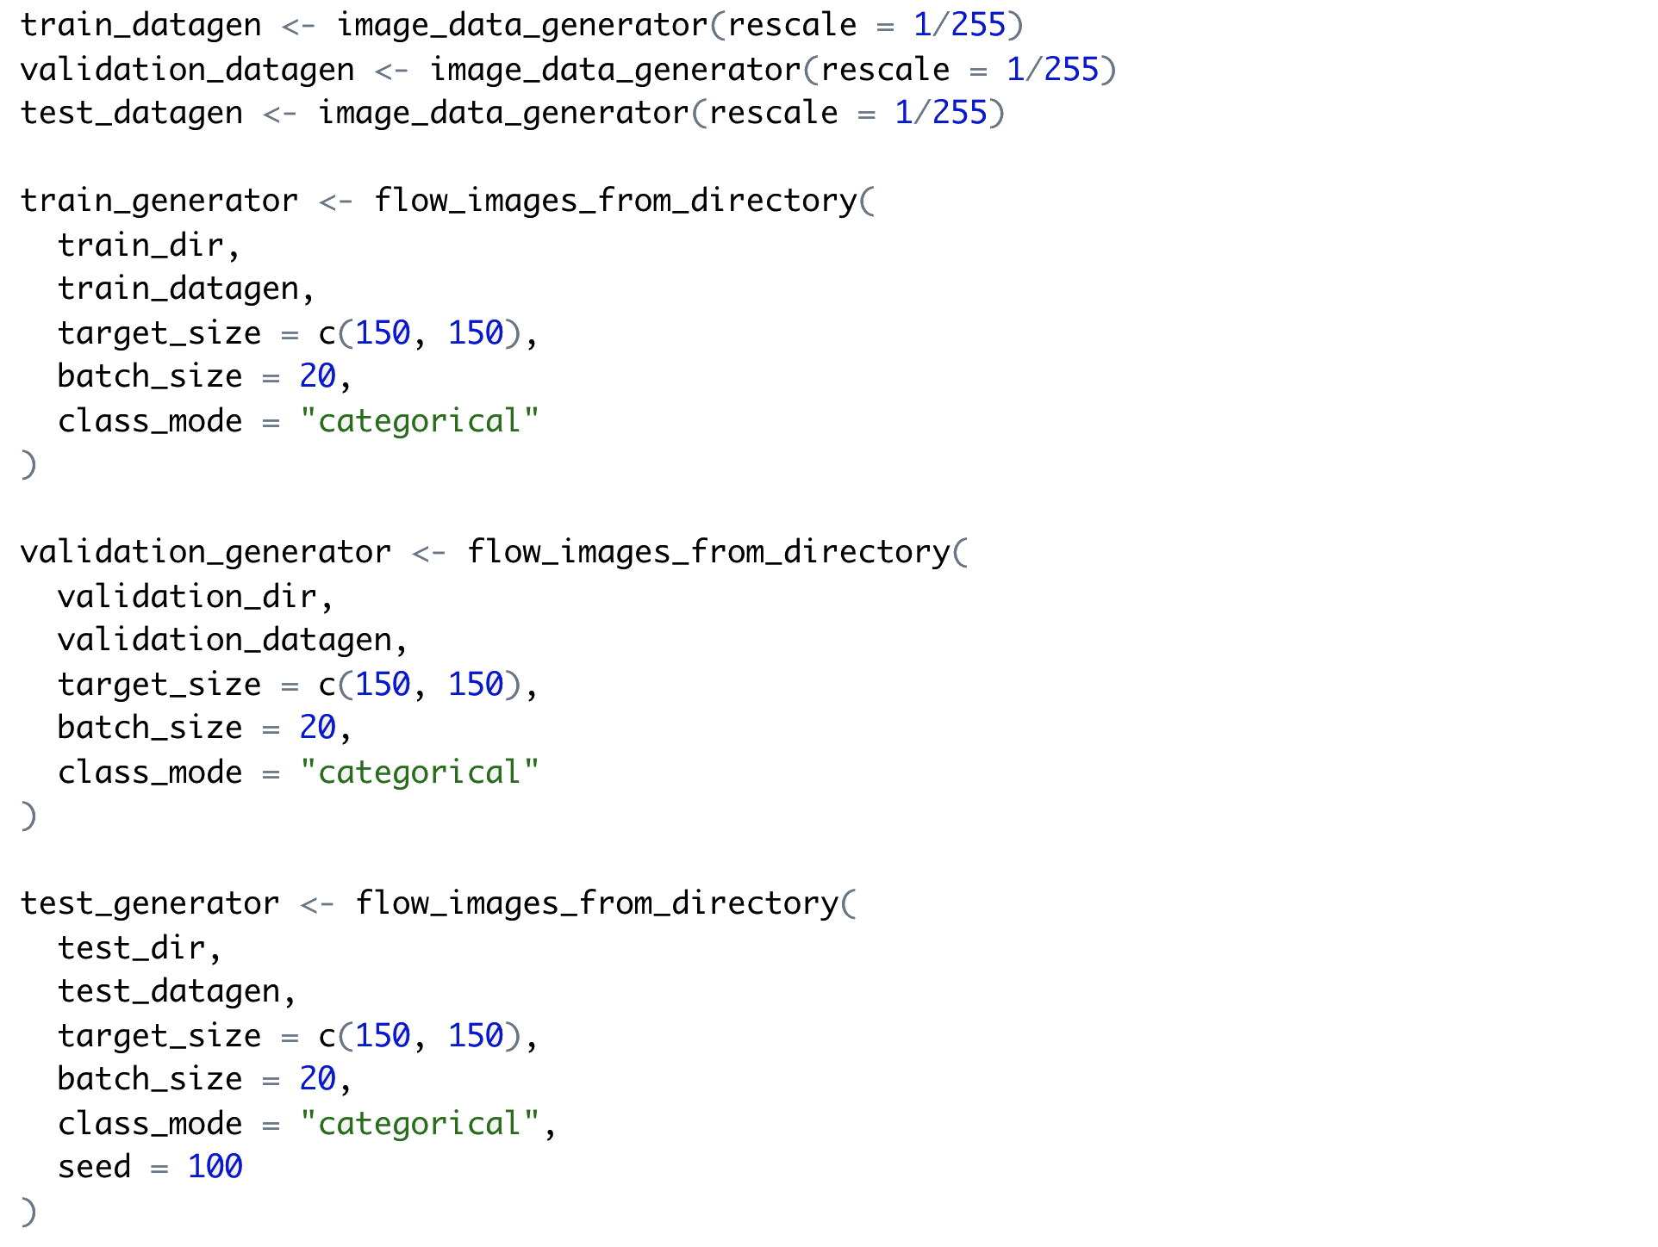

**Multiclass Classifier: Model One: The Base Model**

The same architecture for the binary classifier (except for the 4 units for output layer and softmax activation function) was used to build the multiclass classifier.

The model contained a linear stack of 11 layers, including 4 alternated convolution layers (with relu activation) to augment the network capacity, each followed by a pooling layer to down sample feature maps to reduce feature-map coefficients processing and induce spatial-filter hierarchies. After these 8 intermediate layers was a flattened layer and two dense layers (i.e. fully connected layers). For the 4-label classification problem, the output layer (the 2nd dense layer) had 4 single units, with the softmax activation. The Softmax regression is a form of multinomial logistic regression that normalizes an input value into a vector of 4 values that follows a probability distribution, where the total sums up to 1.

To configure the learning process, the RMSProp optimizer with the learning rate of 0.0001 was used in the compilation step and the `categorical_crossentropy` was used as the loss function. "Accuracy" was used as the metrics, which calculated how often predictions equal labels.

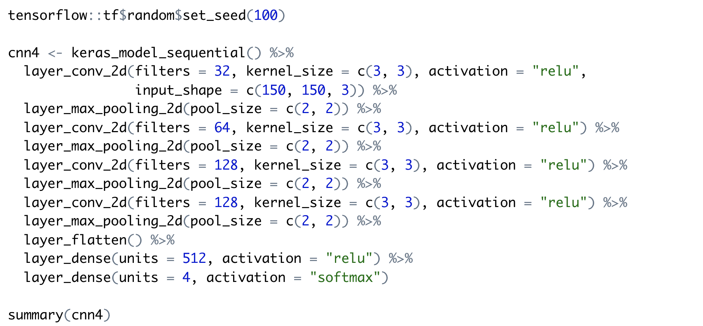

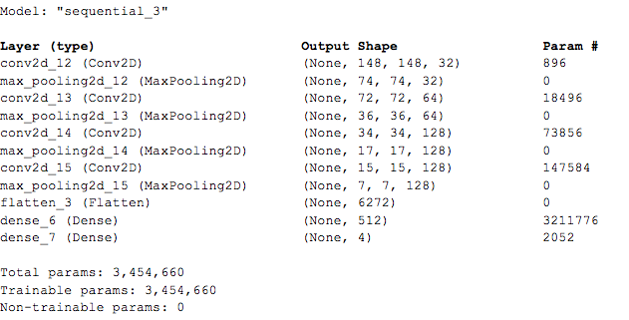

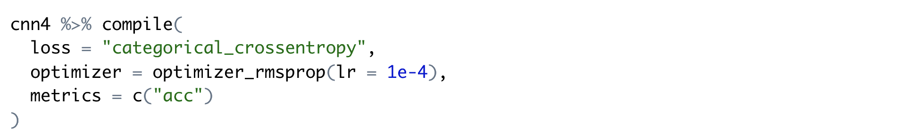

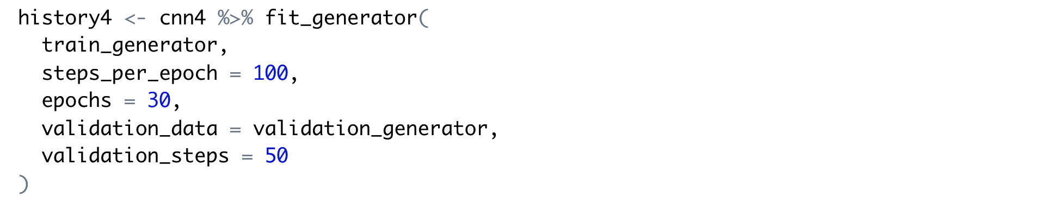

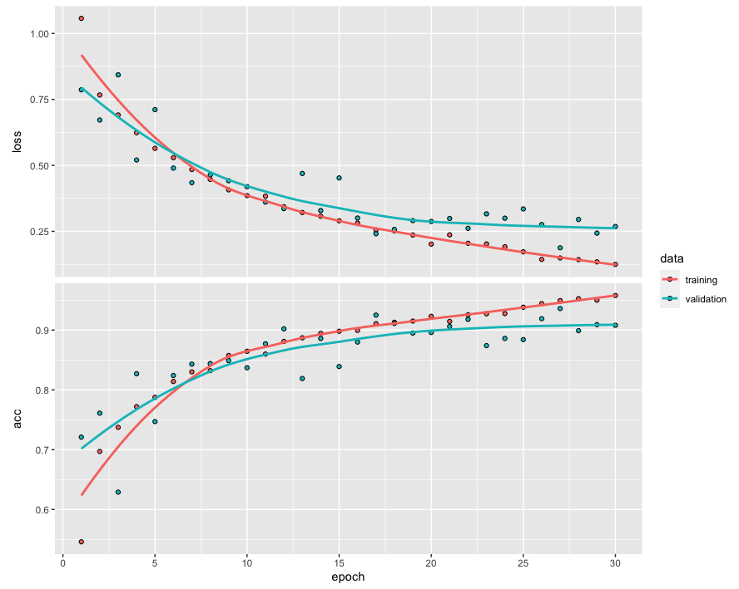

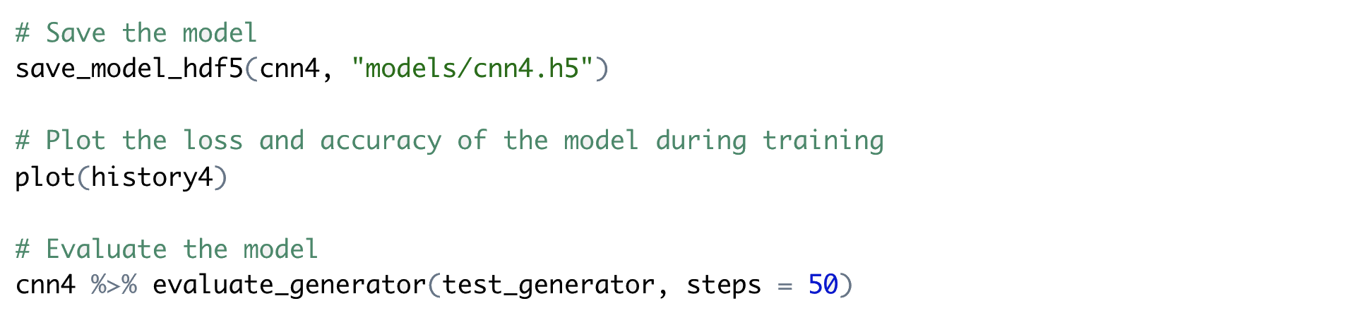

The same as the model one of the binary classifiers, the loss and accuracy plot for this model also showed the sign of overfitting. After 6 epochs, the validation loss gradually rose further above the training loss, and the training accuracy rose further above the validation accuracy. The overfitting problem may have been caused by the relatively small training sample data set (3431 images in 4 classes).

Even though the model was overfitted, the model still reached approximately 91% test accuracy.

**Multiclass Classifier: Model Two: Adding Data Augmentation and Dropout**

Based on the same architecture for model one, the second model added data augmentation and dropout to resolve the overfitting issue.

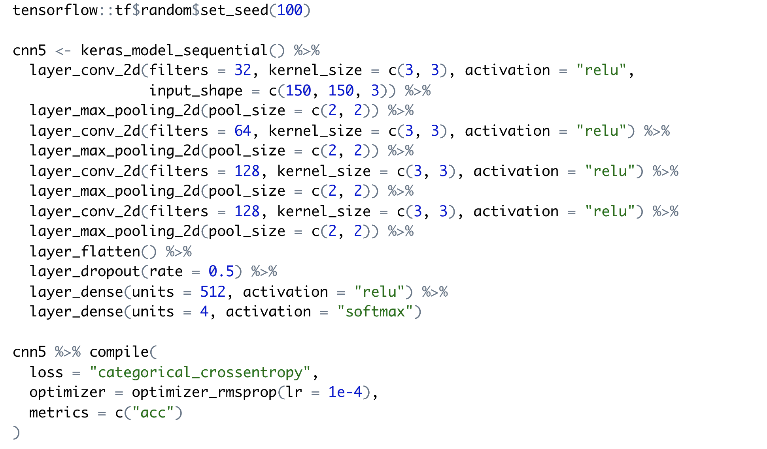

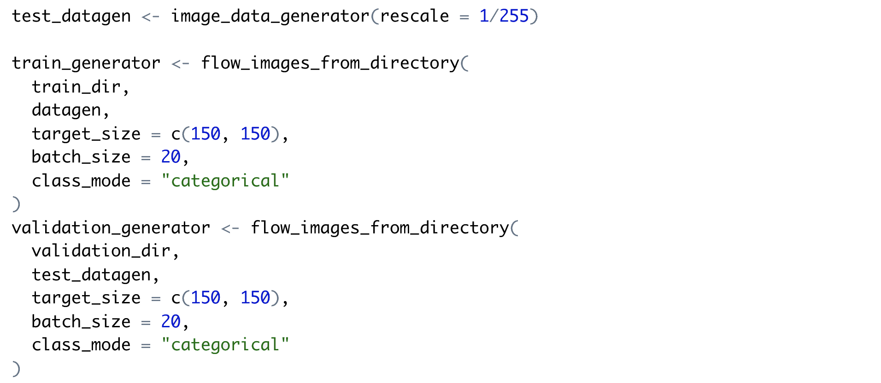

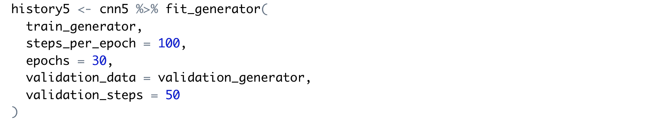

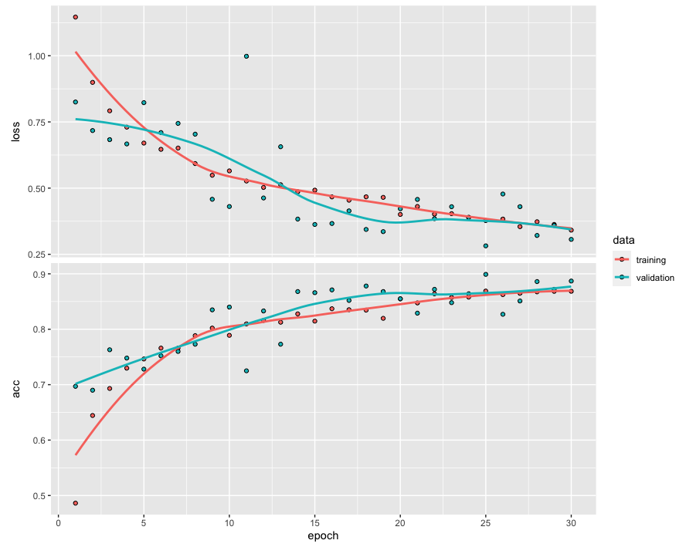

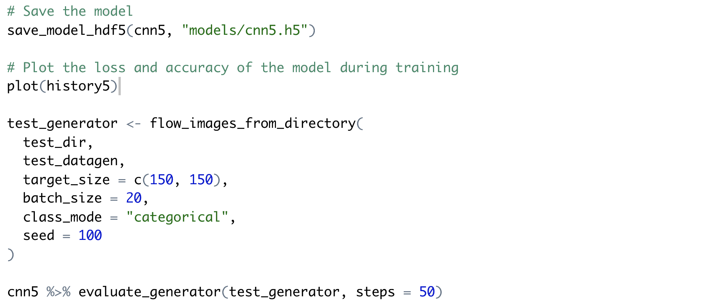

As with binary classification model two, the use of data augmentation and dropout techniques mostly resolved the overfitting issue. The loss and accuracy plot showed that both training loss and validation loss gradually went down and converged after epoch 25. The accuracy for both gradually increased and converged after epoch 25; however, the validation accuracy rose very slightly above the training accuracy at epoch 30. It could have been caused by the dropout rate (50%) being a bit high. Further testing could be done with lower dropout rates.

The evaluation of this model showed approximately 89.8% test accuracy, which is lower than the first model which had approximately 91% accuracy. It was a bit surprising that the overfitted model had better accuracy than the better-fitted model.

##### 

**Multiclass Classifier: Model Three: Using RMSProp's Adaptive Learning Rate**

With the binary classification models, the optimizer RMSProp was manually set with a very low learning rate (0.0001) for the first two models; removing the manual setting of the learning rate for the third model reduced its accuracy slightly.

The same testing of removing the manual setting of the learning rate was done for this multiclass model, to compare with the result of the binary classification model three.

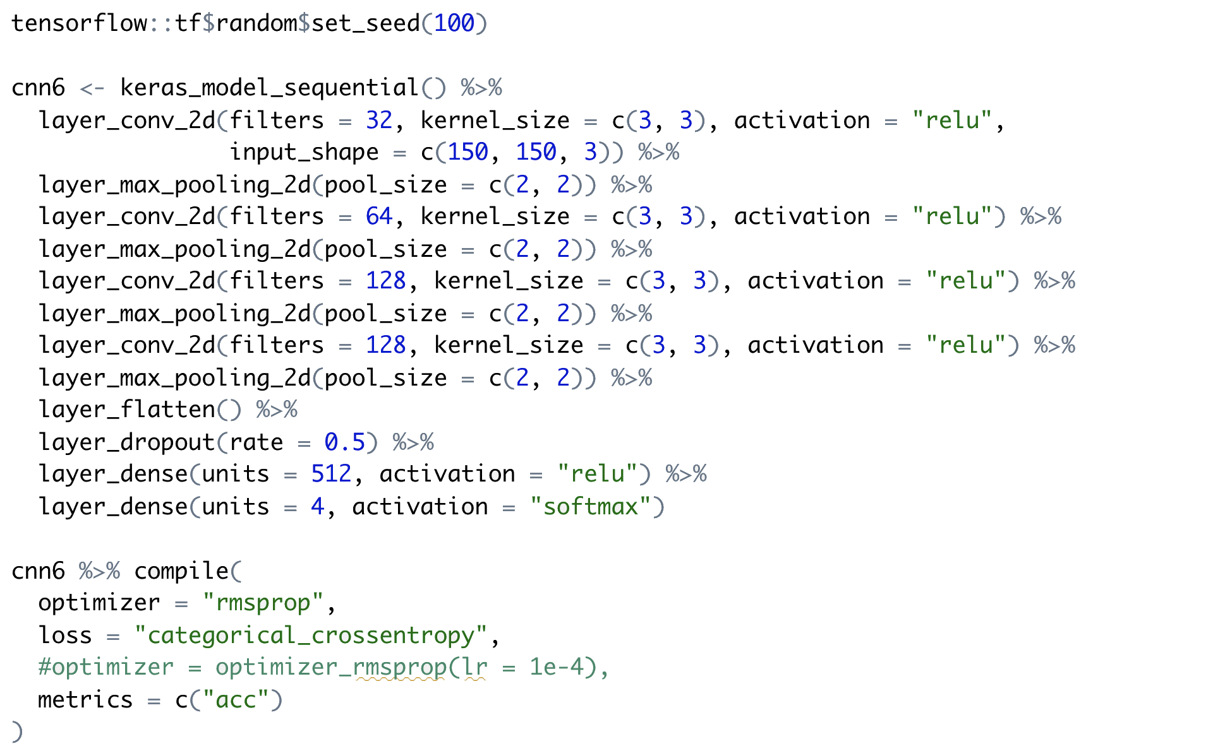

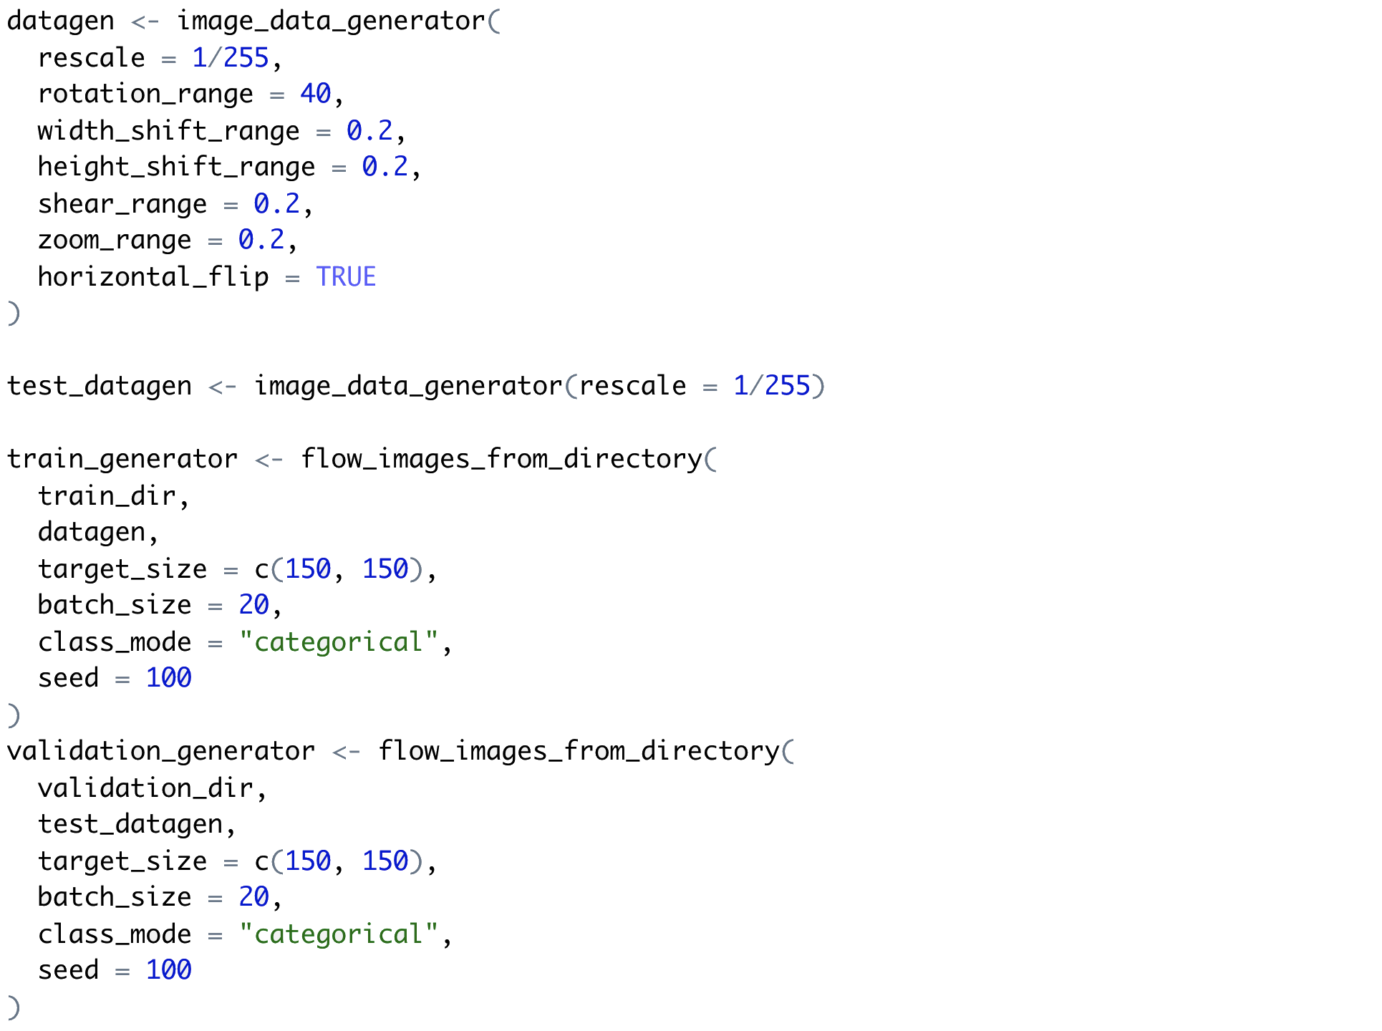

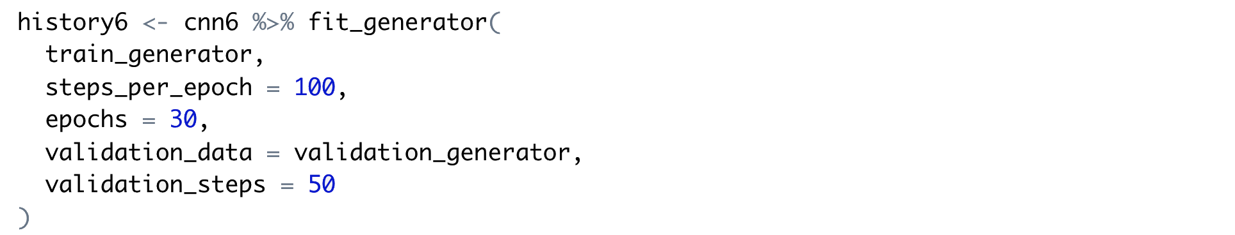

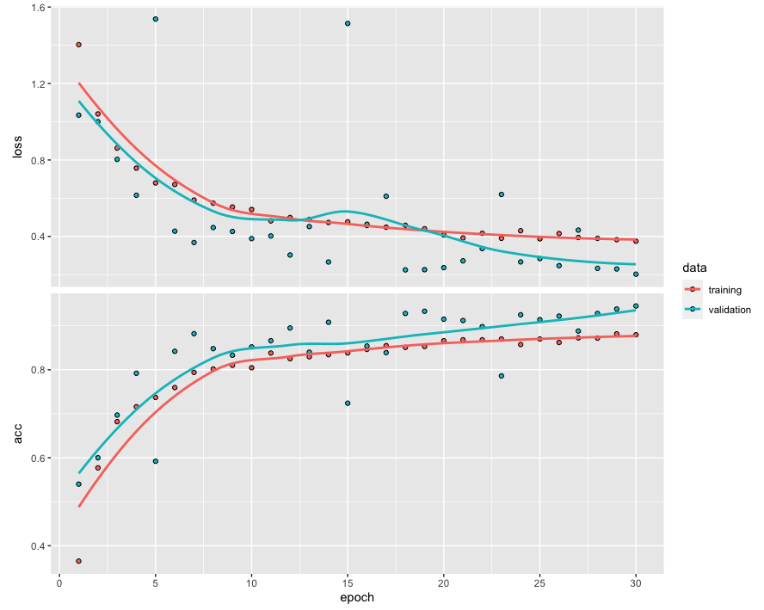

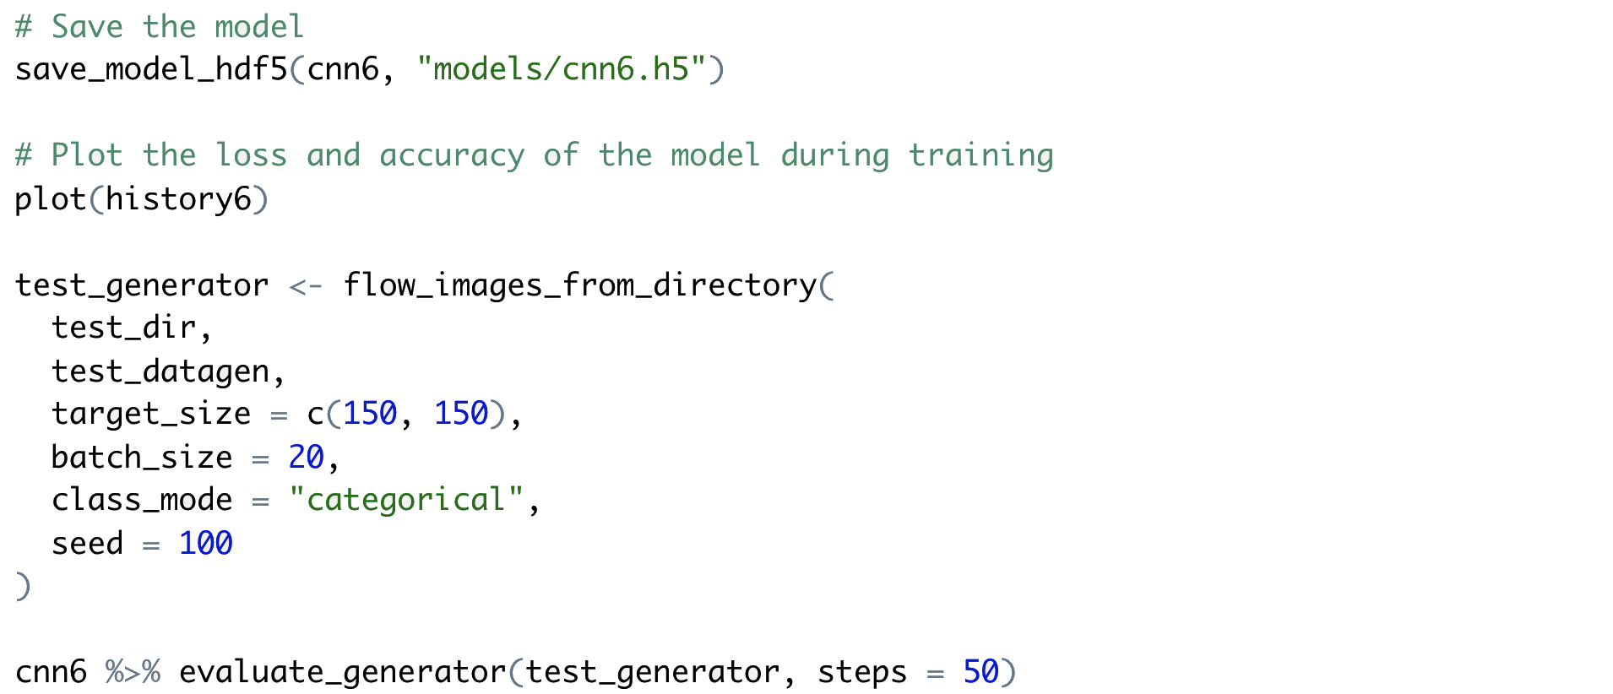

Using the default RMSProp's adaptive learning rate (instead of the manually set low learning rate) in the third model improved the test accuracy of the model from approximately 88.2% to 93.1%. Unlike the binary classification model three, RMSProp's adaptive learning rate was more effective than manually tuning the learning rate hyperparameter in this case.

Even though the RMSProp optimizer seemed to work well without having manually configured the learning rate in this case, as the learning rate was an important hyperparameter, further tuning of this parameter could be tested to see if an optimal learning rate could be found to improve accuracy.

### CNN: Visualizing Intermediate Activations

Activation maps can be created to visualize the activations on intermediate layers of a convolutional neural network. They are useful for understanding what the network sees and learns from the decomposition of the input on each of its intermediate layers.

Below is an exploration of how the binary classification model two learns a new image it has not seen before.

First, load a new image for which the network has not been trained. Then, create a Keras model to take batches of images as input, and output the activations of all convolution and pooling layers.

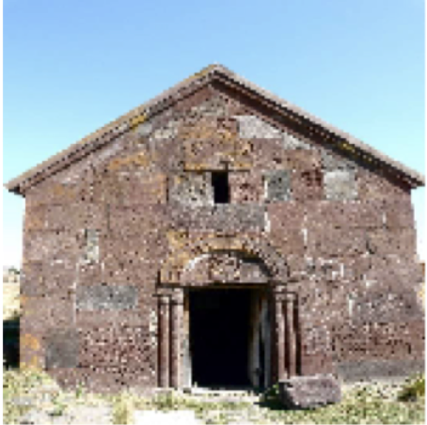

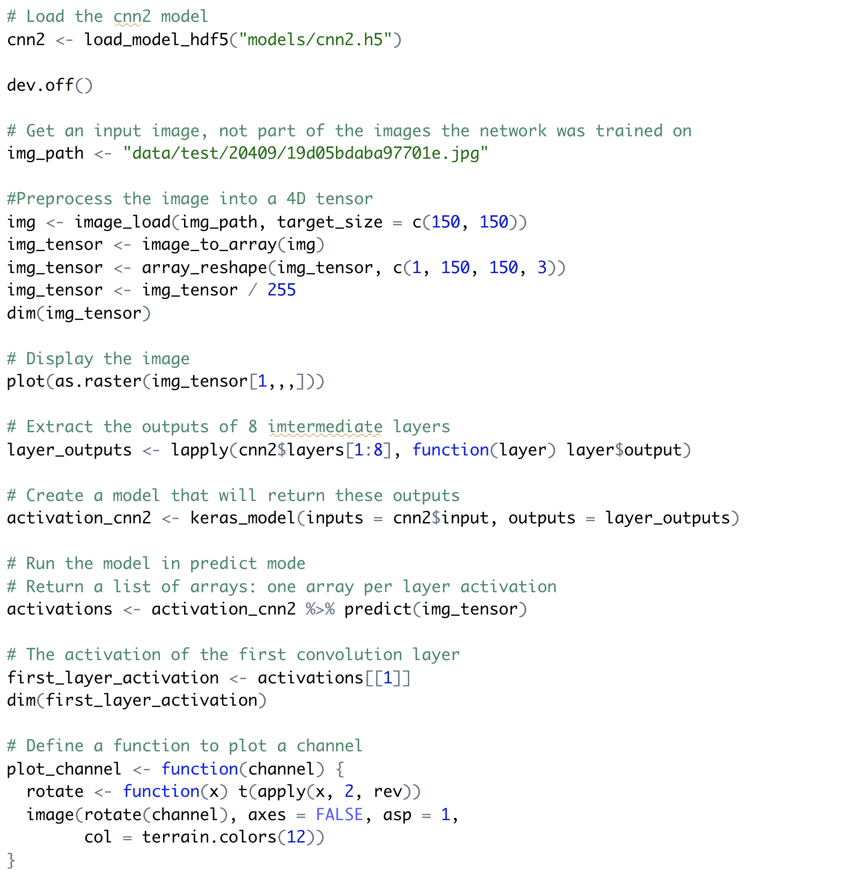

Visualize the first channel of the activation of the first layer of the original model.



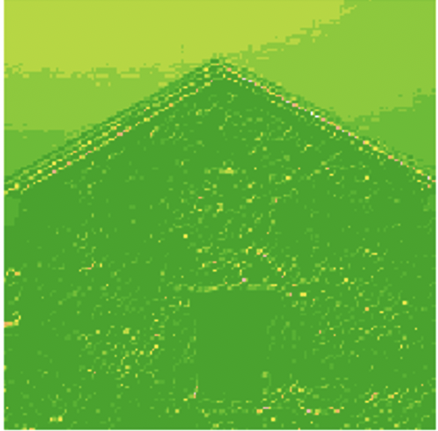

Visualize the second channel of the activation of the first layer of the original model.





Plot all the activations in the network by extracting and plotting every channel for each of the eight activation maps.

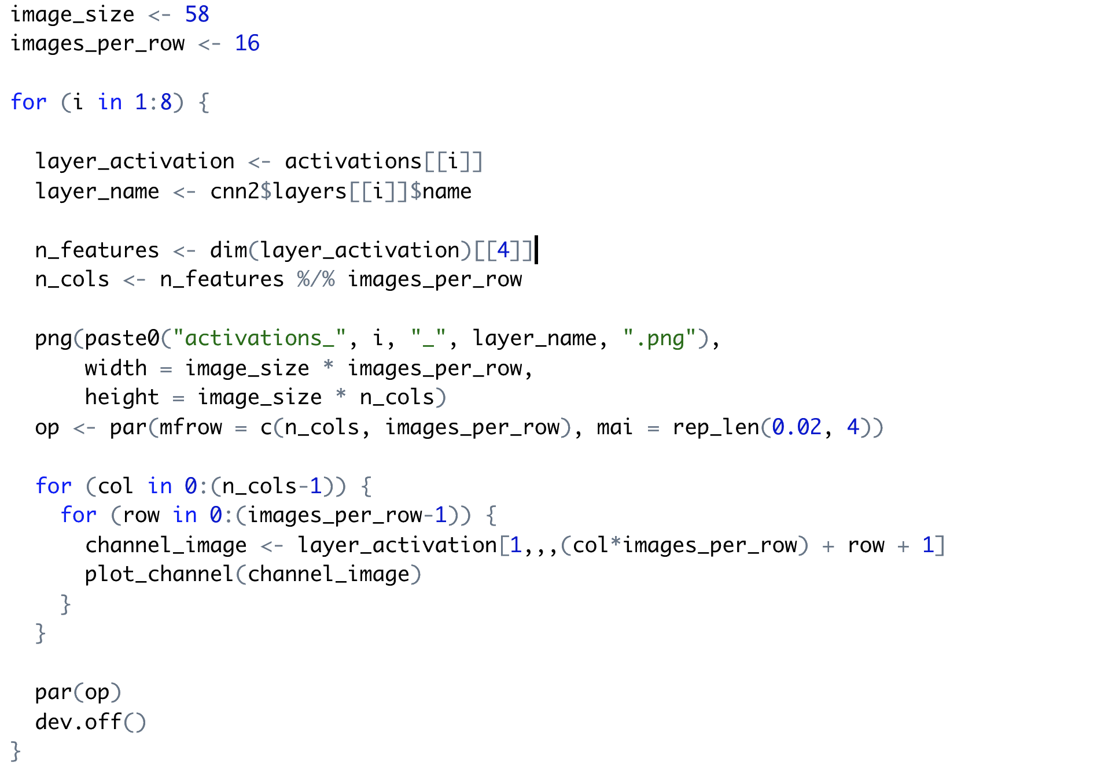

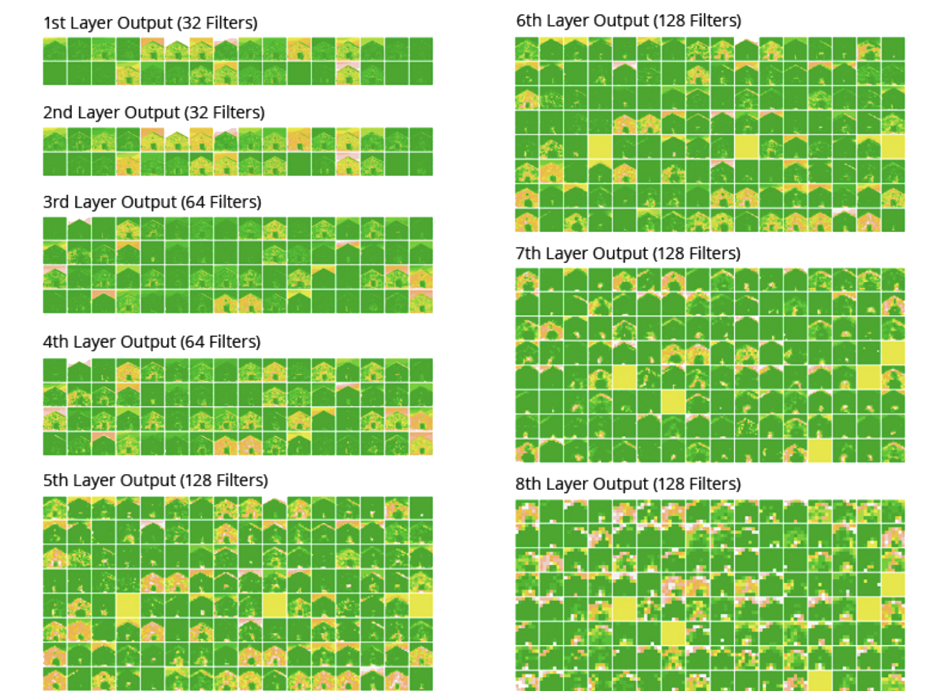

**Fig: Activation Maps on Intermediate Layers of Binary Classification Model Two**

The first layer seems to focus on edge detection, retaining almost all the detailed information from the initial input. It is interesting to note that as the image flows through deeper layers, the activations become increasingly abstract. The details on the image become less and less visually interpretable; the pattern encoding becomes less about the visual content of the image itself and more about the information related to the class the image belongs. The sparsity of the activations also increases with the depth of the layer.

Activation maps give an inside look at how the network distills the input information and repeatedly transforms it to filter out visual details, which are irrelevant to the classification task, and magnifies useful information, which is the information about the class of the image. In this sense, it seems to work like a human brain, which learns to transform visual input into high-level visual concepts while filtering out irrelevant visual details.

## Traditional Models: Binary/Multiclass Classifiers (reduced dataset)

As the third and final experiment, the goal was to classify and predict the images by labels using conventional classifiers such as Decision trees, k-Nearest Neighbors(kNN), Supply Vector Machines (SVM) and Random Forest. In addition, this experiment also uses a binary and multi-class classifier approach to solve and compare the accuracy among conventional vs deep learning models. In this section, 4 sample classes are used to predict the images.

* 20409 - Tombs
* 83144 - Huts
* 113209 - Mountains
* 126637 - Construction sites

### **Data Pre-processing**

Used the same dataset as that of experiments with *Deep Learning: Binary/Multiclass classifiers (reduced dataset)* earlier; however, the images will be converted into 28*28 grayscale image pixels.

Function to convert images into 28*28 grayscale pixels below,



Images from four labels are converted into individual data frames and first column (label) is converted into a factor for classification.

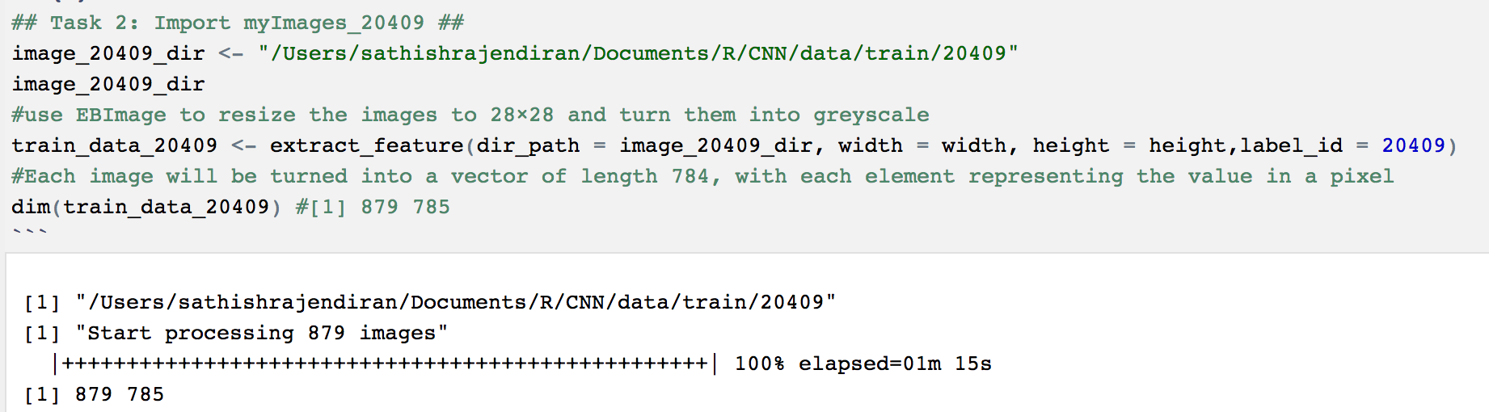

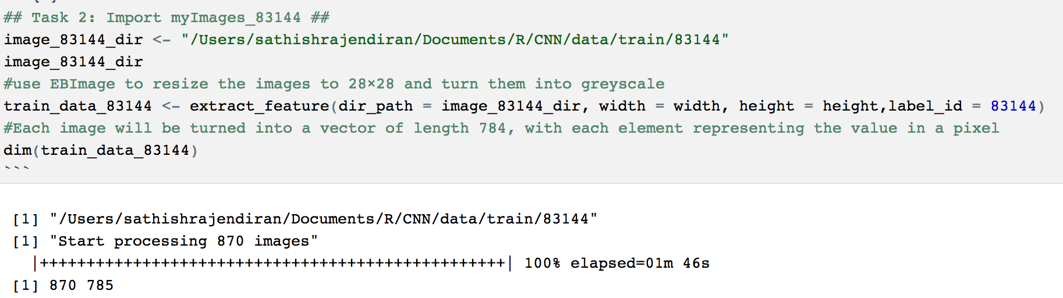

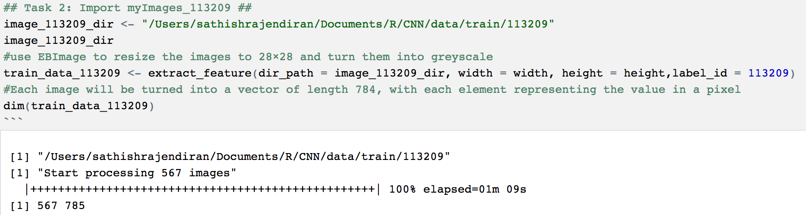

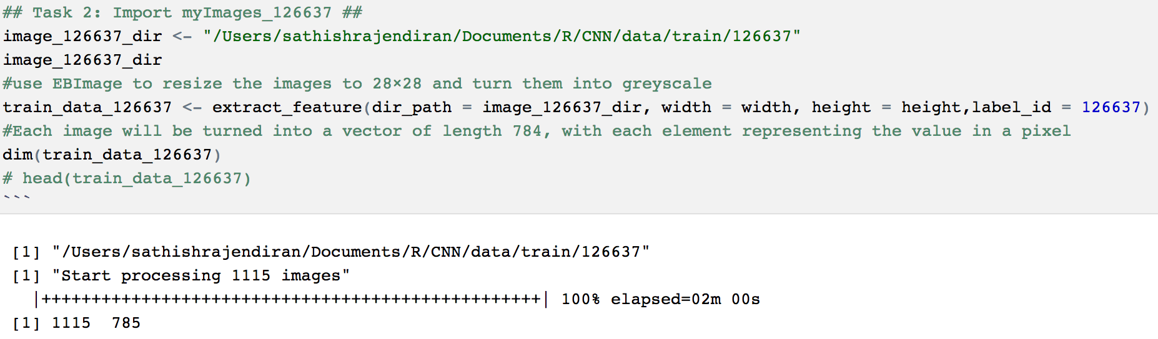

Combined data frame is as below,

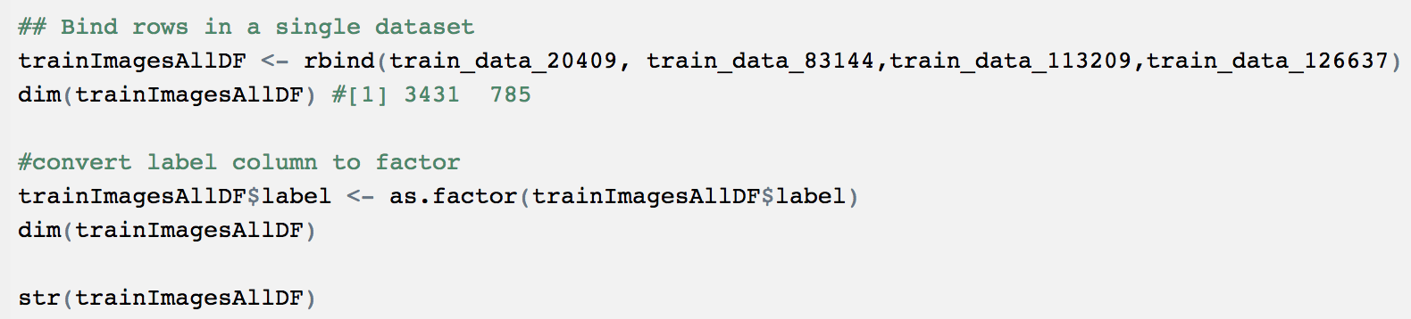

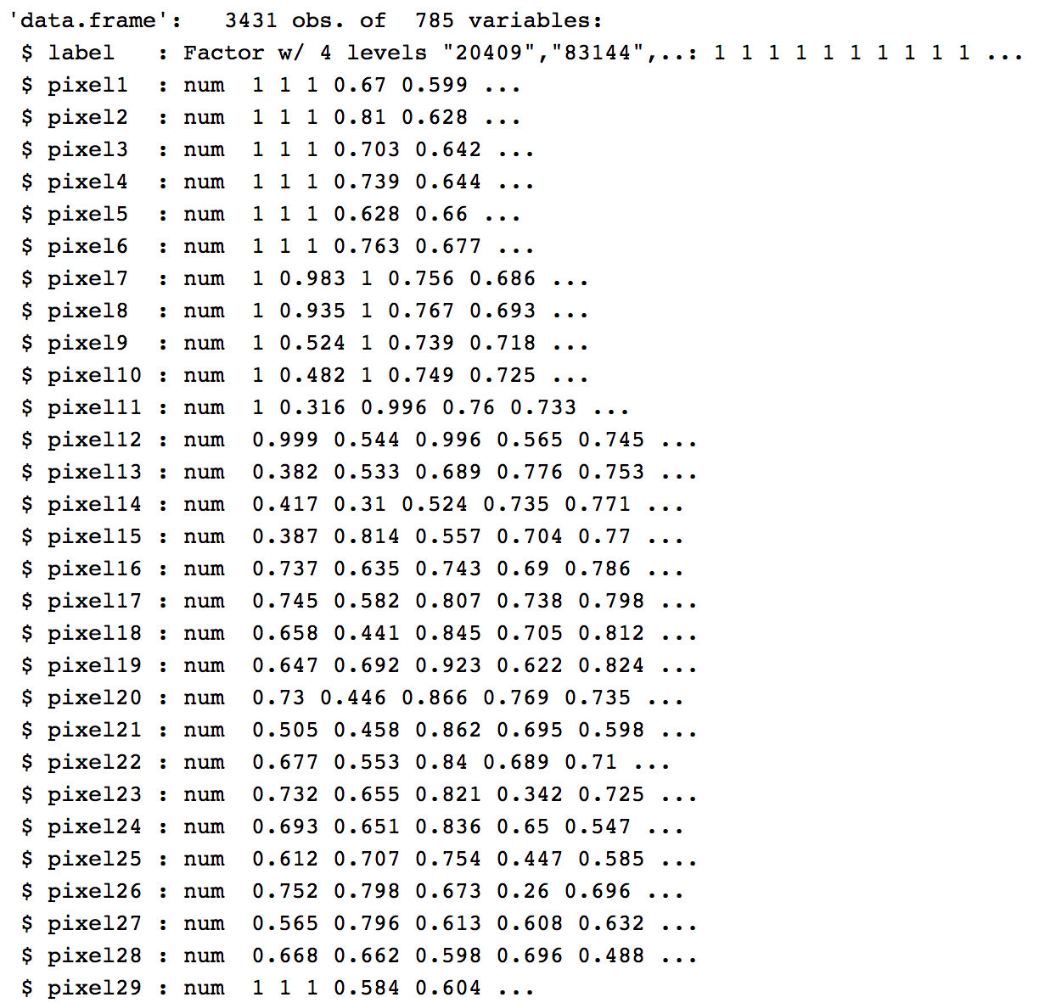

Sample data is further split into train and test data with 80:20 ratio as below,

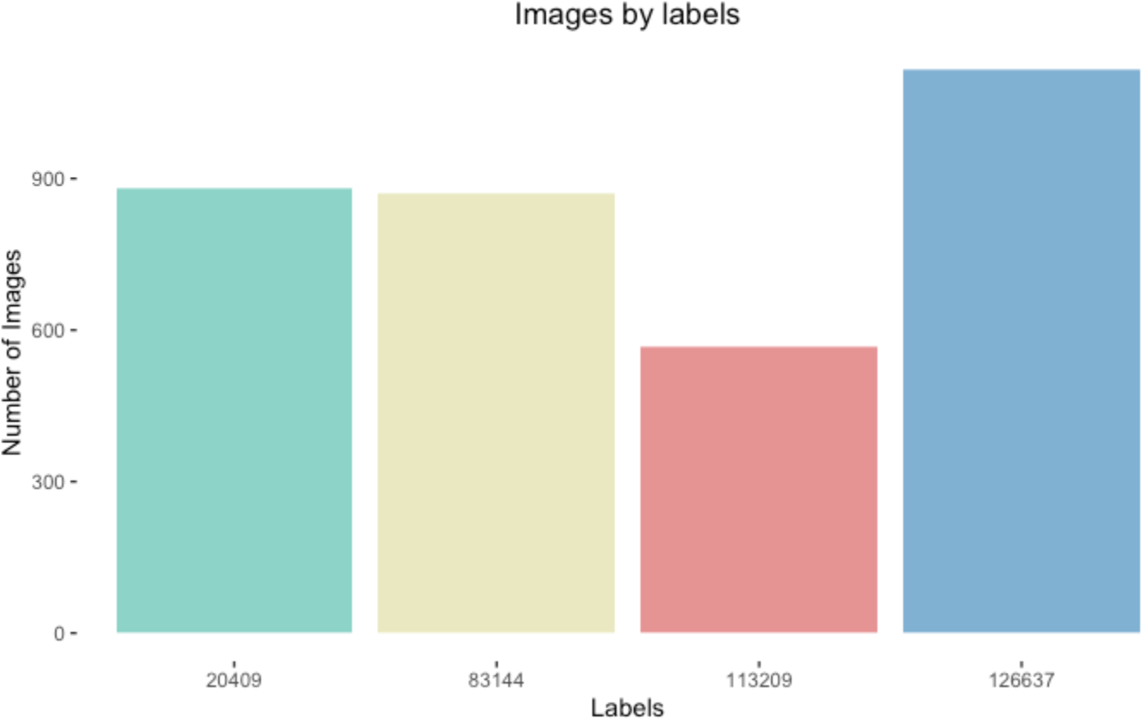

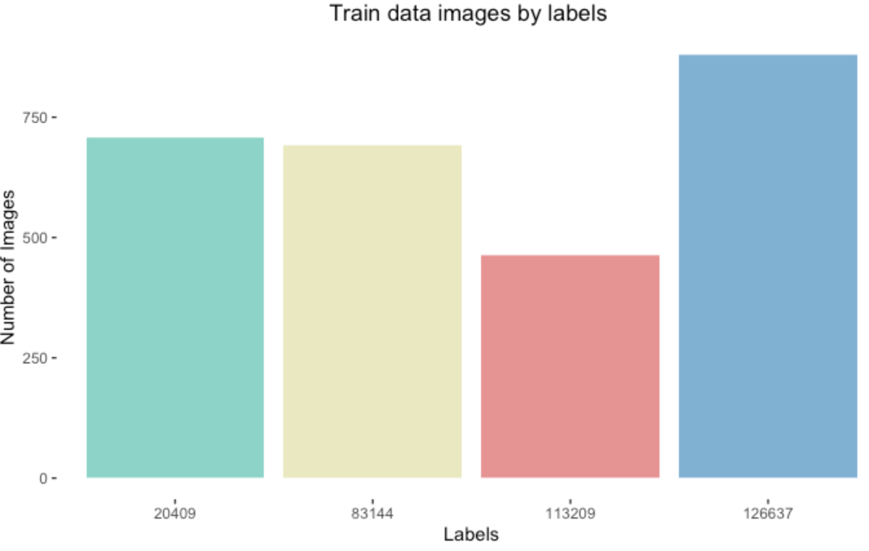

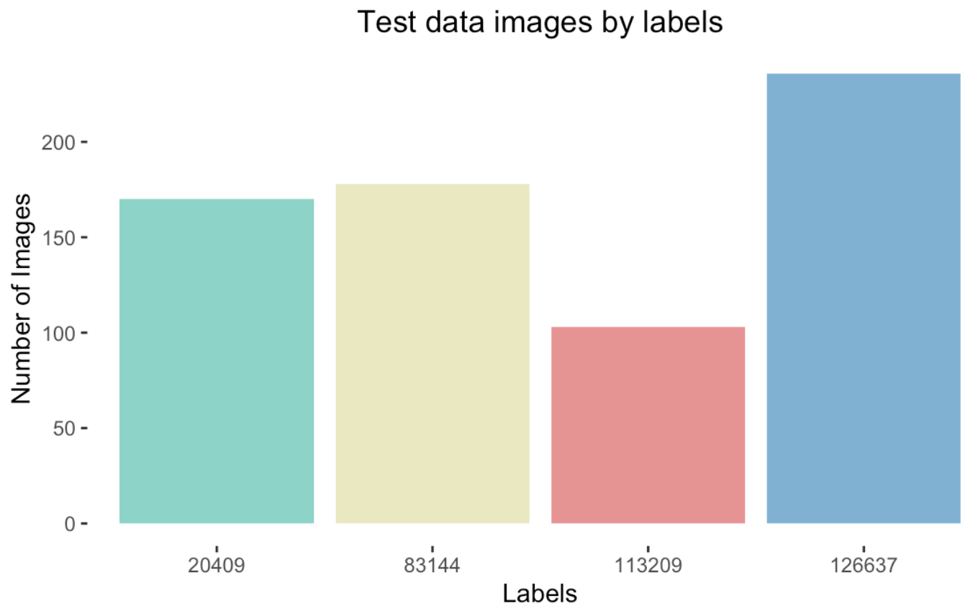

**Data Preprocessing - Dimensionality reduction using Principal Component Analysis (PCA)**

As the number of predictor variables are still huge (784) - dimensionality reduction method is applied to enhance the dataset. Principal Component Analysis (PCA) is used to reduce the number of dimensions to 30.

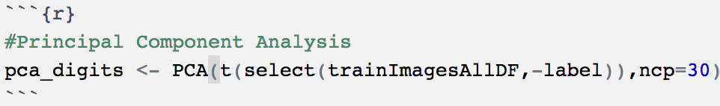

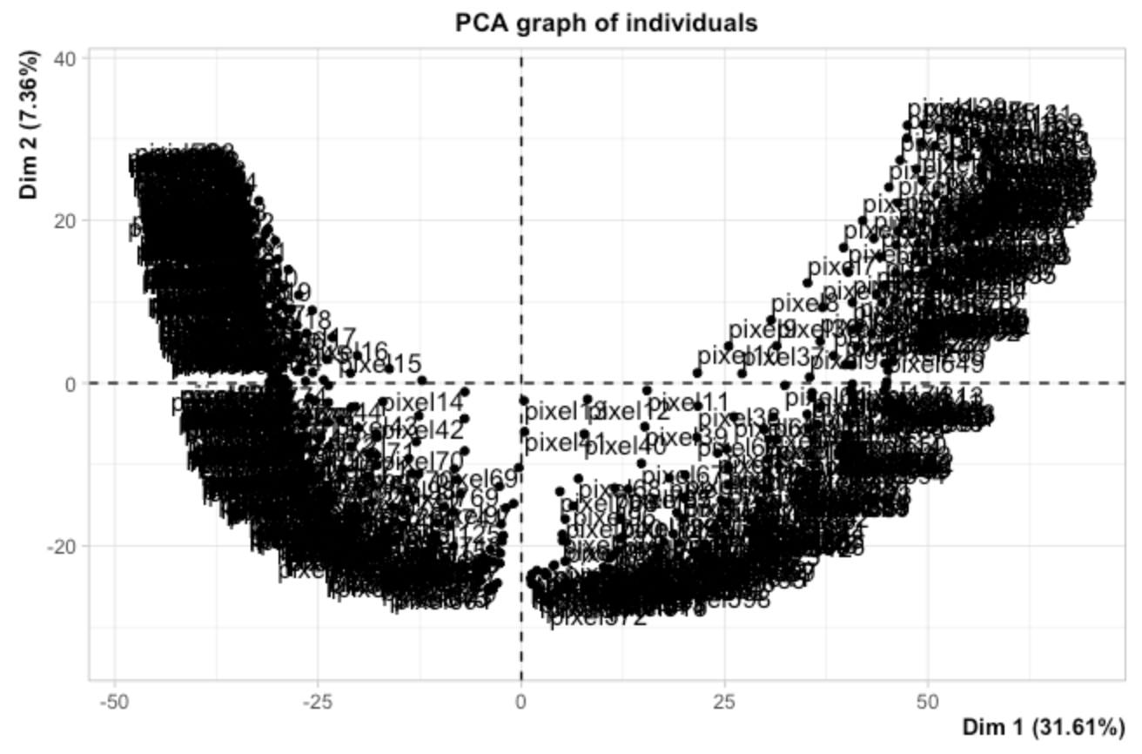

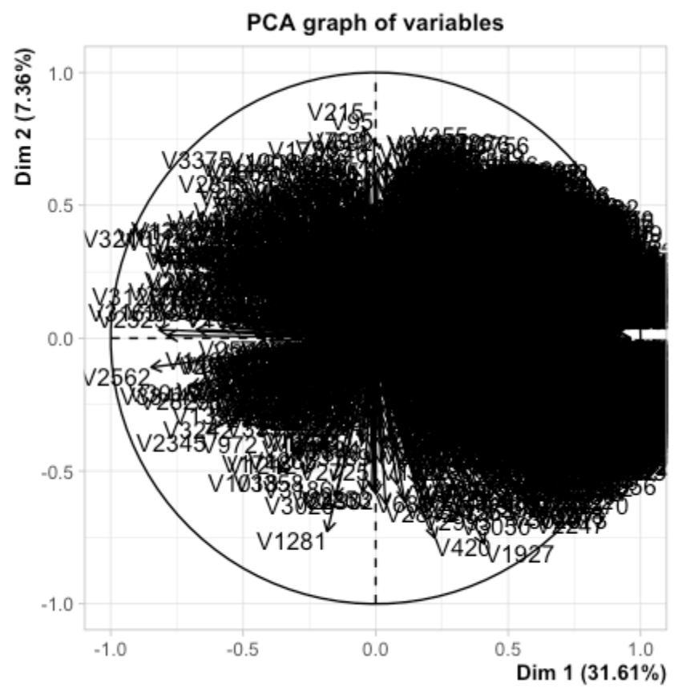

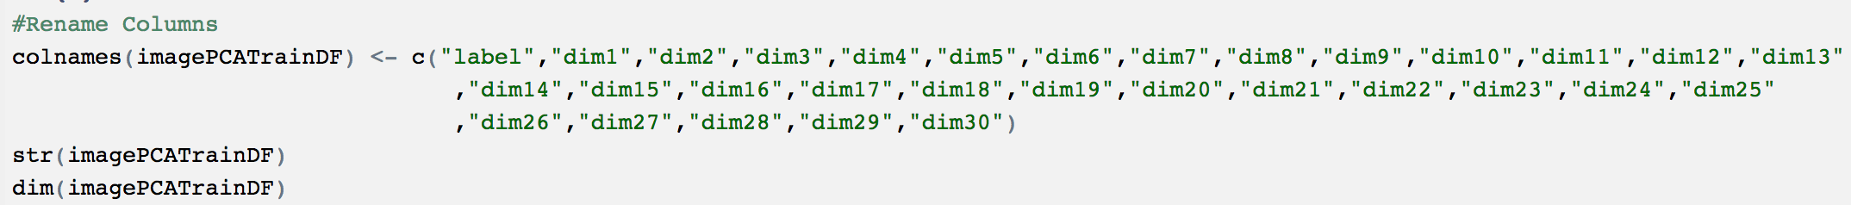

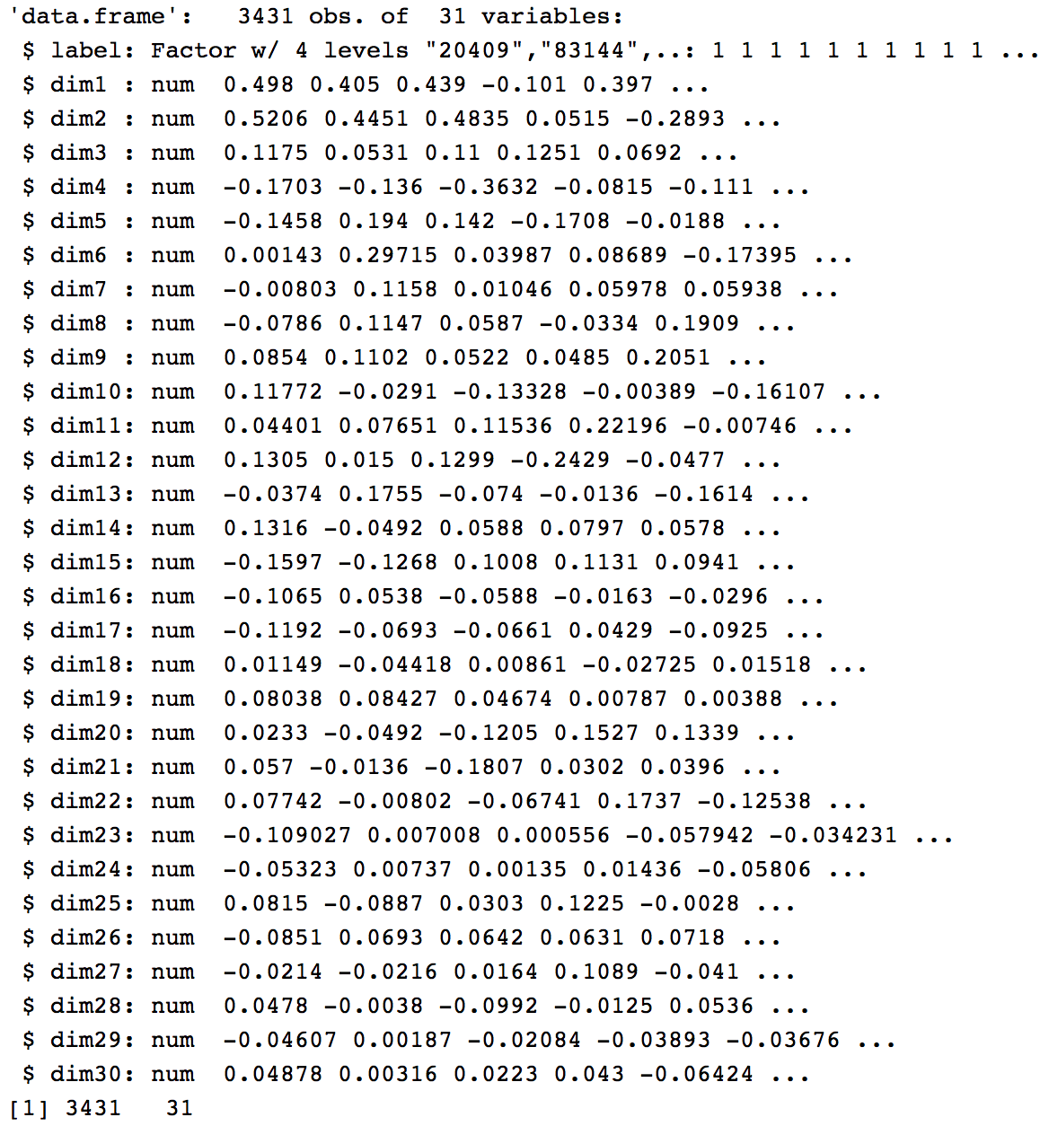

Let's prepare, train and test the dataset from the reduced dimension dataset as well.

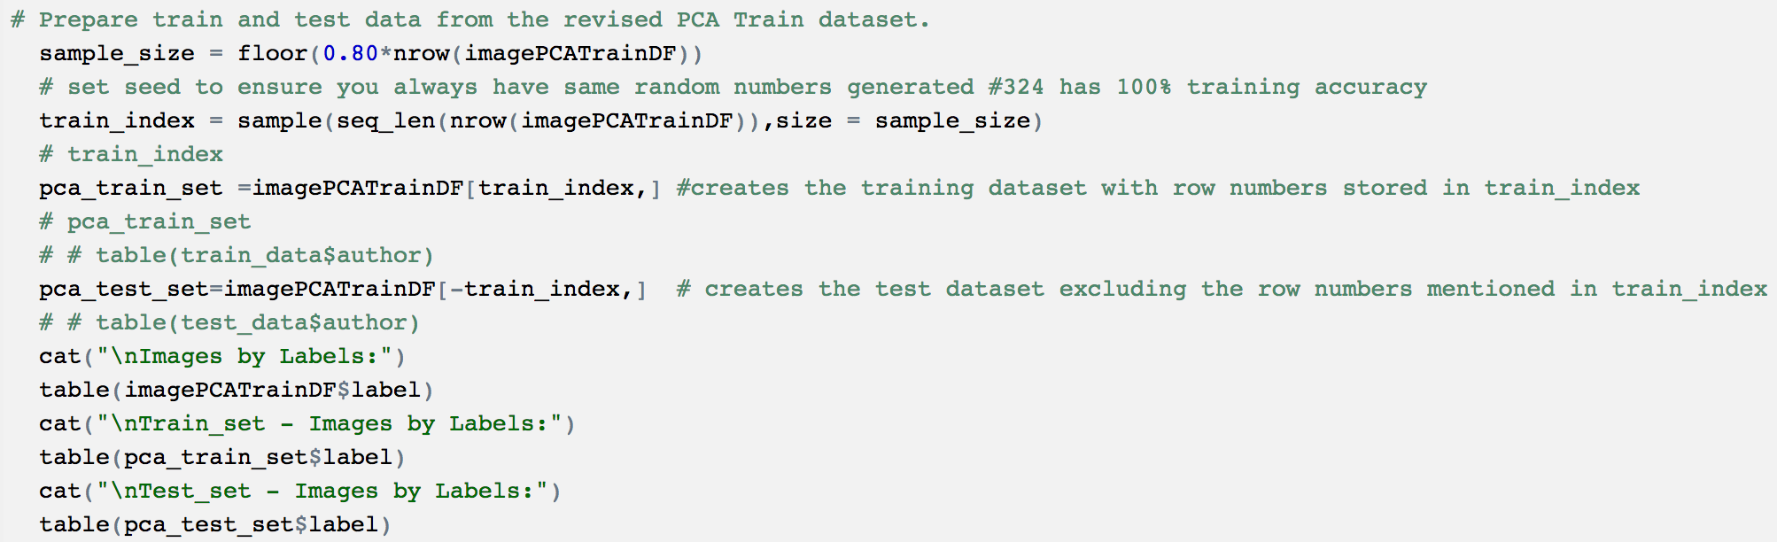

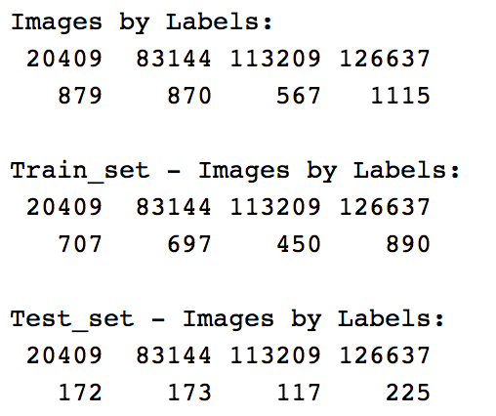

Now that we have datasets from both PCA (30 predictor variables) and actual dataset (784 predictor variables) - it's time to build models based on both datasets.

### Multiclass Classifiers

**Model 1: Decision Trees (DT)**

The DT model is built with control measures including cp, minsplit and maxdepth using the rpart library from R Studio. Initial case let’s use the original data set split with 784 predictor variables and parameters as cp=0, minsplit=1 and maxdepth=5. This process involves, building the tree, plotting and summarizing it with cross validation results.

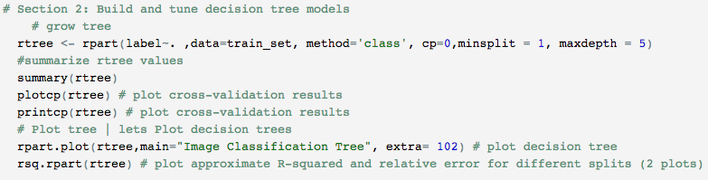

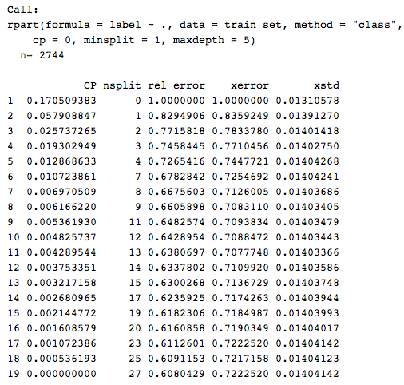

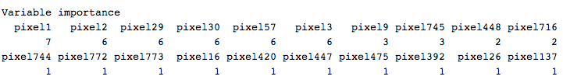

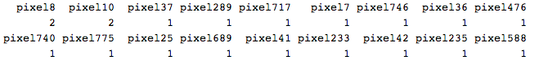

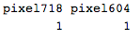

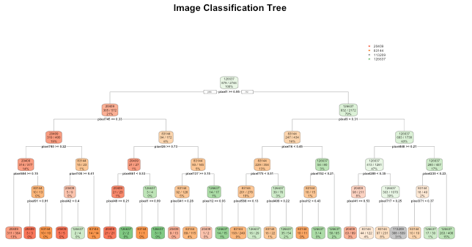

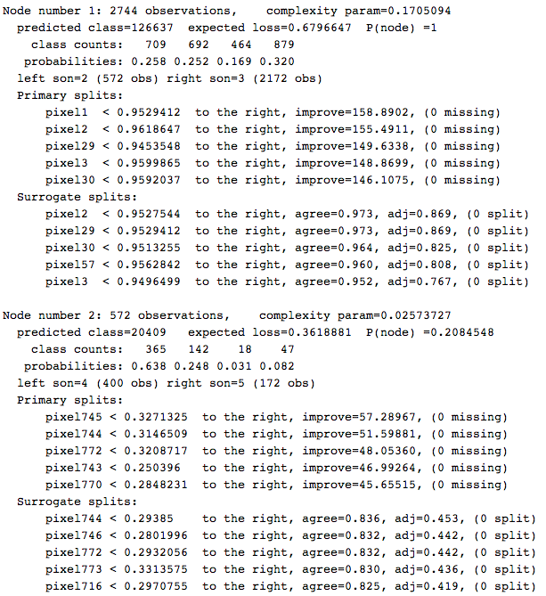

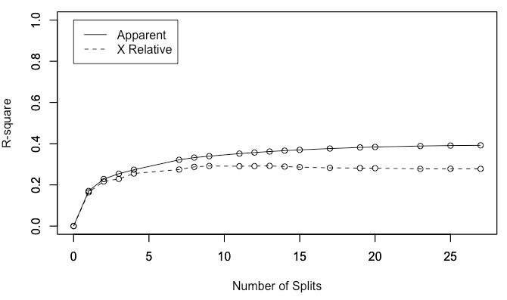

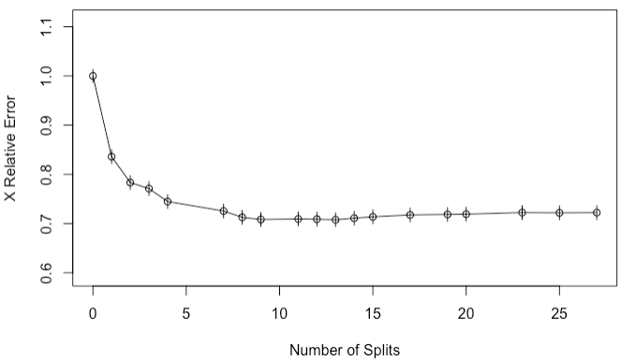

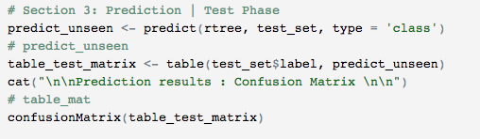

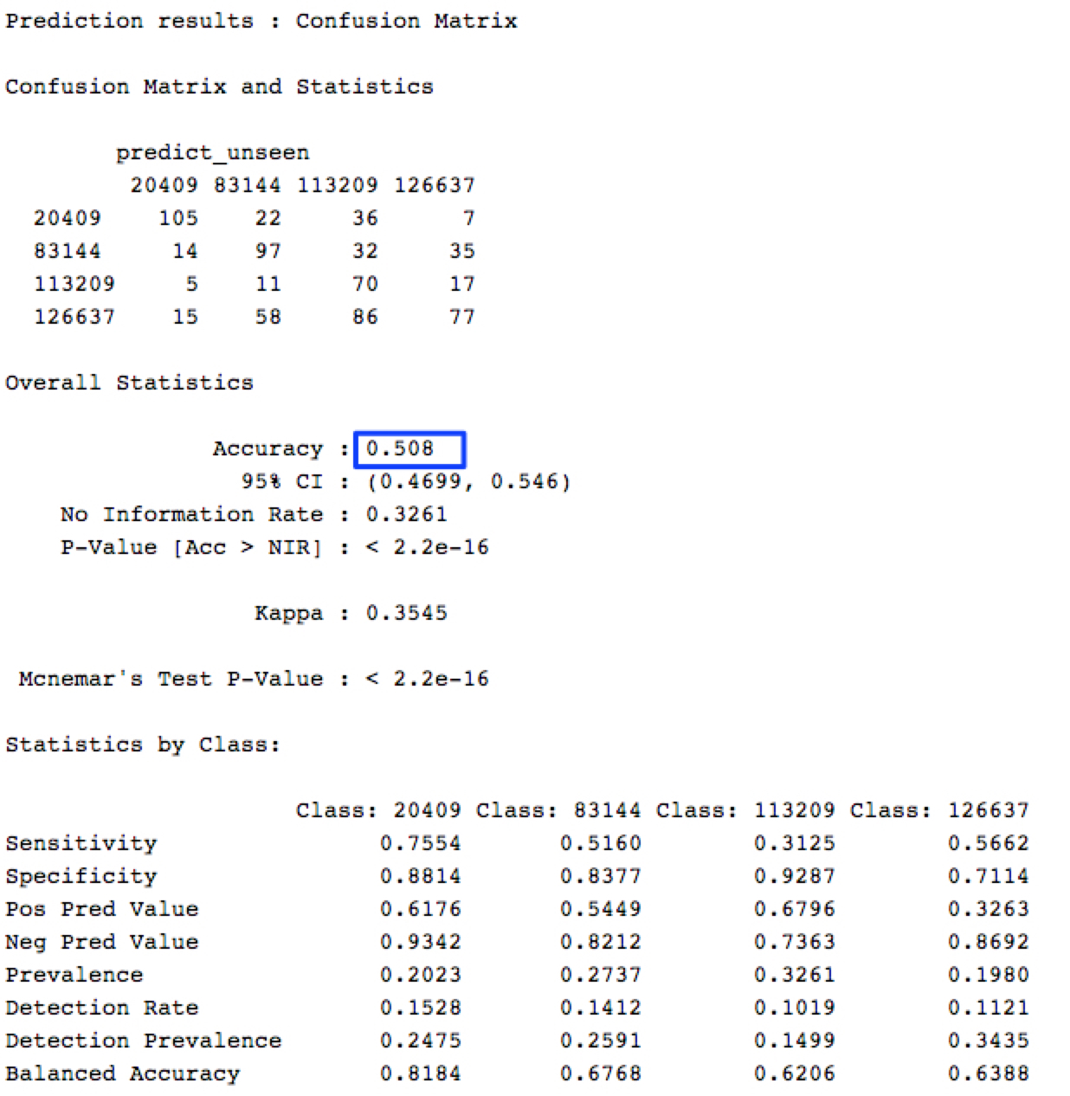

**Model 2: Decision Trees (DT) with PCA**

The DT model was built with control measures including cp, minsplit and maxdepth using the rpart library from R Studio. In this case, the PCA dataset would be split with 30 predictor variables and parameters as cp=0, minsplit=1 and maxdepth=5. This process involved, building the tree, plotting and summarizing it with cross validation results.

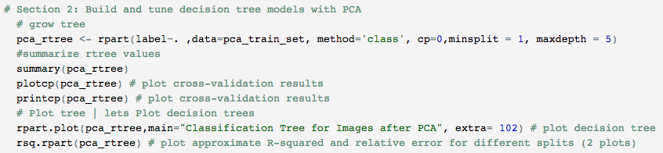

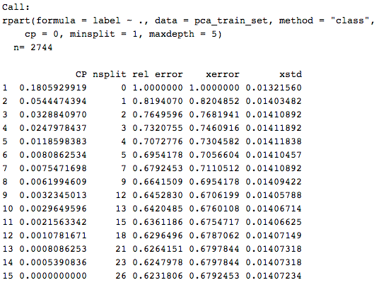



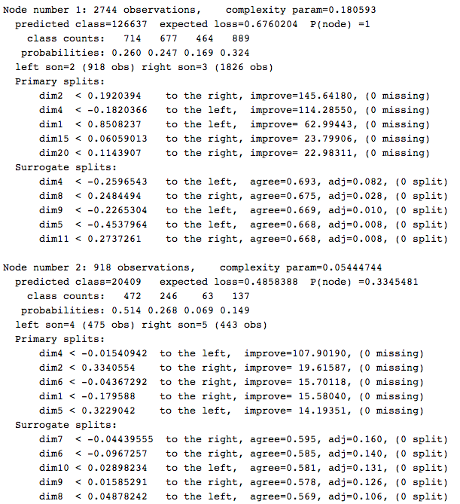

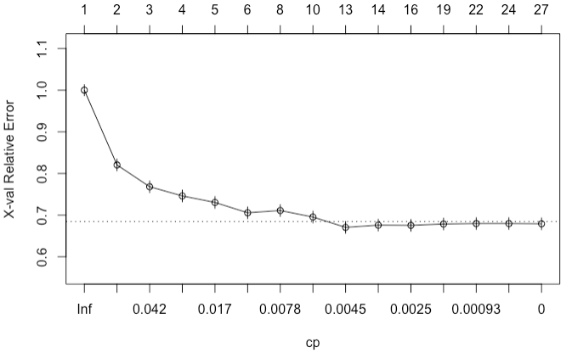

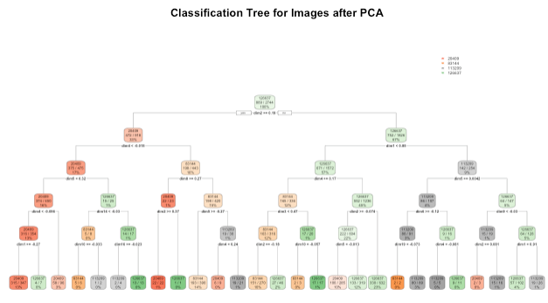

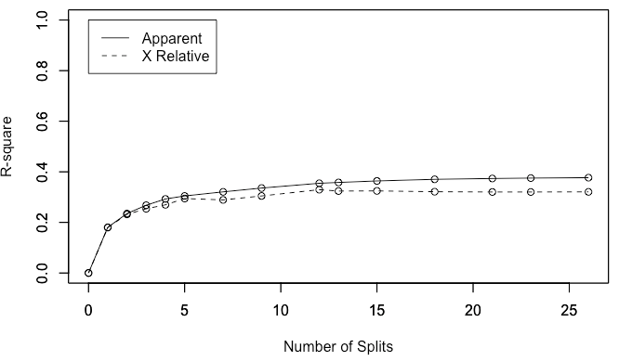

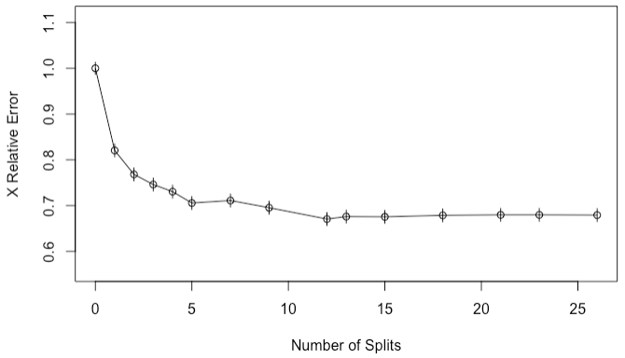

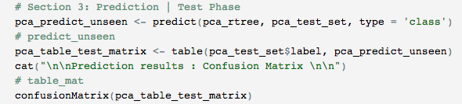

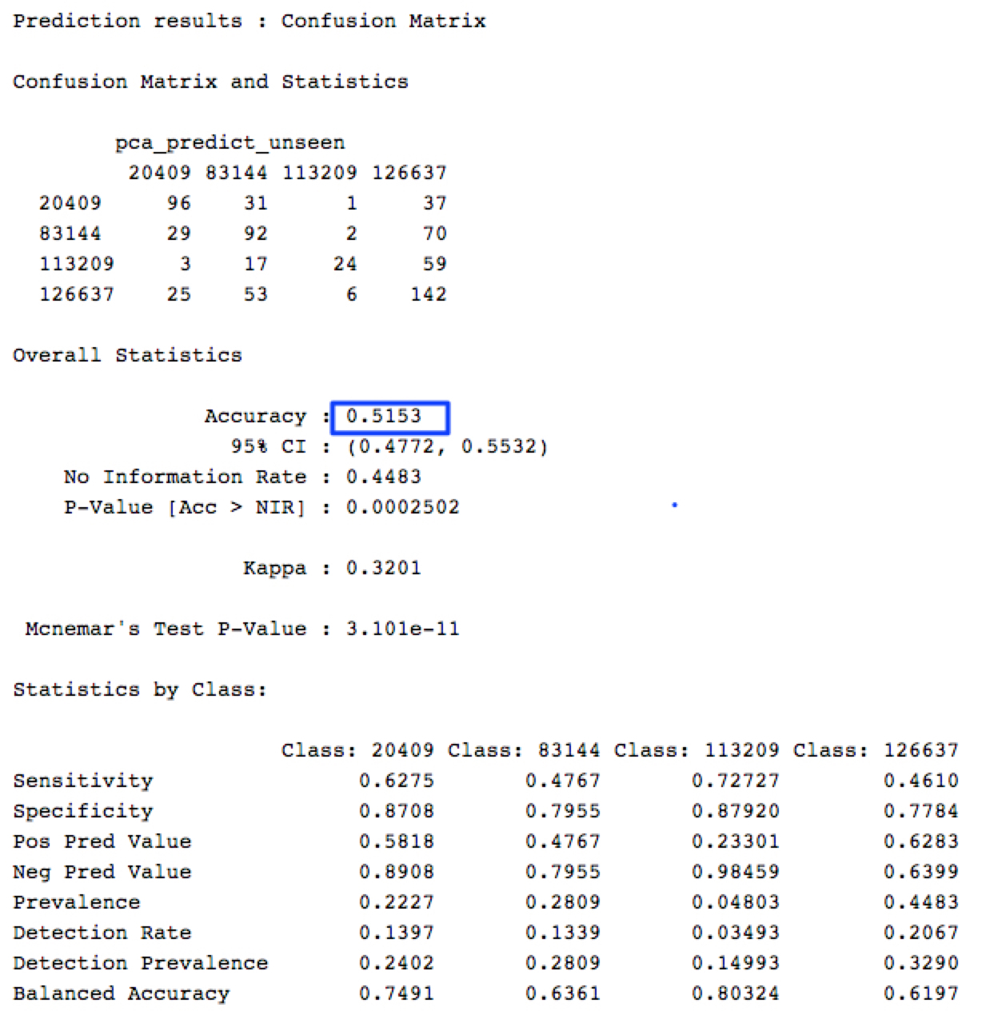

**Model 3: k-Nearest Neighbors (kNN) with PCA**

Next a kNN model was built using the earlier PCA data set, that is with 4 categorical values and 30 predictor variables. kNN models are termed as lazy learning models as it does not construct a general internal model rather simply stores instances of the training data.

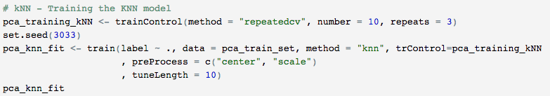

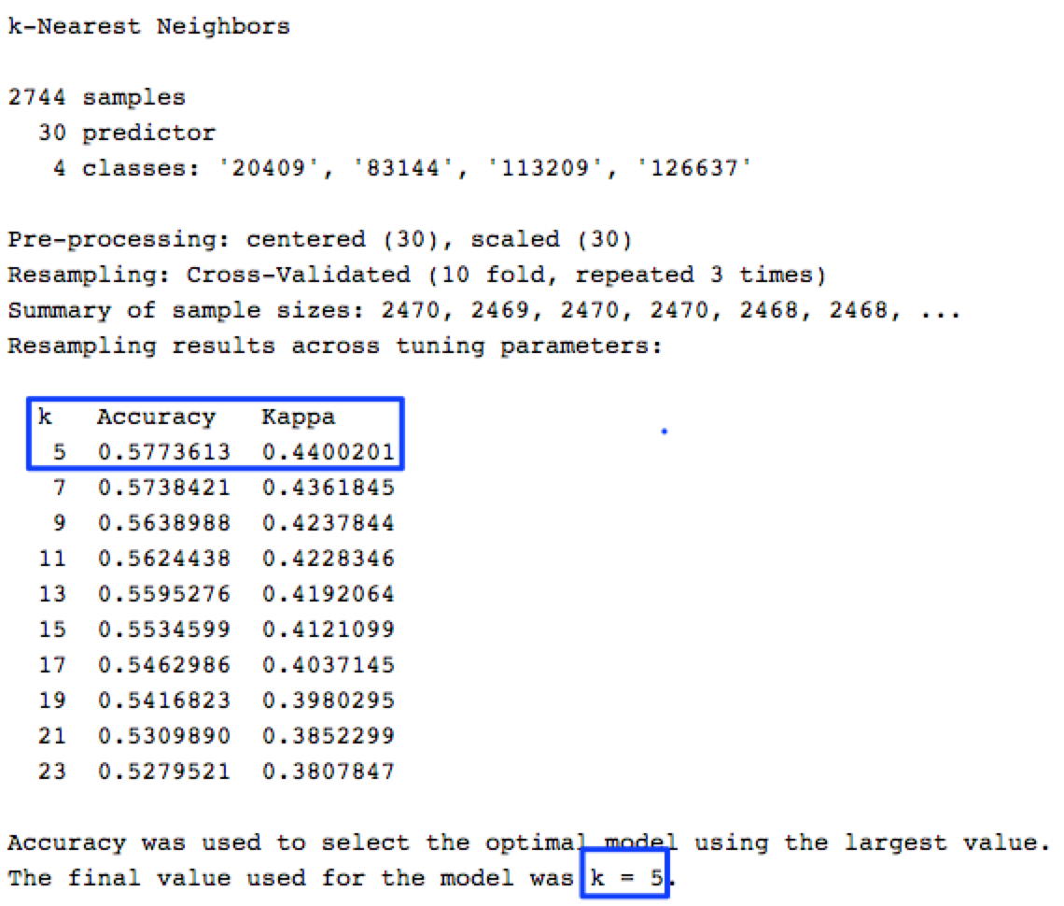

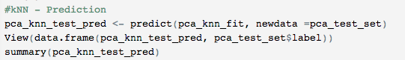

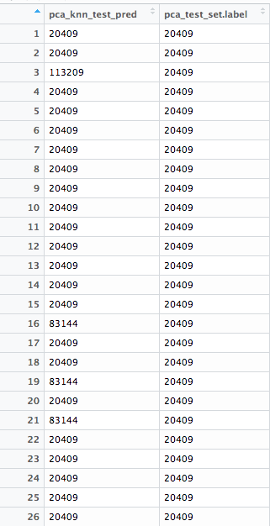

**Model 4: Support Vector Machines (SVM) with Linear Kernel**

Let's build a SVM model using the PCA data set on the Linear kernel, that is with 4 categorical values and 30 predictor variables. SVM models are a representation of training data as points in space separated into categories by a clear gap that is as wide as possible. Number of support vectors identified defines how accurately the model can predict variables.

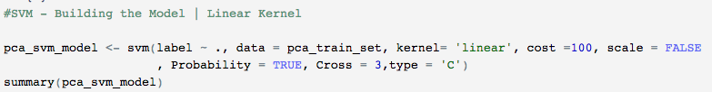

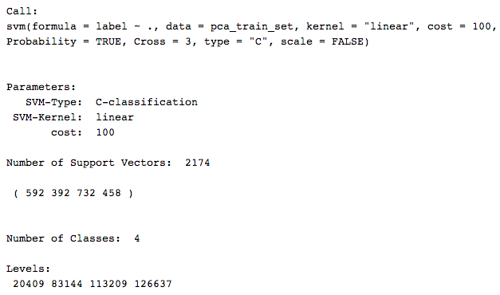

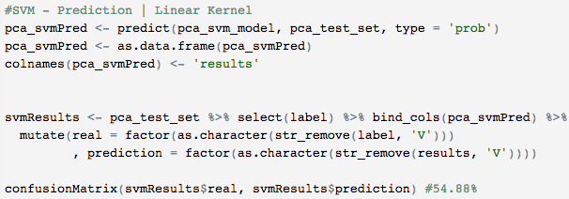

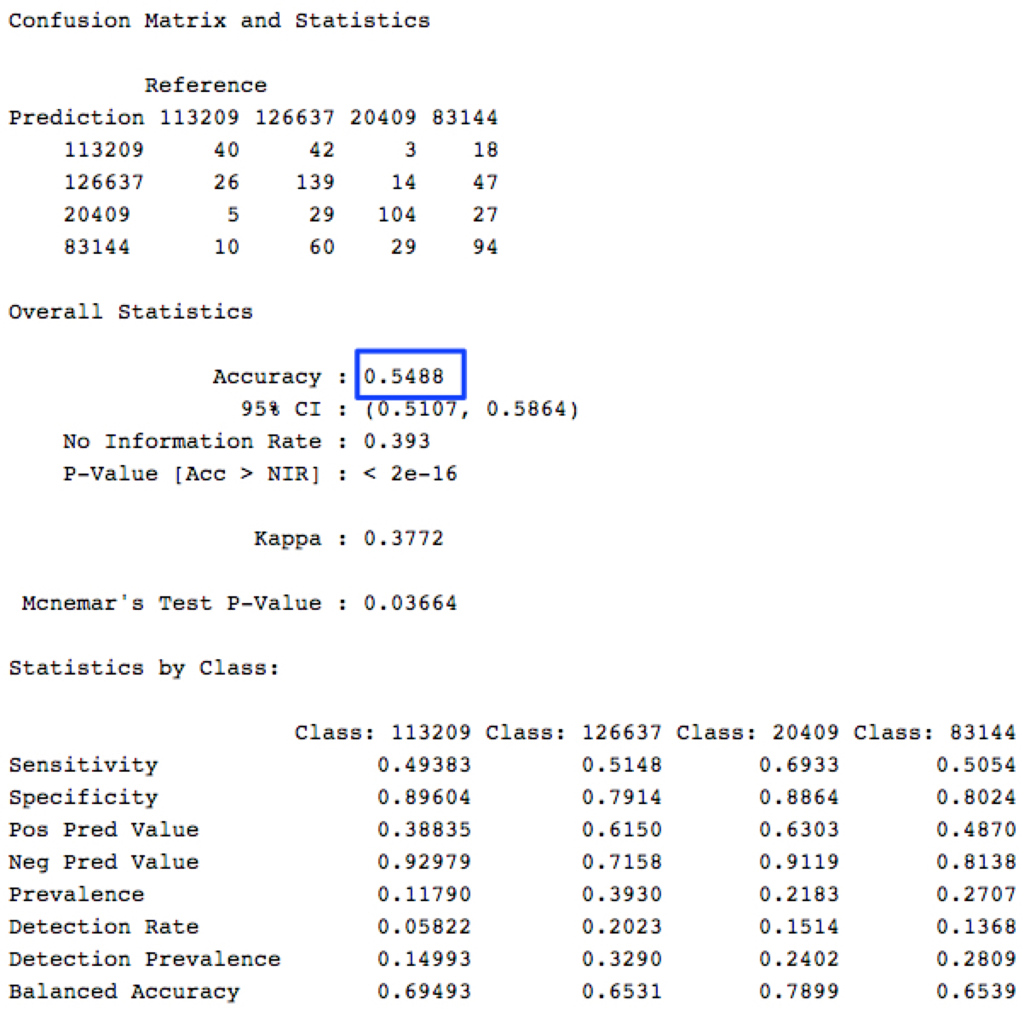

**Model 5: Support Vector Machines (SVM) with Radial Kernel**

Let's build an SVM model using the PCA data set on the radial kernel. i.e. 4 categorical values and 30 predictor variables. SVM models are representation of training data as points in space separated into categories by a clear gap that is as wide as possible. Number of support vectors identified defines how accurately the model can predict variables.

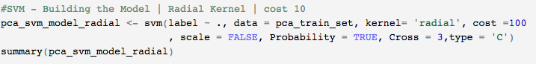

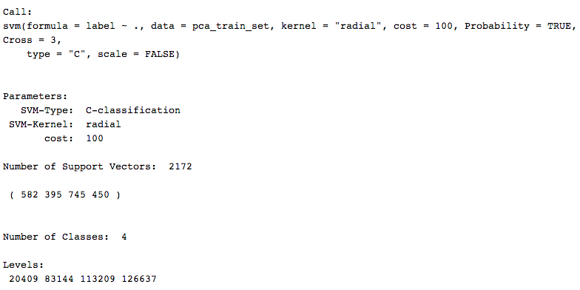

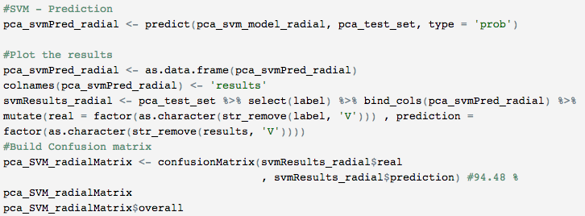

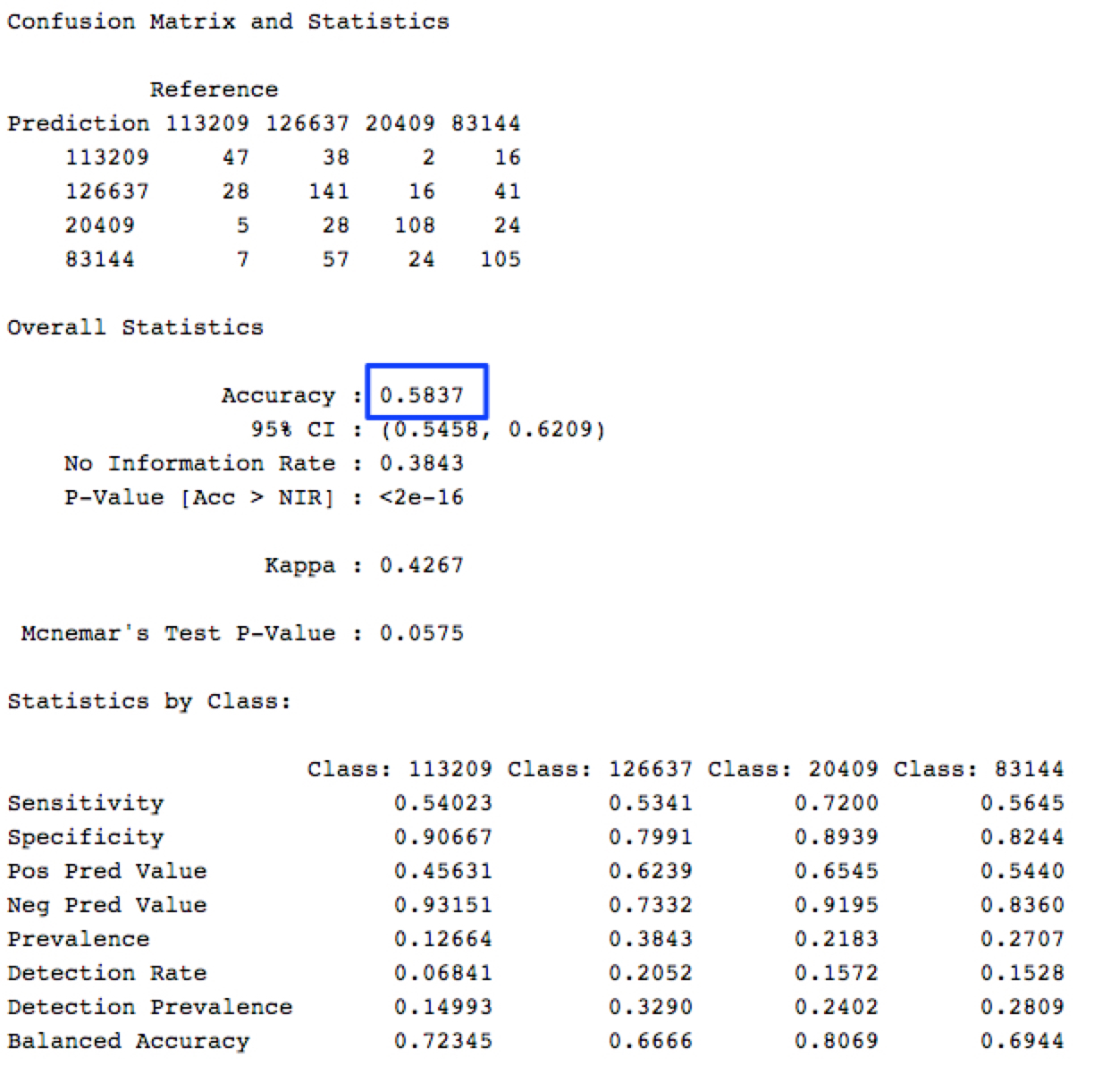

**Model 6: Support Vector Machines (SVM) with Polynomial Kernel**

Let's build an SVM model using the PCA data set on the polynomial kernel. i.e. 4 categorical values and 30 predictor variables. SVM models are representation of training data as points in space separated into categories by a clear gap that is as wide as possible. Number of support vectors identified defines how accurately the model can predict variables.

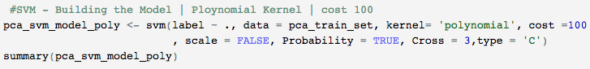

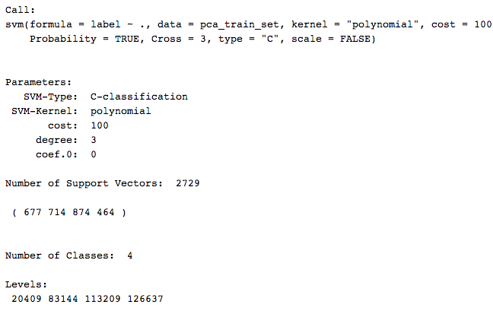

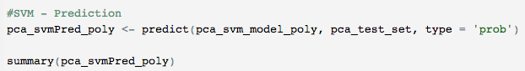

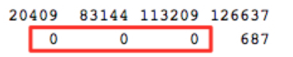

**Model 7: Random Forest (RF) with 100 trees**

Let's build a random forest model using the PCA data set on the polynomial kernel. i.e. 4 categorical values and 30 predictor variables. SVM models are representation of training data as points in space separated into categories by a clear gap that is as wide as possible. Number of support vectors identified defines how accurately the model can predict variables.



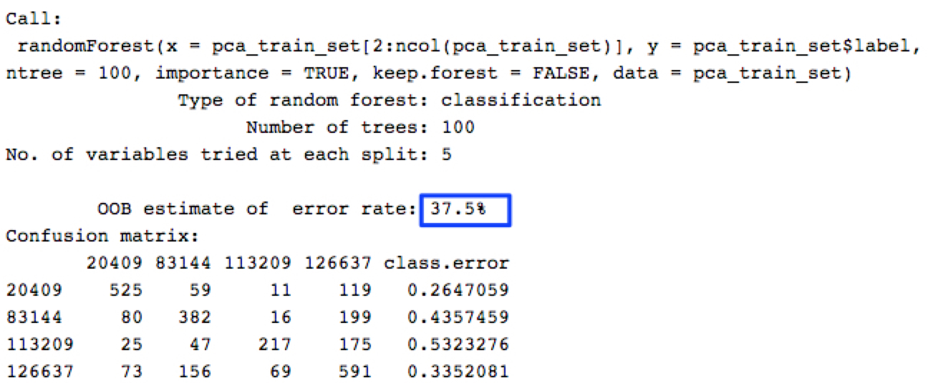

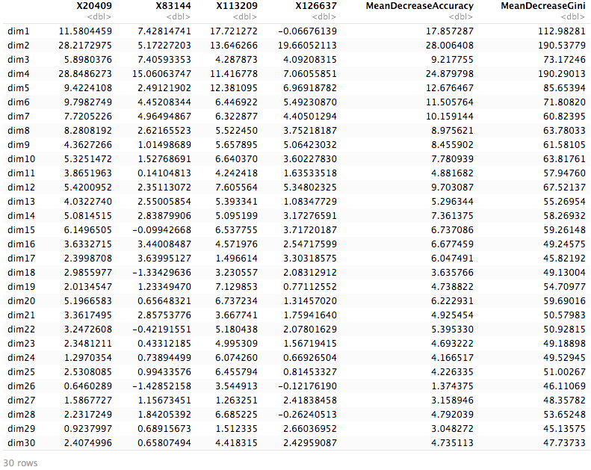

### 

### **Binary Classifier**

In this section, the goal was to classify and predict the images with 2 labels using traditional classifiers such as Decision trees, k-Nearest Neighbors(kNN), Supply Vector Machines (SVM) and Random Forest Trees. In addition, this experiment also uses a binary and multi-class classifier approach to solve and compare the accuracy among conventional vs deep learning models.

* 20409 - Tombs
* 83144 - Huts

**Data Preprocessing**

Used the same dataset as that of experiments with *Traditional Model: Multiclass classifiers* earlier; however, just that the labels 20409 and 83144 would be retained in the new dataframe.

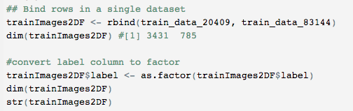

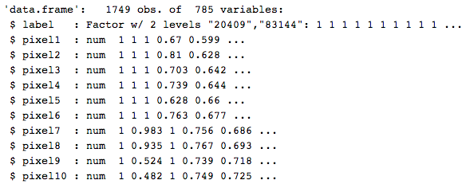

**Data Preprocessing - Dimensionality reduction using Principal Component Analysis (PCA)**

As the number of predictor variables are still large (784) - dimensionality reduction method is applied to enhance the dataset. Principal Component Analysis (PCA) is used to reduce the number of dimensions to 30.

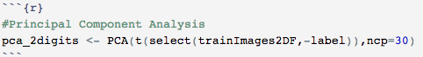

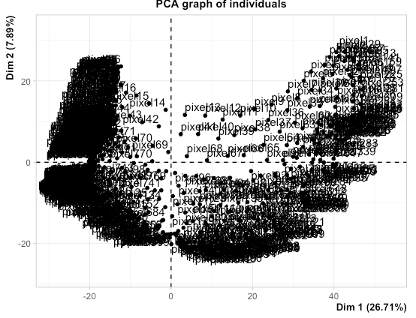

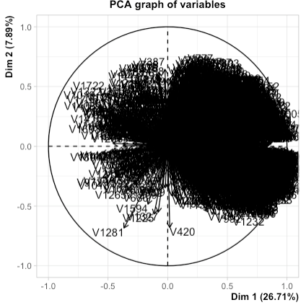

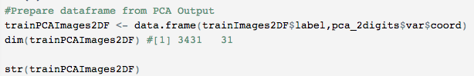

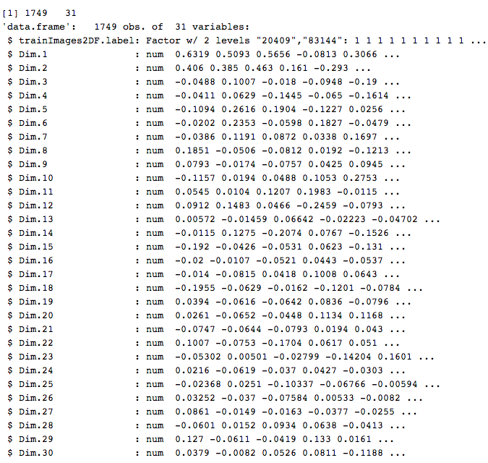

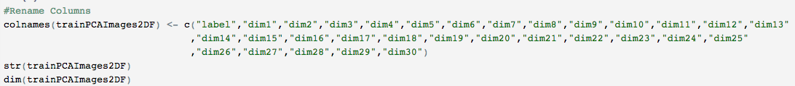

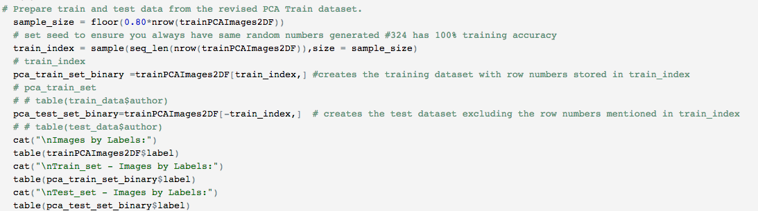

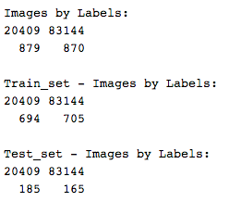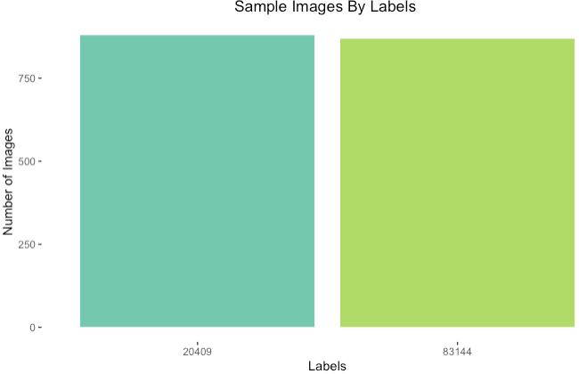

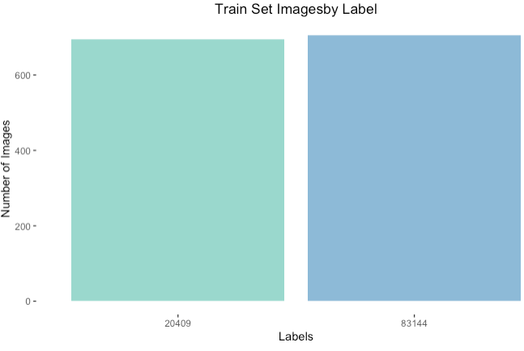

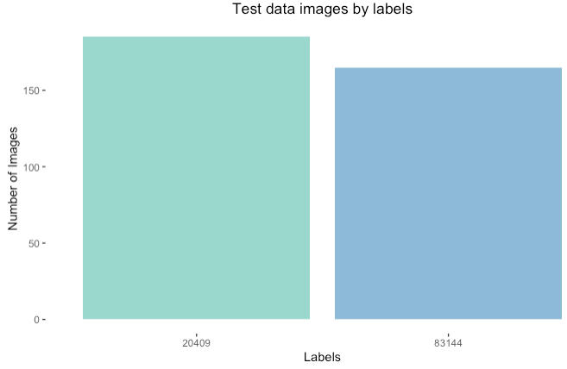

**Model 1: Decision Trees (DT) with PCA and Binary Classifier**

The DT model is built with control measures including cp, minsplit and maxdepth using the rpart library from R Studio. Initial case used the PCA data set split with 30 predictor variables and parameters as cp=0, minsplit=1 and maxdepth=5. This process involves, building the tree, plotting and summarizing it with cross validation results.

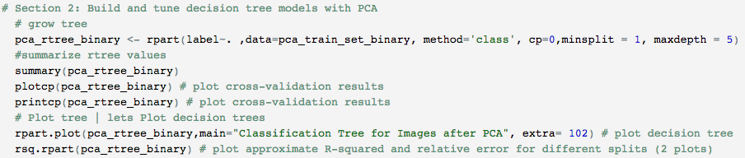

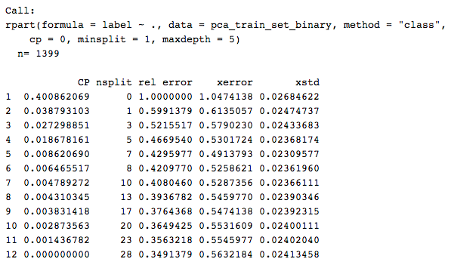

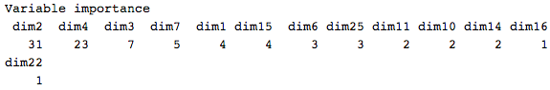



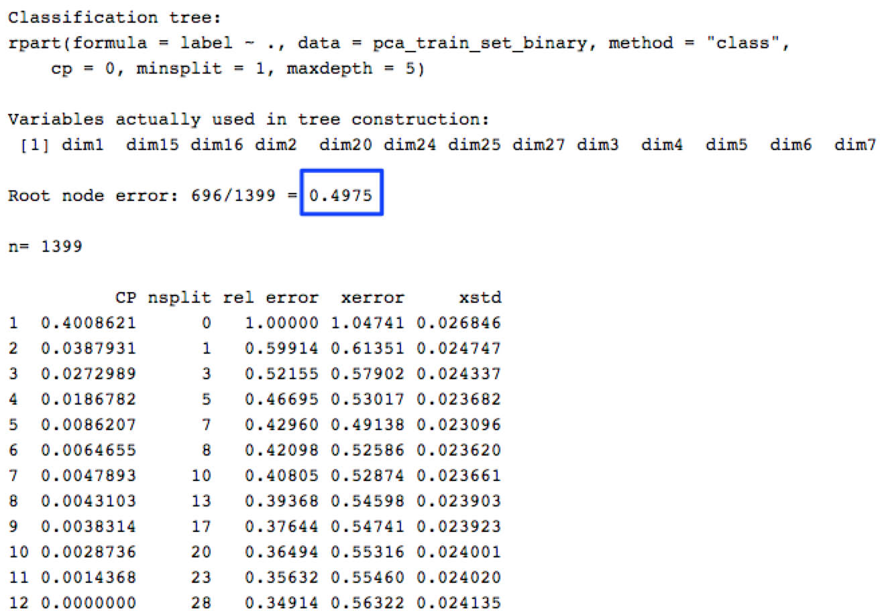

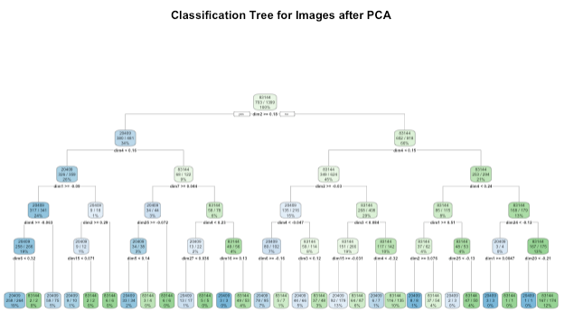

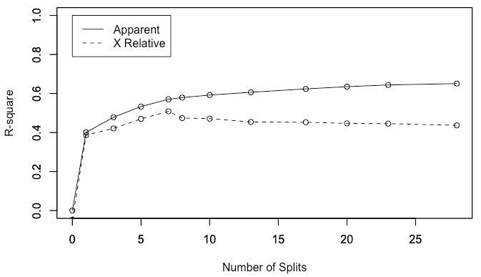

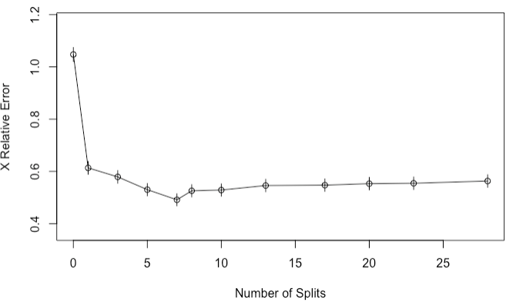

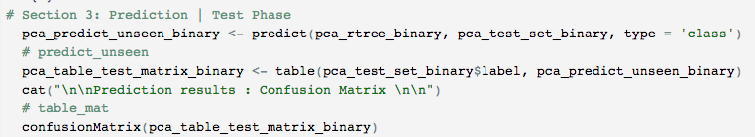

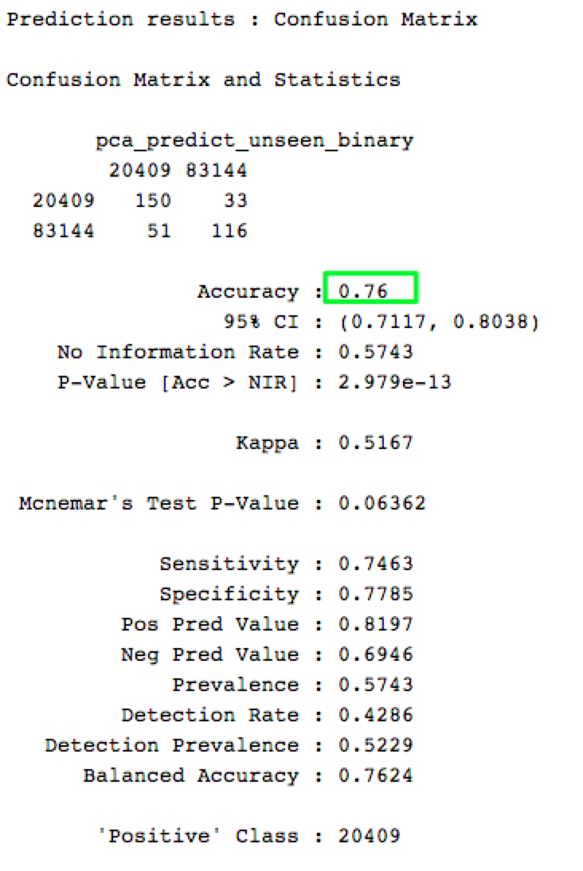

**Model 2: k-Nearest Neighbors (kNN) with PCA**

Let's build a kNN model using the PCA data set. i.e. 2 categorical values and 30 predictor variables. kNN models are termed as lazy learning models as it does not construct a general internal model rather simply stores instances of the training data.

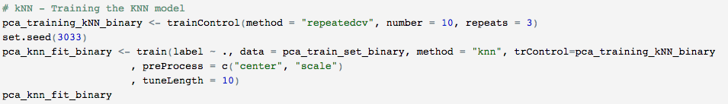

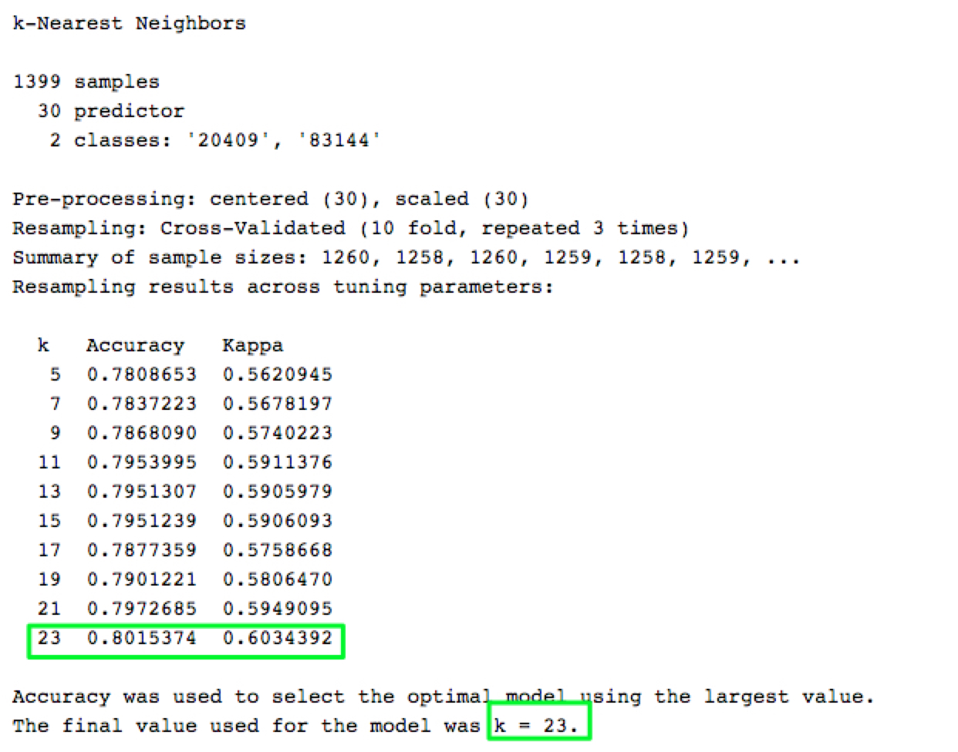

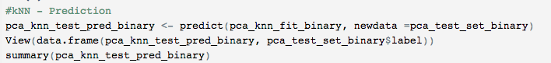

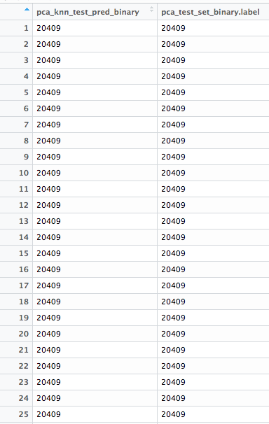

**Model 3: Support Vector Machines (SVM) with Linear Kernel & Binary Classifier**

Let's build an SVM model using the PCA data set on the Linear kernel. i.e. 2 categorical values and 30 predictor variables. SVM models are representation of training data as points in space separated into categories by a clear gap that is as wide as possible. Number of support vectors identified defines how accurately the model can predict variables.

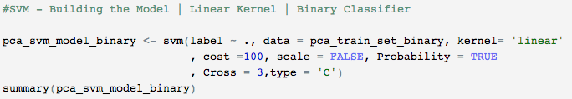

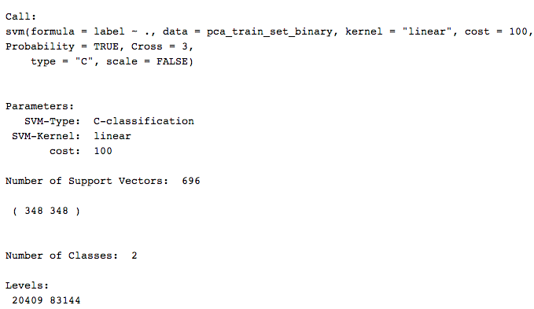

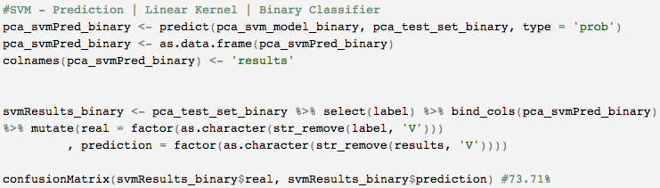

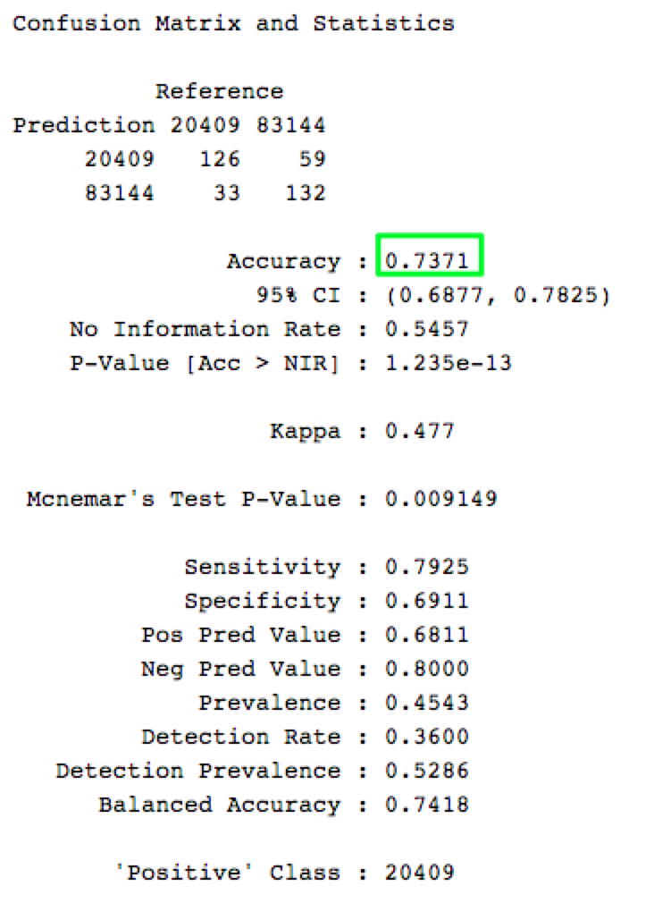

**Model 4: Support Vector Machines (SVM) with Radial Kernel and Binary Classifier**

Let's build an SVM model using the PCA data set on the radial kernel. i.e. 2 categorical values and 30 predictor variables. SVM models are representation of training data as points in space separated into categories by a clear gap that is as wide as possible. Number of support vectors identified defines how accurately the model can predict variables.

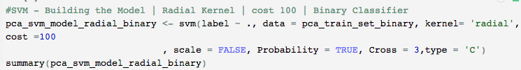

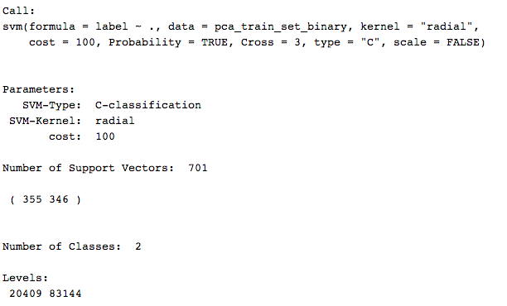

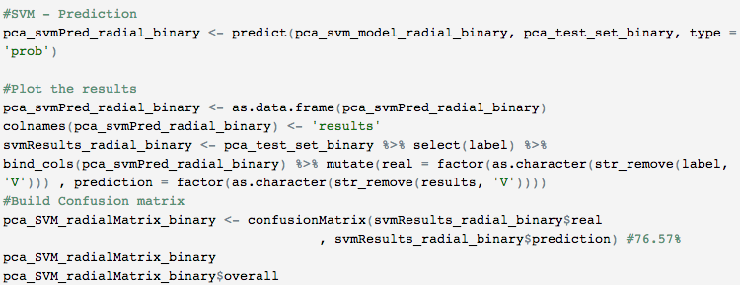

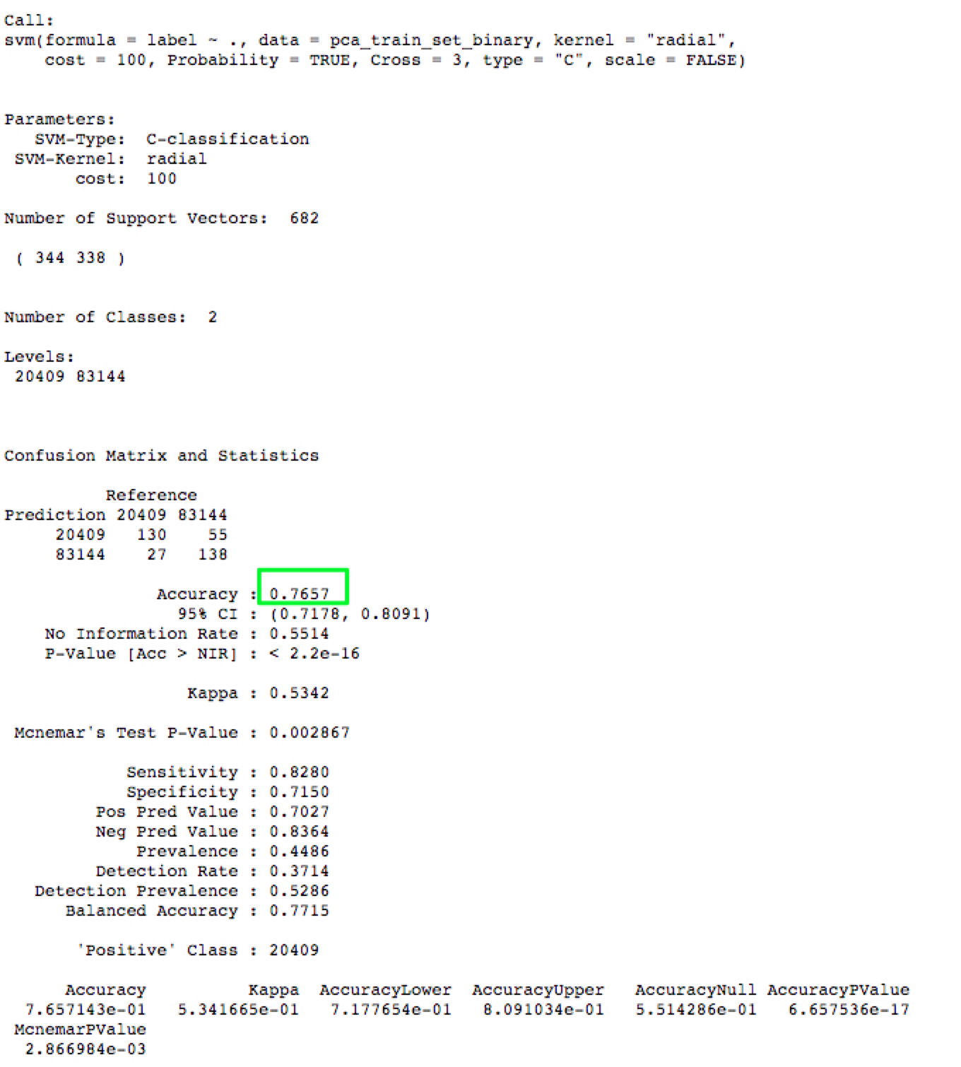

**Model 5: Support Vector Machines (SVM) with Polynomial Kernel and Binary Classifier**

Let's build an SVM model using the PCA data set on the polynomial kernel. i.e. 2 categorical values and 30 predictor variables. SVM models are representation of training data as points in space separated into categories by a clear gap that is as wide as possible. Number of support vectors identified defines how accurately the model can predict variables.

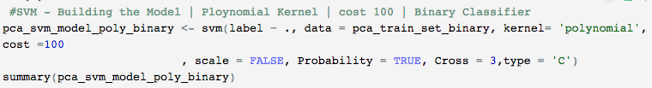

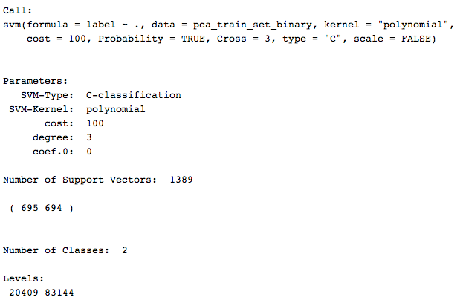

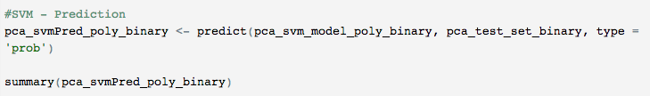

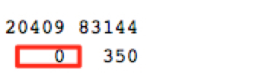

**Model 6: Random Forest (RF) with 100 trees and Binary Classifier**

Let's build a random forest model using the PCA data set on the polynomial kernel. i.e. 2 categorical values and 30 predictor variables models are representation of training data as points in space separated into categories by a clear gap that is as wide as possible. Number of support vectors identified defines how accurately the model can predict variables.

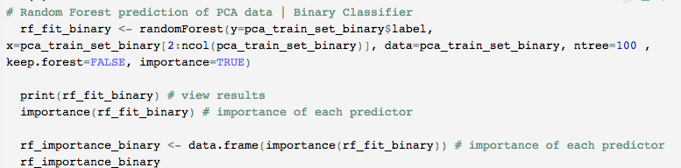

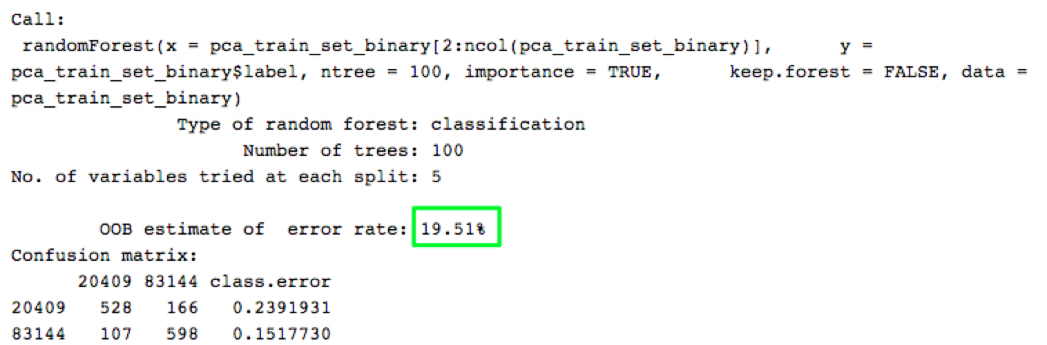

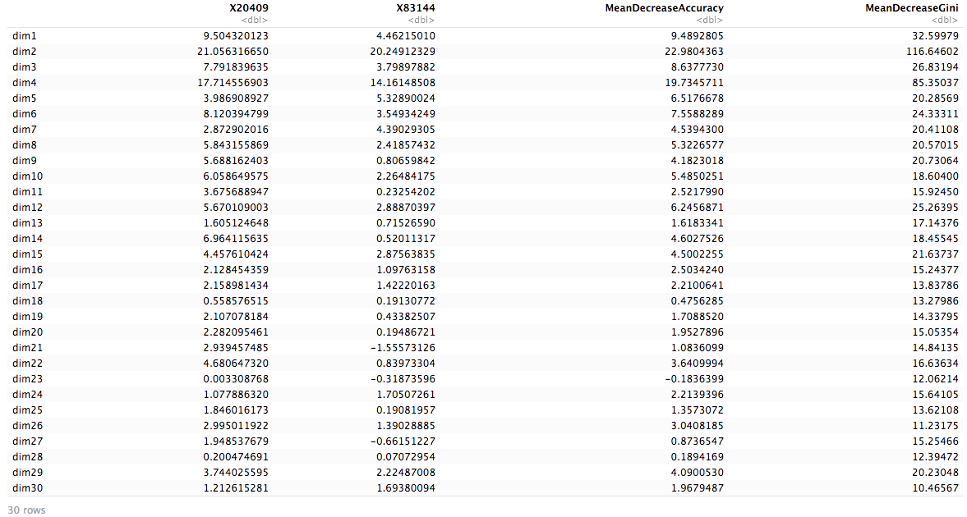

# 

# Results

## Deep Learning: Multiclass Classifiers (large dataset)

This section captures the results around the various experiments outlined earlier:

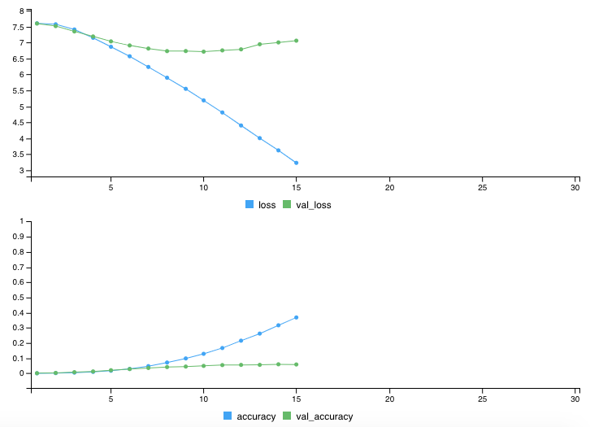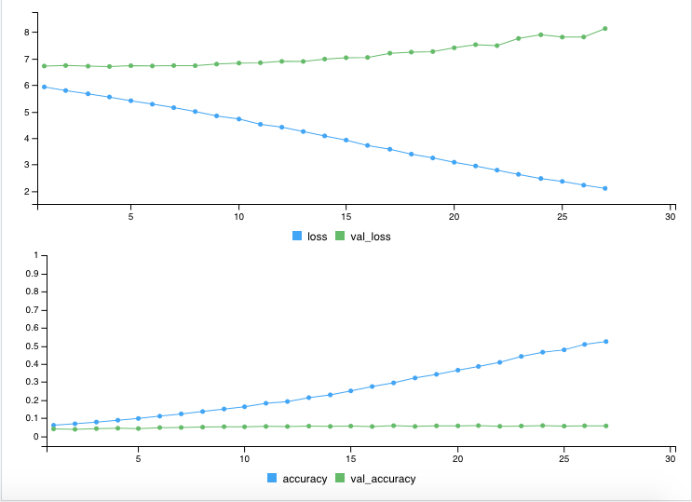

**Fig <>: Results showing poor accuracy with Model-1 params**

Most experiments took several hours to complete and yielded poor intermediate validation accuracy as seen above. Some of the references indicate running the training for up to 100 epochs so it is possible the training was not done for long enough.

The final experiment with VGG16 was so intensive that it repeatedly starved resources and crashed RStudio. For experiments further, some of the considerations are:

* Setup GPUs for intensive image processing
* Loan or buy a deep-learning VM on Google Cloud Platform (some of the landmark retrieval problems take up to a day to complete at any reasonable scale even on deep-learning VMs)
* Possibly make efficient the known bottleneck layers in VGG16

## **Deep Learning: Binary/Multiclass Classifiers (reduced dataset)**

The second experiment investigated using convolutional neural networks to solve a binary classification problem and a multiclass classification problem. After rounds of testing with hyperparameter-tuning, three binary classification models gave high test accuracy between approximately 97.3% and 97.7%. The same network architecture (except for the output layer unit and activation function) was then used to build the multiclass classifier. Three models of the 4-labels classifier reached test accuracy between approximately 89.8% and 93.1%.

**Test Accuracy Comparison**

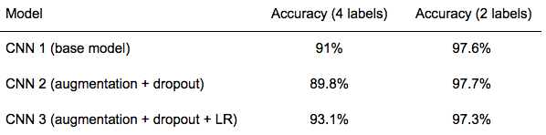

In comparing the accuracy results between the binary classification models and the 4-label classification models, the former had much higher accuracy. It is understandable because a binary classification task is easier than a multi-classification task.

For both binary and multiclass classifiers —

* The first models had an overfitting issue, which is common with models that are trained on small sample data. It is interesting to note that even with an overfitting issue, both models still reached above 90% test accuracy. The binary model reached a high-test accuracy of approximately 97.6%; the multiclass model had approximately 1.2% higher test accuracy than the better-fitted model two.
* The second models used data augmentation and dropout techniques and mostly resolved the overfitting issue. However, the test accuracy did not improve. The binary model has about the same accuracy as the first model and the multiclass model had slightly lower accuracy than the first model. One potential issue could be the dropout rate of 50% being a bit high. Further testing could be done with lower dropout rates.

* The third models used RMSProp's adaptive learning rate (instead of the manual setting of the learning rate as 0.0001 in the previous two models). The test accuracy reduced approximately 0.4% for the binary model but improved approximately 3.3% for the multiclass model. As the learning rate is an important hyperparameter, further tuning of this parameter could be tested to see if an optimal learning rate can be found to improve accuracy. Furthermore, different optimizers, such as Adam (Adaptive Moment Estimation), which is an update to the RMSProp, can be explored and compared the accuracy results with RMSProp.

**Activation Maps: What Does a Model See**

Activation maps are useful for understanding what the network sees and learns from the decomposition of the input on each of its intermediate layers. It is interesting to note that as the image flows through deeper layers, the activations become increasingly abstract. A look into binary classification model two provided insights on how the network distills the input information, filters out irrelevant visual details, and magnifies useful information about the class of the image. In this sense, it seems to behave like a human brain, which learns to transform visual input into high-level visual concepts, while filtering out irrelevant visual details.

## Traditional Models: Binary/Multiclass Classifiers (reduced dataset)

**Multi-Class Classifier**

From this experiment on traditional classifiers using multi-class/4-labels,

* Dimensionality reduction –number of predictor variables were reduced to 30 with **principal component analysis (PCA)**. Train and test dataset size as below,

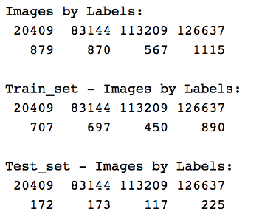

Training data set:

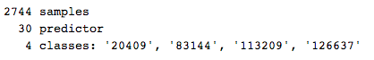

* **Decision Tree** models – decision tree with actual train and test data sets yielded an accuracy of 50.8%; Whereas, with PCA dataset the accuracy has increased to 51.53%
* **k-Nearest Neighbors (KNN)** – on PCA dataset had better results at k value 5 as 57.73%.
* **Supply Vector Machine (SVM)** models– 3 versions of SVM model built on PCA dataset had slightly better results than DT models.
  + SVM with linear Kernel performed better than DT models at 54.88% accuracy
  + SVM with radial Kernel performed at 58.37%
  + SVM with polynomial all images assigned to label 126637.
* **Random Forest** model predicted with 63.5% on the actual dataset with number of trees set as 100

Overall, experiments on Conventional classifiers with 4 labels had consistent accuracy over 50% with Random Forest with highest followed by SVM’s radial kernel.

**Binary Classifier**

From this experiment on traditional classifiers using binary/2-labels

* Dimensionality reduction –number of predictor variables were reduced to 30 with **principal component analysis** (**PCA**). Train and test dataset size s below,

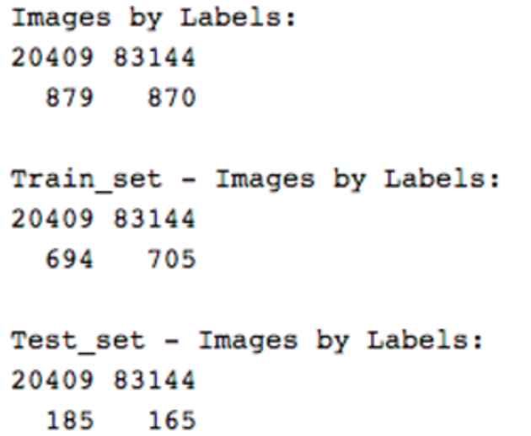

Training data set:

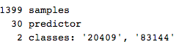

* **Decision Tree** models – decision tree with actual train and test data sets yielded an accuracy of 76%; Whereas, with PCA dataset the accuracy has increased to 76%
* **k-Nearest Neighbors (KNN)** – on PCA dataset had better results at k value 23 as 80.15%. **Supply Vector Machine (SVM)** models– 3 versions of SVM model built on PCA dataset had slightly better results than DT models.
  + SVM with linear Kernel performed better than DT models at 73.71% accuracy
  + SVM with radial Kernel performed at 76.57%
  + SVM with polynomial all images assigned to label 83144.
* **Random Forest** model predicted with 81.49% on the actual dataset with number of trees set as 100

Overall, experiments on Conventional classifiers with 2 labels had consistent accuracy over 70% with Random Forest with highest followed by kNN.

# **Conclusions**

The landmark retrieval problem is a paradigm in itself. While there is a steep learning curve to image processing with understanding the architecture of Convolutional Neural Networks (CNN) there are deeper aspects to experimentation at scale. Given the problem complexity at the outset and the resource limitations (lack of compute resources or GPUs), the Team dissected the project into three parts:

* Focusing on exploring CNNs, generators to sift through images at scale and experimentation with convnet parameters to improve prediction
* Deeper understanding of image processing at each layer and other aspects of CNNs while limiting the data-set classifications to binary or multi-class at most
* Exploring traditional classification and prediction algorithms for image processing

Details of datasets, excerpts of code, meaningful outputs and analysis has been presented in an attempt to fully explain the problem at hand and tools that were used to solve it. The findings from the study are:

* For image classification, convolutional neural networks give much higher accuracy in making predictions than traditional classification algorithms, as shown in the table below.
* CNNs can even work well with very small sample sets.
* When dealing with large image data sets, like Google Landmark data, CNNs need much computing power to carry out their “learning”.
* Keras library with TensorFlow backend provides an easy-to-use framework that allows fast prototyping.
* Hyperparameter-tuning of CNNs can get very complex and time-consuming.

**Accuracy Comparison for All Models**

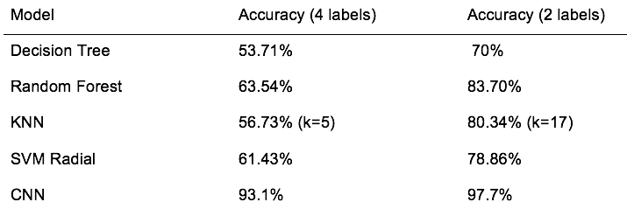

## Extended Research & Future work

In addition, our team also looked into image classification using the SIFT algorithm written by D. Lowe from University of British Columbia. The SIFT algorithm is invariant to image scale and rotation and focuses on steps below,

* Scale-space peak selection: Potential location for finding features using difference of Gaussians/scale-space pyramid techniques
* Keypoint Localization: Accurately locating the feature keypoints
* Orientation Assignment: Assigning orientation to keypoints
* Keypoint descriptor: Describing the keypoints as a high dimensional vector

Our study also suggested that the advantages of using SIFT for its,

* Locality - features are local; Hence, robust to occlusion and clutter and no prior segmentation needed.
* Distinctiveness - Often, the features can be stored and matched against a large database of objects.
* Quantity - Many features can be generated for even smaller objects
* Efficiency -With high Compute – results can be close to real-time performance.
* Extensibility - Features can be extended to a wide range of different feature types.

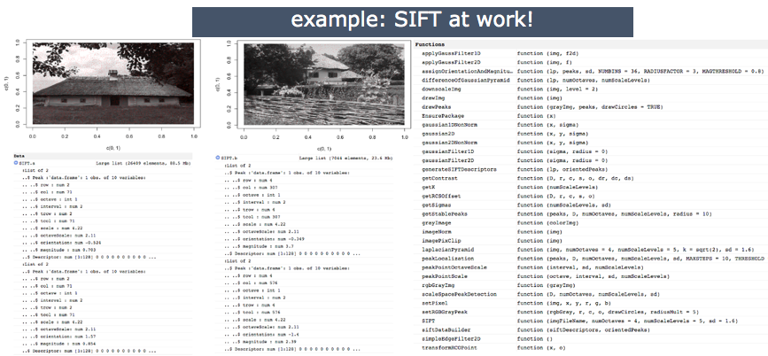

However, considering the short-duration and limited resources; Our team decided to extend this research further by procuring GPUs or utilizing other cloud resources (GCP offers deep-learning VMs) to experiment with models and measure its efficiency at scale.

# **References**

Chollet, François & Allaire, J.J. *Deep Learning with R.* Shelter Island, NY: Manning Publications, 2018. <https://www.manning.com/books/deep-learning-with-r>.

Kaggle. “Google Landmark Retrieval 2020.” Accessed July 26, 2020. <https://www.kaggle.com/c/landmark-retrieval-2020>

Kaggle. “Deep Learning.” Accessed August 2020. <https://www.kaggle.com/learn/deep-learning>.

TensorFlow for R. “Basic Image Classification.” Accessed August 2020. <https://tensorflow.rstudio.com/tutorials/beginners/basic-ml/tutorial_basic_classification>.

Weyand, Tobias, Andre Araujo, Bingyi Cao, and Jack Sim. “Google Landmarks Dataset v2 - A Large-Scale Benchmark for Instance-Level Recognition and Retrieval.” CVPR’20 (April 2020) <https://arxiv.org/abs/2004.01804>.